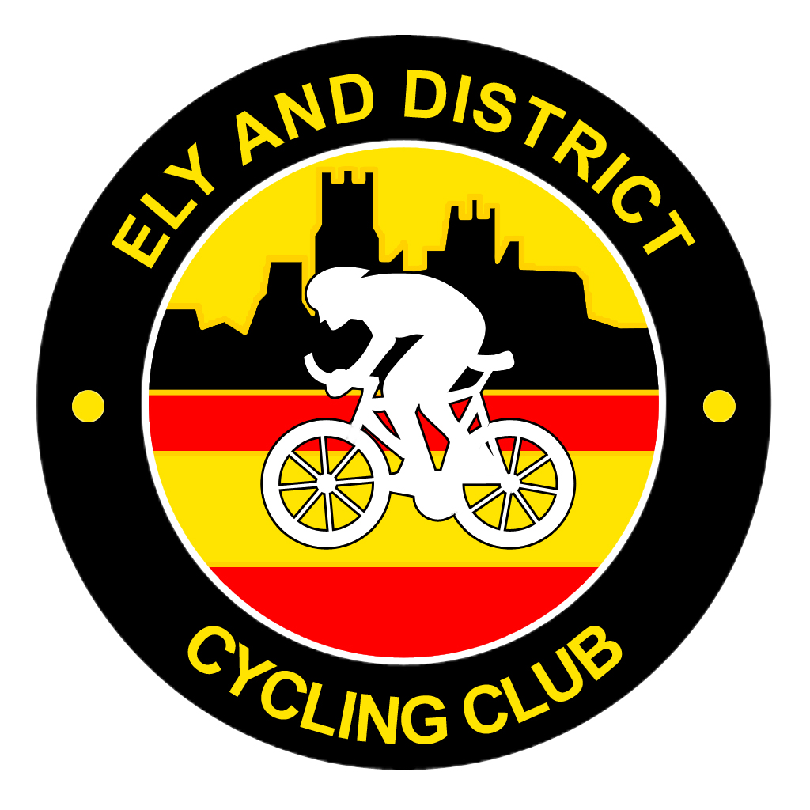 Ely & District CC 
Open 10 Mile Time Trial

To be held on Sunday 10th June 2018 starting at 09:05hrs on course B1/10R

The event is promoted for and on behalf of Cycling Time Trials under their Rules & Regulations.

Event Secretary: Will Shepherd, The Old Coach House, Main St, Coveney, Ely, Cambs, CB6 2DJ
Tel: 01353 774928 or 07501 469387, Email: willshepherd27@gmail.com

Course B10/1R Course Record - Ollie Jones 20.18 (2017)
Ladies – Verity Smith 23.34 (2017)

Start approx 50yds from A142 on Mepal access road, turn left on to A142 (TAKE EXTREME CARE WHEN JOINING A142) and proceed along A142, straight over first RAB (Sutton) to Lancaster Way Roundabout (Witchford), retrace outward route to finish on A142 at gateway to shooting club at the top of the hill (just after the road straightens after the bend).

HQ & Parking – is at Witcham Village Hall, Martins Lane, Witcham, Ely, CB6 2LB. Turn off A142 into Witcham village, go into the village and HQ is on the right by the playing field. Changing facilities will be available on the day. HQ will be open from 07:30hrs. Please note this is a new HQ, but only about 1.5 miles from the start.

Numbers and Signing on at the HQ and not at the start, numbers can be exchanged for a free drink.

Timekeepers: Mike Wiseman and Mary Holland
Marshalls & Catering: Members and Friends of Ely & District CC

Prizes, one per rider (except team), will be sent with the result sheets

Prizes: 1st £30.00 1st Vet Std £30.00
2nd £20.00 2nd Vet Std £20.00
3rd £15.00 3rd Vet Std £15.00
4th £10.00 4th Vet Std £10.00

1st Lady £30.00 1st Lady Vet Std £30.00
2nd Lady £20.00 2nd Lady Vet Std £20.00
3rd Lady £15.00 3rd Lady Vet Std £15.00
4th Lady £10.00 4th Lady Vet Std £10.00

Team x 3 Riders £10 Each
Prize Money Sponsored by B&T Motor Repairs – Ely

Local Regulations

U turns will not be permitted on the course or adjacent roads to the start or finish whilst the race is in progress.
Note: any breaking of this regulation in the first case will mean disqualification from the event. Further cases will be referred to the District Committee.
Definition: A U-turn is defined as a 180 degree turn completed within the highway whilst astride the machine. It is recommended that the rider(s) should dismount, check the road is clear in both directions, then with the machine walk across the road.
No warming up on the course by competitors once an event has started.
The use of turbos is banned at all events with a.m. start times.
All competitors under the age of of 18 and/or juniors must wear a properly affixed helmet which must be of a hard/soft shell construction. Helmets should conform to a recognised standard such as SNELL B95, ANSI Z90.4, AUS/NZS 2063:96, DIN 33-654, CPSC or EN1078. It is the responsibility of the rider (or the parent or guardian if the rider is under 18 years of age) to:-
Select a helmet that offers protection against head injury and does not restrict the riders vision or hearing.Ensure that the helmet is properly fitted, is undamaged and in good condition.

In the interest of your safety, Cycling Time Trials and the event promotors strongly advise you wear a HARD SHELL HELMET that meets an internationally accepted safety standards.
The East District committee recommend that competitors should fit a rear L.E.D light to enhance visibility to other road users

PLEASE TAKE CARE ON THE ROUNDABOUTS AND HAVE A SAFE RIDE

