

10 Mile Open Time Trial for Bicycles
Promoted for and on behalf of Cycling Time Trials under their Rules and Regulations

23rd June 2018 Start: 07.23 am Course G10/97

Prize List
1st on actual time £30
2nd on actual time £20
3rd on actual time £10

1st Veteran, actual v CTT 10 mile Standard £20
2nd Veteran £10

Fastest Lady £20
2nd Fastest Lady £10

Fastest team of 3 £5 each

(Only one prize per rider except for Team Prize)

Event Secretary: Jon Fry
Flat 4 Stanmore House, 118-120 High Street

Billingshurst, West Sussex, RH14 9QS

Tel: 01403 783438 or 07881 345549 on the day.

Timekeepers: Start: Mike Labram (Crawley Wheelers) Finish: Peter Delve (Horsham Cycling)

Headquarters: The Steyning Centre, Fletcher’s Croft,
Steyning, West Sussex, BN44 3XZ

Headquarters open from 06:00.
Plenty of parking is available.
Free till 09:00 then pay and display (or Horsham annual parking disc), or park in road by church for free.

Thank you in advance for not wearing cycling shoes or cleats in the hall.

Numbers at HQ only. After the event please return your race number to the event HQ and complete the sign-out sheet in exchange for a cup of tea or coffee.

HQ to start: 1.83 miles Finish to HQ: 1.42 miles

Route to Start:
Left out of the car park to the mini roundabout, then right onto the High Street. Proceed North to the A283 junction. Left and continue West on A283 for 0.7 miles.

Route from Finish to Headquarters:
Continue past finish line and take 1st left. Head south along Steyning High Street, turn left at mini roundabout onto Church Street. Turn right after the Library.

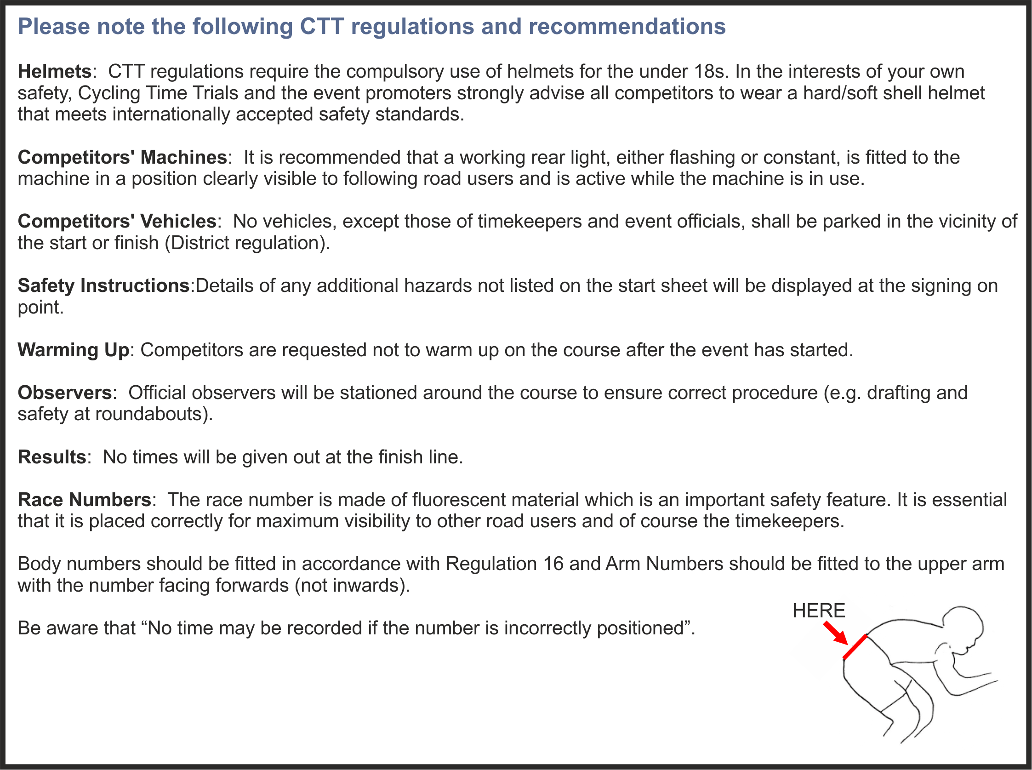



COURSE DIRECTIONS – G10/97 | MILES
START on A283 at yellow paint mark 39 yards east of centre of entrance to Hammes Farm (and Studio) and 0.52 miles west of junction with B2135 | 0.00
Proceed south-eastwards along A283 via Bramber Castle and Beeding Court RBTs to Adur Bridge RBT, Shoreham where turn (CHECK) | 5.41
Take fourth exit to retrace on A283 via Beeding Court and Bramber Castle RBTs to FINISH at yellow paint mark 25 yards west of “Public Bridleway” sign and 271 yards before left turn into Steyning | 10.00

Thanks to Sussex Cyclists’ Association for the following course map.
See their website for downloadable Garmin file - http://www.sussexca.org.uk/g1097.html

Open 10 mile Time Trial Saturday 23rd June 2018
Course G10/97
