East District Cycling Association

Open 25 mile Time Trial - Course B25/6 17/06/2018
“Promoted for and on behalf of Cycling Time Trials under their rules & regulations”

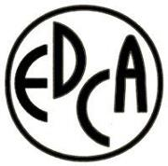

AWARDS

East District Cycle Association Medals awards

See results sheet

I like to thank the time keepers Hal West(Wisbech Wheelers) and Andy Moore(CC Breckland) for their help, and Pete Church for his assistance at the finish, Stuart Emmett(Wisbech Wheelers) at the start and signing. Ian Highnam(Wisbech Wheelers) for pushing off and phoning back results. Marshals (Wisbech Wheelers) Peter Baldwin, Derek Hall, Lou Campion, Adrian Churchill, JohnBates and John Brown. Bruce Williams (North Norfolk Wheelers). Adrian Whiting (Wisbech Wheelers) for large results and signing sheets, and tech support. My husband Kevin for doing the donkey work and Skaters for providing the venue and refreshments. Finally the riders for making it an enjoyable event and returning safe. Apologies to anyone I have forgotten.

