ROYAL NAVY & ROYAL MARINES CYCLING ASSOCIATION
www.navycycling.org.uk

 | 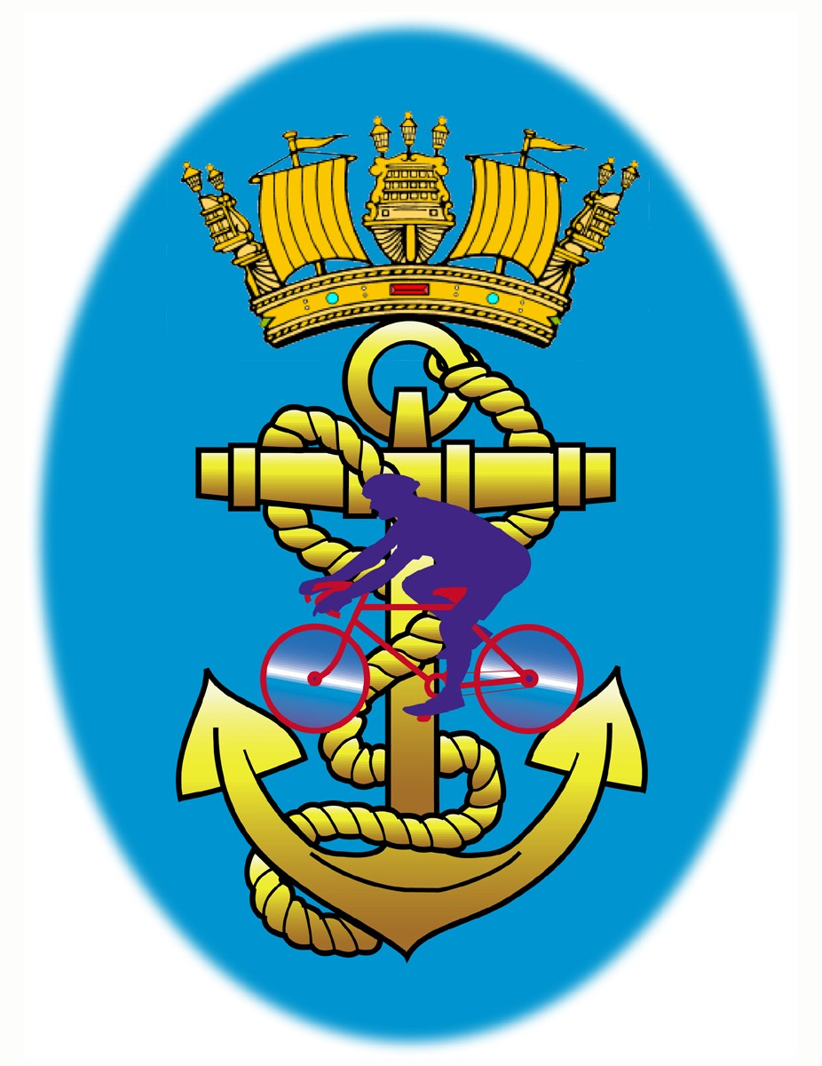  HEARTS OF OAK | WO1 ET (WE) Barry Moss  FOST WE19  S31, Grenville Block  HMS Drake  Plymouth  DEVON  PL2 2BG  Tel: 01752 567307  Navyoptrg-fostswe19@mod.uk

ROYAL NAVY & ROYAL MARINES CYCLING ASSOCIATION

Presents an

Open 10 Mile Time Trial

Promoted for and on behalf of the Cycling Time Trials under their Rules and Regulations.
On Thursday 5th Jul 2018 at Buckfastleigh, Devon, TQ11 0DA.

Timekeepers: Events: Event Secretary:
Start – Mr Ian Myers RNRMCA members Mr Barry Moss
Finish – Mrs Caroline Twigger & Families 9 Broomfield drive
Hooe
Plymouth
PL9 9PG
Tel: 01752 481127
Mob: 07881900519

1st Rider Off: 19:01
I/C Pusher Off ‘s: Mr Ian Jacques
Turn Marshalls: Mr Gary Whittles, Mr Rob Smith, Mr Terry Dawson

Course details: S4/10

Start: on the A38 approximately 1.3 miles South West of Buckfastleigh at a point level with the penultimate sink in the acceleration lane opposite Dean Prior Parish Church (GR SX730634). Proceed Northeastwards towards Exeter and take the second slip road signed “Ashburton” (Linhay), where filter left into slip road. At the give way line turn right and bear right in 50 yards to cross A38 and rejoin the A38 towards Plymouth. Retrace outward route passing Ashburton, Buckfastleigh and the slip road signed “Lower Dean”. Finish at the drain cover level with the start of the taper at the western end of the lay-by and approximately 500 yards before Dean Prior Church (GR SX730640).
Intermediate mileage – Ashburton Town Sign 5.33miles
Headquarters: St Lukes Church , Buckfastleigh Devon, TQ11 0DA – will be open from 1800 where numbers and signing on sheet will be available. Please park in Victoria Woodholme Pay and Display car park 200yds from Church. Directions from car park- Leave car park turn right and the church is 100yds on the right.

Race Numbers: These will be available from HQ. All riders are to ensure they wear the correct numbers as indicated on the start sheet. Please ensure these are returned to HQ on completion and that you sign to say you have returned from the course.

Refreshments: They will be available at H.Q. after the event. Please do remember to return numbers at the same time.

Prize List: Totalling £255

1st Man - £30, 2nd Man - £20, 3rd Man - £15.

1st Vet 40-44 £15, 2nd Vet 40-44 £10

1st Vet 45-49 £15, 2nd Vet 45-49 £10.

1st Vet 50-59 £15, 2nd Vet 50-59 £10.

1st Vet 60 & Over £15, 2nd Vet 60 & Over £10.

1st Lady - £30, 2nd Lady - £20 3rd Lady £15.

1st Lady Vet - £15, 2nd Lady Vet £10

Please note: One Rider One Prize

Notes to riders: PLEASE READ

- In the interest of your own safety, CYCLING TIME TRIALS and the event promoters strongly advise you wear a Hard Shell Helmet that meets CTT regulation No.15. All juveniles and juniors must wear a helmet.
- Riders waiting to start must do so 20 metres before the timekeeper and stand well to the left in the layby and in single file.
- It is strongly recommended that a working rear light, either flashing or constant is fitted to your machine in a position clearly visible to road users and is active whilst the machine is in use.
- The course used for this event is on a main road. Overtaking traffic will be moving fast. For your own safety, keep well to the left.
- There will be time when you join an ‘A’ road from a ‘B’ road. The traffic has the right away. Be aware of this when you join the main road.
- Do observe the Highway Code.
- Event officials must not seek to regulate or interfere with other traffic.
- Ride with your head up. Do not “white line”
- Drafting-Paced Riding: CTT regulation No.21 must be applied at all times. Any rider seen taking pace from another competitor will be disqualified. Overtaken teams are to fall back to a distance behind the other one...At least 50 yards is required.
- On completion of their ride, all competitors must continue without turning in the road to the event HQ Rattery turn on the A38.

Sponsored Clubs
As per start sheet.

