

https://www.sherwoodcc.org.uk

OPEN 10 MILE TIME TRIAL

(Promoted for and on behalf of Cycling Time Trials under their Rules and Regulations)

Saturday, 7th July 2018 at 5.01pm on A10/14 Course

Event Secretary: Roger Widdowson, 27 Morley Road, Thorneywood, NOTTINGHAM. NG3 6LL
Tel: 07966 777 475 E-mail: roger.widdowson@ntlworld.com

Timekeepers: Bill Stanley, Melton Olympic CC
Steve Custance, Beeston Road Club

Event Headquarters: Long Bennington Sports Pavilion, Main Road, Long Bennington, NEWARK. NG23 5HE
(open from 4pm)

Numbers and Signing On – Numbers will be at the Event HQ and can be collected when you sign on. Please return your number in exchange for a drink after your ride.

You MUST personally sign back in again upon completion of your ride otherwise YOU WILL be disqualified!

At the request of the custodians of the Pavilion, please, no cycling shoes in the HQ.

Parking is available along the Main Road and throughout side roads within the village. There is no parking for competitors at the Pavilion this year. Please be respectful to residents at all time.
DO NOT PARK ON THE SAME SIDE OF MAIN ROAD AS THE START LINE NOR BEYOND IT!

PRIZE LIST
One rider −One prize (except for team prize)
1st Fastest | £75
2nd Fastest | £55
3rd Fastest | £35
4th Fastest | £15
Fastest in Category A through J | £10 each
Fastest Woman | £30
Fastest Team of 3 Riders | £10 each

No formal presentation is planned after the event, but results will be posted up on the board at the Event HQ as soon as they are made available. Prizes will be posted out to riders after the event. One individual prize per rider (excluding team prize, which can be in addition to individual prize). You may collect your prize in cash on the day if you contact the organiser after the event.

We hope that you have an enjoyable, swift and safe ride. Good Luck.

Instructions
Course Map
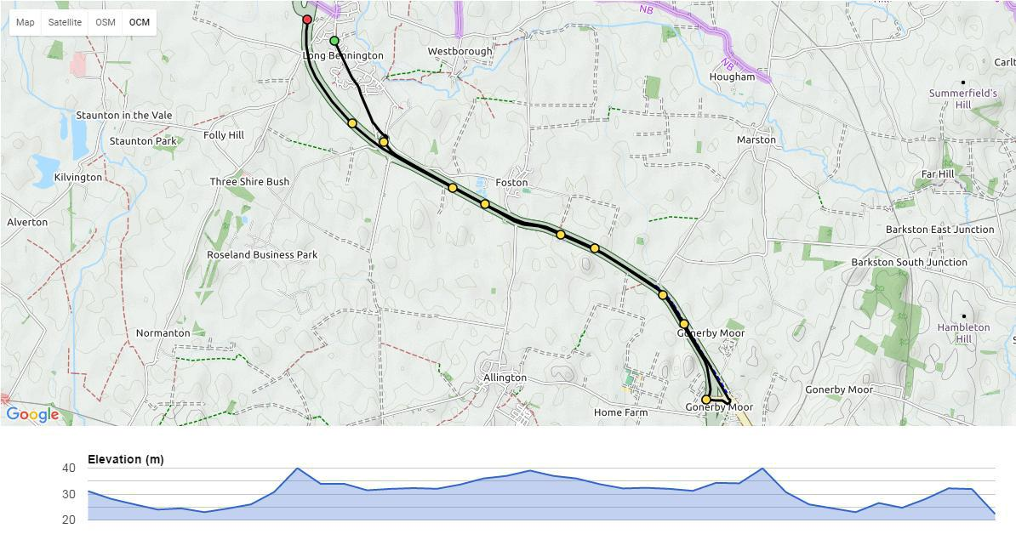

Course Details
Start at 9th kerb south of driveway to Jasmine House opposite St James Village Hall. 0.00 miles.
Proceed south through the village on old A1 to traffic island on New Foston Link Road.0.966 miles.
Take third exit onto A1 slip road proceed south to new slip road at Gonerby Moor. 4.243 miles.
Exit A1 on slip road to Old Gonerby Moor island. 4.804 miles

Take third exit onto new road over A1 on road bridge to new island. 5.000 miles Take third exit onto new slip road and rejoin A1 northbound.
Proceed to finish on slip road at old finish point approx 108 yards from end of armco barrier. 10.000 miles

Notes
IN THE INTEREST OF YOUR OWN SAFETY, Cycling Time Trials and Sherwood Cycling Club strongly advise you to wear a HARD SHELL HELMET that meets internationally accepted safety standards. It is recommended that a working rear light, either flashing or constant, is fitted to the machine and is active whilst the machine is in use.
Please allow at least 5 minutes from the HQ to the start. The start is south through Long Bennington Village.
Please ride carefully, especially when merging onto the A1 South and North and turning at Gonerby Island.
Please do not warm up on the course after the event has started. Strictly NO U-Turns near the start and finish between 5-7pm.
Marshals are instructed to report dangerous riding so keep your head up and be considerate of other road users.
After passing the finish timekeeper, riders should continue back to Event HQ, without stopping, up the sliproad to the junction with Valley Lane and turn right. Continue along Valley Lane until the T-junction with Main Road, Long Bennington. Turn left here to make your way back to the Pavilion. DO NOT TURN RIGHT ALONG MAIN ROAD TO COOL DOWN AS PASSING THE START TIMEKEEPER MAY RESULT IN DISQUALIFICATION.
Remember, you are required to return to the HQ to sign back in again after finishing your ride.
Pos | Time Off | Name | Club | Gender | Category | Time
1 | 17:01 | Roger Widdowson | Sherwood CC |  | F | 00:23:59
2 | 17:02 | David York | Ratae RC |  | H | 00:25:37
3 | 17:03 | Ron Hallam | South Pennine RC |  | F | 00:23:46
4 | 17:04 | Mark Saunders | Melton Olympic CC |  | F | 00:23:21
5 | 17:05 | Ian Guilor | Mapperley CC |  | A | 00:18:02
6 | 17:06 | Kathryn Smith | Sleaford Wheelers Cycling Club | F | I | 00:26:16
7 | 17:07 | Jo Corbett | Mapperley CC | F | E | 00:22:32
8 | 17:08 | Ian Wroblewski | Lutterworth Cycle Centre Racing Team |  | C | 00:20:52
9 | 17:09 | Simon Geraci | Team Swift |  | C | 00:20:46
10 | 17:10 | Ashley Roue | Lutterworth Cycle Centre Racing Team |  | B | 00:19:37
11 | 17:11 | Michael Church | Rockingham Forest Whs |  | H | 00:25:15
12 | 17:12 | Kevin Humphreys | Sherwood CC |  | F | 00:23:38
13 | 17:13 | Andrew Bright | Chronos RT |  | E | 00:22:26
14 | 17:14 | Craig Lamb | Alford Whs |  | D | 00:21:17
15 | 17:15 | Gary Kondor | Sherwood CC |  | C | 00:20:41
16 | 17:16 | Rod Weston | Race Hub |  | G | 00:24:44
17 | 17:17 | Rob Keep | Sleaford Wheelers Cycling Club |  | F | 00:23:34
18 | 17:18 | Vincent Jenkins | LeisureLakesBikes.com |  | E | 00:22:26
19 | 17:19 | Philip Collier | Mapperley CC |  | D | 00:21:17
20 | 17:20 | Jonathan Wears | NOPINZ |  | A | 00:18:34
21 | 17:21 | Thomas Ireland | East Lancashire RC |  | H | 00:25:59
22 | 17:22 | Michelle Morley | Team Swift | F | F | 00:23:34
23 | 17:23 | Stephen Robinson | North Notts Olympic CC |  | E | 00:22:25
24 | 17:24 | Ryan Ballard | Team Bottrill / Vanguard |  | D | 00:21:22
25 | 17:25 | Jon Surtees | NOPINZ |  | A | 00:18:38
26 | 17:26 | Gill Henshaw | Velo Club Long Eaton | F | H | 00:26:35
27 | 17:27 | Paul Jones | Sherwood CC |  | F | 00:23:06
28 | 17:28 | Daniel Reidenbach | Ratae RC |  | E | 00:22:23
29 | 17:29 | Jez Willows | Velo Club Flintham |  | D | 00:21:16
30 | 17:30 | Matt Plews | Welland Valley CC |  | D | 00:21:14
31 | 17:31 | James Byatt | Ilkeston Cycle Club |  | H | 00:25:48
32 | 17:32 | Martin Lister | Witham Wheelers |  | F | 00:23:04
33 | 17:33 | Ian Fensom | Fenland Road Club |  | E | 00:22:21
34 | 17:34 | Matthew Miller | Team Bottrill / Vanguard |  | D | 00:21:14
35 | 17:35 | Richard Dean | CYCLOMANIA |  | B | 00:19:03
36 | 17:36 | Caroline Frank | Lindsey Roads Cycling Club | F | H | 00:25:26
37 | 17:37 | Roy Oakes | South Pennine RC |  | F | 00:23:04
38 | 17:38 | Simon Cooper | Nottingham Clarion CC |  | E | 00:22:19
39 | 17:39 | Paul Ripley | Alford Whs |  | D | 00:21:11
40 | 17:40 | David Mead | Lutterworth Cycle Centre Racing Team |  | B | 00:19:04
41 | 17:41 | Derek Hodgins | Stockport Clarion CC |  | H | 00:25:25
42 | 17:42 | Andrew Spittlehouse | Calder Clarion |  | F | 00:23:03
43 | 17:43 | Giles White | Sherwood CC |  | E | 00:22:18
44 | 17:44 | Nicholas Hitchens | Peterborough CC |  | D | 00:21:08
45 | 17:45 | Anthony Keyworth | Kiveton Park Cycling Club |  | B | 00:19:20
46 | 17:46 | Charlotte Ridsdale | Rutland Cycling Club | F | H | 00:25:11
47 | 17:47 | Simon Smith | Coventry Road Club |  | E | 00:22:59
48 | 17:48 | Nigel Finch | Mercia - Lloyds Cycles CC |  | E | 00:22:11
49 | 17:49 | Chris Spray | Ratae RC |  | D | 00:21:08
50 | 17:50 | Robert Gibbons | Team Klincutapparel.com |  | B | 00:19:24
51 | 17:51 | Michael Davis | Beeston Road Club |  | G | 00:24:46
52 | 17:52 | Gary Clarke | Rutland Cycling Club |  | E | 00:22:57
53 | 17:53 | Matthew Stretton | Coalville Whs |  | E | 00:22:11
54 | 17:54 | Chris Draper | Sherwood CC |  | D | 00:21:07
55 | 17:55 | James Bentley | Team Bottrill / Vanguard |  | B | 00:19:28
56 | 17:56 | Julie Lambourne | TFN Triathlon Club | F | I | 00:26:00
57 | 17:57 | Garry Shuker | Walsall Roads Cycling Club |  | E | 00:22:56
58 | 17:58 | Michael Wilkinson | North Notts Olympic CC |  | D | 00:21:59
59 | 17:59 | Mervyn Wilson | North Lancashire Road Club |  | D | 00:21:07
60 | 18:00 | Andrew Green | Team Jewson - MI Racing ~Poly Pipe~McCann |  | B | 00:19:29
61 | 18:01 | Stephen Littlewood | Sherwood CC |  | G | 00:24:15
62 | 18:02 | Gary Thornton | Barnsley Road Club |  | E | 00:22:56
63 | 18:03 | Phillip Tyas | Barnsley Road Club |  | D | 00:21:57
64 | 18:04 | Steven Loraine | Team Swift |  | D | 00:21:04
65 | 18:05 | Sean Vincent | Team Bottrill / Vanguard |  | B | 00:19:34
66 | 18:06 | Lauren Pike | Fenland Road Club |  | I | 00:26:42
67 | 18:07 | David Ireland | East Lancashire RC |  | E | 00:22:55
68 | 18:08 | Mark Booth | Kettering CC |  | D | 00:21:48
69 | 18:09 | Steve Hancock | Calder Clarion |  | C | 00:20:59
70 | 18:10 | Stuart Wells | Flex-Tech Ettridge Cycles Racing Team |  | B | 00:19:35
71 | 18:11 | Andrew Porter | Welwyn Whs |  | G | 00:24:39
72 | 18:12 | Fidel Gonzalez | South Western Road Club/Evans Cycles |  | E | 00:22:51
73 | 18:13 | Paul Eveleigh | Lincoln Wheelers CC |  | D | 00:21:46
74 | 18:14 | Gareth Pymm | Team Bottrill / Vanguard |  | C | 00:20:56
75 | 18:15 | Paul Cox | wattbike.com |  | B | 00:19:36
76 | 18:16 | Chris Close | Sleaford Wheelers Cycling Club |  | G | 00:24:30
77 | 18:17 | David Yarham | Peterborough CC |  | E | 00:22:47
78 | 18:18 | Ian Pike (Trike) | Lincoln Wheelers CC |  | D | 00:21:45
79 | 18:19 | Andrew Hicklin | Peak Road Club |  | C | 00:20:50
80 | 18:20 | Karl Caton | Elmsall Road Club |  | B | 00:19:58
81 | 18:21 | Wayne Fuller | Rotherham Wheelers Cycling Club |  | G | 00:24:29
82 | 18:22 | Mark Hulme | West Pennine Road Club |  | E | 00:22:43
83 | 18:23 | David Wright | Cheshire Roads Club |  | E | 00:22:43
84 | 18:24 | Edward Mellor | Mapperley CC |  | D | 00:21:45
85 | 18:25 | Kevin Hobbs | Peterborough CC |  | C | 00:20:48
86 | 18:26 | David Manship | Leicester Forest CC |  | G | 00:24:18
87 | 18:27 | Rod Weston | NOPINZ |  | E | 00:22:42
88 | 18:28 | Wendy Gooding | Team Bottrill / Vanguard | F | D | 00:21:45
89 | 18:29 | Paul Heggie | Birdwell Wheelers |  | D | 00:21:41
90 | 18:30 | Nicholas Cousins | Derby Mercury R C |  | B | 00:19:59
91 | 18:31 | David Fear | South Pennine RC |  | G | 00:24:04
92 | 18:32 | Patrick Kelly | Velo Club Long Eaton |  | E | 00:22:41
93 | 18:33 | Brian Sunter | Condor RC |  | C | 00:20:44
94 | 18:34 | Edwin Kaye | Alford Whs |  | C | 00:20:45
95 | 18:35 | Colin Parkinson | South Western Road Club/Evans Cycles |  | B | 00:19:42
96 | 18:36 | Lucy Sturgess | Leicester Forest CC | F | G | 00:24:00
97 | 18:37 | Charlie Holton | Welland Valley CC |  | F | 00:23:50
98 | 18:38 | Chris Sprott | Leicester Forest CC |  | D | 00:21:36
99 | 18:39 | Richard Sheldrake | Lincoln Wheelers CC |  | C | 00:20:44
100 | 18:40 | Richard Boot | Beeston Cycling Club |  | C | 00:20:03
101 | 18:41 | Matthew Finch | Leicester Forest CC |  | F | 00:23:49
102 | 18:42 | Paul Ashdown | Kettering CC |  | E | 00:22:38
103 | 18:43 | Brett Lowndes | Pro Vision Cycle Clothing |  | D | 00:21:34
104 | 18:44 | Robert Cooke | CYCLOMANIA |  | C | 00:20:37
105 | 18:45 | Kenny Cliffe | Leicester Forest CC |  | C | 00:20:04
106 | 18:46 | John Smith | Thurcroft CC |  | F | 00:23:41
107 | 18:47 | Peter Stirk | Elmsall Road Club |  | E | 00:22:32
108 | 18:48 | Rich Steels | Belper BC |  | D | 00:21:32
109 | 18:49 | Gary Symons | Witham Wheelers |  | C | 00:20:21
110 | 18:50 | Jeremy Hargrave | Fenland Road Club |  | C | 00:20:05
111 | 18:51 | David Smith | Sleaford Wheelers Cycling Club |  | F | 00:23:41
112 | 18:52 | Anthony Hardenberg | Witham Wheelers |  | E | 00:22:30
113 | 18:53 | Francesca Hall | D A P Cycling Club | F | D | 00:21:29
114 | 18:54 | Tim May | MediaVelo |  | C | 00:20:07
115 | 18:55 | Shaun Eden | Mapperley CC |  | B | 00:19:18
116 | 18:56 | Steven Barrell | Mapperley CC |  | E | 00:22:28
117 | 18:57 | Mark Atkinson | Alford Whs |  | D | 00:21:19
118 | 18:58 | Michael Wills | Lutterworth Cycle Centre Racing Team |  | C | 00:20:18
119 | 18:59 | Ben Trippier | East Lancashire RC |  | C | 00:20:12
120 | 19:00 | William Perrett | University of Derby Cycling Club |  | B | 00:19:05
 | RESERVE | Kenneth Stevens | South Pennine RC |  | I | 00:26:30
 | RESERVE | Cyril Wynne | Stretford Wheelers CC |  | J | 00:27:42
 | RESERVE | John Atkin | Melton Olympic CC |  | H | 00:25:57
 | RESERVE | Andy Clark | Rutland Cycling Club |  | G | 00:24:44

