Start Sheet for the  Northampton & District Cycling Association  Rockingham Time Trial (TT Series Event 7 of 10) | 
Saturday 14th July 2018 starting at 7:15 pm | FOUNDED 1935
 | PRESIDENT:
Promoted for and on behalf of Cycling Time Trials under their Rules and Regulations | Ray Grundy
This event is a counting event for the following categories of the N&DCA Time Trial Series Championships, Overall, Ladies, Junior, Veteran and Team.

For up to date N&DCA news including the latest points tables visit our website
http://www.northamptondca.org.uk

Event Secretary: Steve Robinson, 17 Manor Way, Potton, Beds, SG19 2RH, 07432 177854

Headquarters: Rockingham Motor Speedway, Mitchell Rd, Rockingham, Corby NN17 5AF

Arrival time: There is a motorbike track day on during the day, and as a consequence we will not be allowed into the inner paddock until some time between 18:00 and 18:15. The exact time is out of our control, so please bear with us.

Please don’t arrive before 18:00 as you will not be allowed into the circuit, and will be parked up in a holding area until the track day entrants are clear.

Accessing the venue: Once we are given clearance to enter the venue you should follow the signs for “Inner Paddock”. Take the 2nd right after the security gates and go through the tunnel under the track into the inner paddock. There is plenty of parking in the middle.

Facilities: The HQ and signing on will be in the end room of the pit garages on your right as you enter the car park. The HQ will be open from approximately 18:15 pm. There are toilets between the pit garages on the left hand side of the car park.

Parking: Parking is available in the inner paddock. See full details on the next 2 pages.

Timekeepers: Michael Bannister and Michael Church

Prize  Values | Fastest | Lady | Junior / Juvenile | Masters X  (born 1957-1966) | Masters Y  (born 1947-1956) | Masters Z  (born 1946 or earlier) | Team  of 3
1st | £15.00 | £9 | £9 | £9 | £9 | £9 | £6 each
2nd | £12.00 | £7 | £7 | £7 | £7 | £7 | £5 each
3rd | £10.00 | £6 | £6 | £6 | £6 | £6 | -
4th | £9.00 | - | - | - | - | - | -
5th | £8.00 | - | - | - | - | - | -
6th | £7.00 | - | - | - | - | - | -

Numbers: These will be available at the Event Headquarters, not at the Start. Please ensure that you sign the "Signing-On" sheet and clearly call out your number when crossing the finish line.

Signing-off: Please ensure you return your number to HQ and sign-off, using the signing-on/off sheet. Failure to do so could result in your exclusion from the results.

Doping Control: This event may be subject to Doping Control. As soon as you have finished you should return to HQ as it is your responsibility to check if you are required for a Doping Control. Race numbers required for Doping Control will be displayed at the HQ adjacent to the results board. If your number is displayed you should report immediately to Doping Control which will be nearby. Remember, it is up to you to check and ensure you comply

COURSE details

The circuit we are using is 3 laps of the 3.15 mile circuit, starting and finishing in the pit lane. Please be aware that you will be on track with riders of vastly differing speeds, so you should always check behind before moving across or changing your line.

If you are starting your 2nd or 3rd lap please keep to the right on the start/finish straight. At the end of your 3rd lap (9.4 miles) keep to the left to enter the pitlane to finish. If you fail to enter the pit lane at the end of the 3rd lap your time will not be recorded!

When heading into the finish area please be aware of the need to stop shortly after the finish line.

Do not go inside the white line on the bowl (marked point 8 on next page) as this will not only result in disqualification but will probably give you a puncture as there are a lot of shards of metal on the track there!

Take care on the corners!

A couple of the corners on the circuit are quite sharp, and care must be taken. Your safety is more important than your time. In particular, the corner onto and off the bowl section sees riders heading in both directions, so please moderate your speed, and always heed warnings from our marshals.
If it is wet then you will need to reduce speed considerably on the sharp corners!

Familiarisation laps

We will be opening the circuit up from approximately 18:30 to 19:10 for you to ride to familiarise yourself with it ahead of your start time. You must be off track by 19:10.

Results

The results board will be in the HQ by signing on.

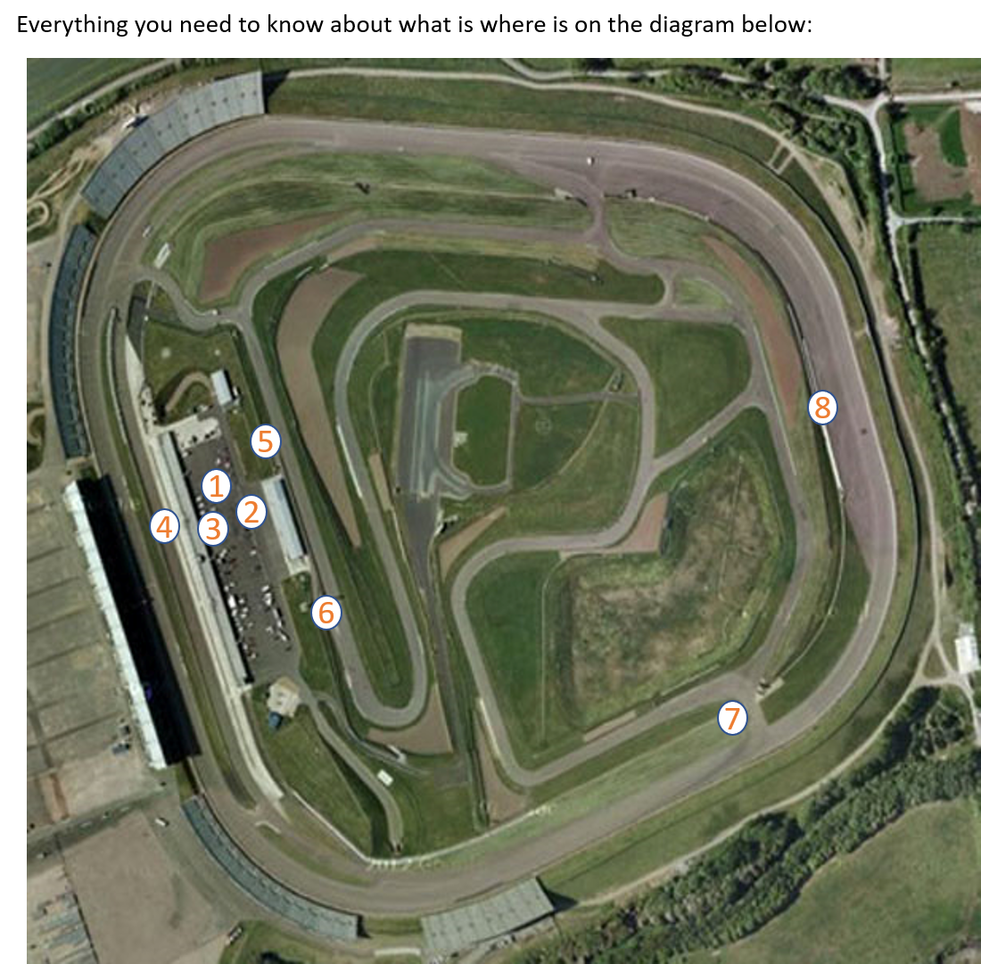

Key:
5 – Start
6 – Finish
7 – Tight corner – take care
8 – Do not cross inside the white line
1 – Car parking
2 – Signing on
3 – Toilets
4 – Warm up area

The circuit heads up from the start (point 5) and then round to the right to run clockwise all the way round the infield to the turn onto the outer bowl (point 7). Here you turn sharp left to ride a complete anticlockwise lap of the outer bowl back to point 7, where you turn sharp left back into the infield to loop clockwise back round to the start. We recommend riding the circuit during the familiarisation period, and you can find further info on it by searching ‘Rockingham’ on Strava.

No. | Start time | Firstname | Lastname | Club | Category
1 | 19:15 | Mark & Anna | Fraser | CC Ashwell | Tandem
2 | 19:16 | Jack | Mace | Icknield RC | Juv
3 | 19:17 | Mason | Bradley | Icknield RC | Juv
4 | 19:18 | Michael | Carter | Welland Valley CC | Juv
5 | 19:19 | Jonathan | Toma | Fenland Clarion CC | Juv
6 | 19:20 | Trystan | Barnett | 45 RC | Jun
7 | 19:21 | Noah | Field | CC Ashwell | Jun
8 | 19:22 | Jane | Lea | Ambleside Velo | W X
9 | 19:23 | Elaine | Maitland | Bonito Squadra Corse | W S
10 | 19:24 | Jackie | Field | CC Ashwell | W X
11 | 19:25 | Emma | Koppe | CC Ashwell | W S
12 | 19:26 | David | Cook | Bedfordshire Road RT | X
13 | 19:27 | Peter | Nix | Rockingham Forest Whs | Y
14 | 19:28 | Enrico | Cacciatori | QN Coaching | S
15 | 19:29 | Chris | Rimes | Team Salesengine.co.uk | S
16 | 19:30 | Pete | Trotman | A5 Rangers CC | Y
17 | 19:31 | Stuart | Field | CC Ashwell | X
18 | 19:32 | Bill | Barrie | Welland Valley CC | Z
19 | 19:33 | David | Morgan | Icknield RC | S
20 | 19:34 | Jack | Patmore | VeloElite RC | S
21 | 19:35 | Stuart | Emmett | Wisbech Whs | S
22 | 19:36 | Malc | Jacklin | Fenland Clarion CC | X
23 | 19:37 | Adrian | Mchale | Peterborough CC | S
24 | 19:38 | William | Tusting | Bonito Squadra Corse | Y
25 | 19:39 | Chris | Green | St Neots CC | S
26 | 19:40 | Dave | Wilson | St Neots CC | S
27 | 19:41 | Richard | Glover | CC Ashwell | Z
28 | 19:42 | James | Billingham | Kings Cliffe Flyers | X
29 | 19:43 | Michael | Wood | Kettering CC | Z
30 | 19:44 | Kevin | Hobbs | Peterborough CC | S
31 | 19:45 | Martin | Hedley | Witham Wheelers | X
32 | 19:46 | Julian | Freeman | Rockingham Forest Whs | S
33 | 19:47 | Steve | Maile | Fenland Clarion CC | S
34 | 19:48 | Martin | Webb | Icknield RC | Y
35 | 19:49 | David | Lindsay | St Neots CC | S
36 | 19:50 | James | Mckenzie | CC Ashwell | Y
37 | 19:51 | David | Ledgerton | Team Salesengine.co.uk | X
38 | 19:52 | John | Osborne | Kettering CC | S
39 | 19:53 | Michael | Harvey | Rockingham Forest Whs | Z
40 | 19:54 | Nicholas | Hitchens | Peterborough CC | X
41 | 19:55 | Sam | Mcdonald | St Neots CC | S
42 | 19:56 | Ian | Waddilove | Fenland Clarion CC | Y
43 | 19:57 | Trevor | Parrish | A5 Rangers CC | Z
44 | 19:58 | Dave | Bailey | QN Coaching | S
45 | 19:59 | Graham | Martin | A5 Rangers CC | S
46 | 20:00 | Patrick | Ellerbeck | St Neots CC | Y
47 | 20:01 | James | Burden | Rapha Cycling Club | S
48 | 20:02 | Graeme | Hall | Rockingham Forest Whs | X
49 | 20:03 | David | Jones | CC Ashwell | S
50 | 20:04 | Steve | Franklin | Team Salesengine.co.uk | S
51 | 20:05 | Glyn | Poole | Wellingborough Cycles | S
52 | 20:06 | Geoff | Platts | Team Bottrill / Vanguard | Y
53 | 20:07 | Mark | Bottrill | Team Bottrill / Vanguard | S
54 | 20:08 | Paul | Pardoe | Peterborough CC | S
55 | 20:09 | Kristian | Woolf | VC Equipe/Flix Oral Hygiene/Propulse | S
56 | 20:10 | James | Gelsthorpe | Velo-One Cycling Team(Staples Vegetables/Neil Palmer Electrical) | S
57 | 20:11 | Thomas | Weir | Hitchin Nomads CC | S
58 | 20:12 | Fabos | Young | VeloElite RC | S
59 | 20:13 | Ryan | Witchell | Team Salesengine.co.uk | S
60 | 20:14 | Mark | Avil | QN Coaching | X
61 | 20:15 | George | Fox | Team Bottrill / Vanguard | S

