
RON SPENCER MEMORIAL TIME TRIAL

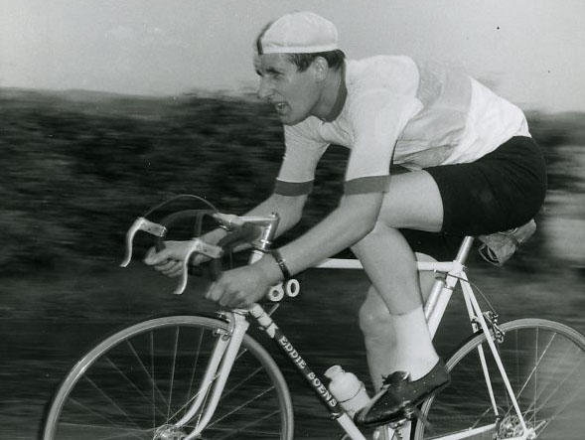

Ron Spencer joined Warrington Road Club in 1958 as a youngster and soon became one of the best Time Trial riders not only in the club, but soon enough the whole UK. Ron was National 12-hour champion in 1963 and second in the BBAR that year. Thirty years later, he was still clocking fast standards against the clock under the hour on the course you ride for this event until his untimely passing in 2011. Warrington Road Club dedicate this Time Trial to the memory of Ron Spencer, to our former President and an active part of the cycling community.

Many thanks for your entry in this event.

FOUNDED 1923

Presents the Ron Spencer Memorial 25 Mile Time Trial
On Saturday 14th July 2018 1st rider off at 14.04

The event is ‘Promoted for and on behalf of Cycling Time Trials under their Rules & Regulations’.

Event Secretary:
Alan Ottiwell, 73 Highfield Road, Lymm, Cheshire, WA13-0DT (07814-327863) alanottiwell@hotmail.co.uk

Event HQ:
CRANAGE VILLAGE HALL, 7 miles south of Knutsford and 1 mile north of Holmes Chapel on the A50.
Postcode CW4-8EQ. Open from 12:30pm

Time Keepers:
Graham Lawrence and Tony Millington

Be Warned!
Dangerous riding causes accidents and most certainly endangers the future of our sport.
Ride with your head up at all times. Observers are being used during this event.

PRIZES

One Prize per Rider (with Exception to Team Prize)

In addition, the Fastest Warrington RC rider to hold the Ron Spencer Memorial Trophy for one year.



COURSE J2/9 25 miles

START
At a “JS2” mark in Bomish Lane (Jodrell Bank to Goostrey road). At a telegraph pole No 2 approx 300yds west of the A535.
Proceed East to the A535 and forward on the A535 to:-
CHELFORD ISLAND 2.169 m
2nd exit left on the A537 to Seven Sisters lane at:-
OLLERTON CROSS ROADS 5.219 m
left along the lane to the A50 and left on the A50 to Twemlow Lane at:-
CRANAGE 11.408 m
left into and along the lane to join the A535 at Twemlow Green, left to:-
CHELFORD ISLAND 18.064 m
2nd exit left on the A537 to Seven Sisters Lane at
OLLERTON CROSS ROADS 21.052 m
left along the lane to the A50 and, left on the A50 to:-
FINISH 25.000 m
At a “JF2” mark opposite the right hand field gate post opposite and just before the entrance to the Mount Pleasant Nursing Home, approx 500yds past the cross roads after the Drovers Public House.

INTERNET DIRECTIONS BELOW of the Course
https://www.cyclingtimetrials.org.uk/course-details/j2-9
https://connect.garmin.com/modern/course/12901859

Directions to the start from HQ:

The Start is approx 4.4 miles away so allow sufficient time. Turn left out of HQ and take the 2nd Right crossing over the A50 with care on to Goostrey Lane approx less than half a mile from HQ. Keep straight on Goostrey Lane on to Main Road for approx 2 miles where you will need to Turn Left in to Blackden Lane front of church and down the hill. Follow lane ignoring left and right forks, to start which is just over the railway bridge after a sharp right bend and adjacent to the entrance to Jodrell Bank Telescope. Continue to the start where you will see the Warrington Road Club Flags at the start. Please avoid using the course to warm up or to ride to the start. NO U turns at start – dismount!!

INTERNET DIRECTIONS BELOW from HQ to the Start.
https://connect.garmin.com/modern/course/15489446

Directions from the Finish back to HQ:

Once you've crossed the line, please ride back safely on the left hand side of the road and consider other cyclists still competing as well as traffic like normal. Remain on the A50 for approx 2.5 miles until you get to HQ which will be on your right hand side. Cross over the A50 into the HQ with care

INTERNET DIRECTIONS BELOW from Finish to HQ.
https://connect.garmin.com/modern/course/15489573

GENERAL NOTES

- Riders must SIGN ON the signing on sheet and collect their numbers at the HQ before starting.

- Rides must SIGN OFF at the HQ once the race has finished. Not doing so will result in disqualification.

- Riders must return their numbers to the HQ after riding.

- Refreshments will be available at the HQ after the event.

SAFETY NOTES

- No parking at the start or finish. Vehicles must not be parked, however briefly, in any part of the access area to Mount Pleasant Nursing Home, opposite the finish.

- Any rider making a U turn in the vicinity of the start or finish will be disqualified.

- Riders must not stop at the finish but should continue on to the event headquarters where times will be displayed.

- Riders must negotiate Chelford Island in a safe and sensible manner in accordance with CTT Reg. 20 and the rules of the road.

- Riders must be able to brake and stop at the island if traffic conditions require this. Riders MUST NOT approach and encircle the island using tri-bars. Remember - traffic on the island has priority over traffic (including riders) entering it. Any rider seen to be in breach of this regulation will be disqualified from the event and may be reported for further disciplinary action.

- Care at Road Junctions: Riders must exercise care at all junctions. Any competitor who’s riding line causes him/her to cross the white line when approaching or leaving a junction will be liable to disqualification and may be reported to the District Committee for further disciplinary action.

- Riders must take extra care when exiting from Seven Sisters Lane onto the A50.

- Be aware that there is a double bend shortly after turning into Twemlow Lane at Cranage. Riders need to anticipate this and be prepared to negotiate it in a safe manner. In wet weather the metal covers and edges become a skid risk. Please take care.

- IN THE INTERESTS OF YOUR OWN SAFETY, Cycling Time Trials and the event promoters strongly advise you to wear a HARD SHELL HELMET that meets an internationally accepted safety standard. In accordance with Regulation 15 ALL JUNIOR & JUVENILE competitors must wear Protective Hard Shell Helmets.

- It is recommended that a working rear light, either flashing or constant, is fitted to the machine in a position visible to following road users and is active whilst the machine is in use.

MAP OF J2/9 COURSE

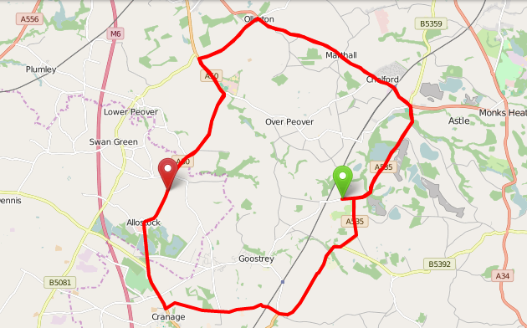

SEE YOU ON THE DAY, GOOD LUCK & RIDE SAFE

