10 Mile Time Trial- 21st July 2018
Promoted for and on behalf of Cycling Time Trials under their rules and regulations.

Event Sec: Stephen Penney, 3 Blackberry Close, Dereham, Norfolk NR20 3TB
Tel: 07984 147 118 |  | Email: | smpenney@outlook.com
TimeKeeper-Start: | Andy Moore | Timekeepers-Finish | Mick Wiseman / Anna Wiseman
Pusher Off: | Richard Reade, Huw Jones | Results Board: | Stephen Penney
Marshals & Observers: | Bruce Williams, Phil Hollingsworth, Roger Sayer, Mark Smart, Jen Smart, Danny Watkins, Gail Watkins, Roger Hollis
Refreshments | Maggie, Sam & Charlotte Penney

H.Q. and Parking, Village Hall, Golf Links Road, Morley St Peter, Wymondham, NR18 9SU.
Village Hall will be open from 1400. Please park with consideration to fellow competitors and local residents. There is plentiful parking available at the village hall and carefully along Golf Course Road.

Please note the following.
Numbers and signing in/out sheet will be at HQ and NOT at the start, please ensure that you sign-on when you collect your number, Please note that all competitors are required to PERSONALLY sign the sign-out sheet when returning their race number. Failure to do will result in the competitor being recorded as DNF.

Attn: The Start area is within a residential area and there have been complaints of competitors urinating prior to their event. Please refrain from doing this.

Course Details: B10/3b (Attleborough ←→ Snetterton)
Start by paint mark adjacent to A11 (West bound) at Attleborough (Inter Junction A11-A1077).
Proceed to join slip road and A11 and continue via Attleborough rab to Snetterton.
Take slip road and proceed to rab. Take 1st exit and proceed to 2nd rab.
Take 1st exit and proceed (over bridge) to 3rd rab to take 1st exit.
Proceed to 4th rab, take 2nd exit to join A11 east bound.
Proceed via Attleborough rab to FINISH at paint mark approx. ½ mile from start area.

Continue along A11, past the BP petrol station and leave the A11 at the next slip road. Turn left and proceed along Attleborough Road and then right into Golf Links Road, back to Morley Village Hall.
Course Records:
Men: Jason Bouttell 19:04 (2018)
Lady: Becky Murley 22:23 (2018)
Tandem: Mark Arnold / Glen Taylor 18:40 (2015)

Prizes: | 1st | 2nd | 3rd
Scratch / Ladies / Vets on Std. : | £25 | £15 | £10
Team (3 riders) | £10 each
Maximum one prize per winner (except Team).

CTT EAST DISTRICT LOCAL REGULATIONS 8,11,12

(8) U Turns: U turns will not be permitted on courses or roads adjacent to start / finish areas whilst a race is in progress
NOTE: Any breaking of this Regulation in the first case may mean disqualification from the event. Further cases will be referred to the District Committee.
Definition: A U-Turn is defined as a 180 degree turn completed within the width of the carriageway whilst astride the machine. It is recommended that the rider(s) should dismount, check the road is clear in both directions then, with machine, walk across the road.

(11) Numbers: and signing in/out sheet will be at HQ and NOT at the start.

(12) Warming up: No riding along the course by competitors once an event has started.

Cycle Helmets:  In the interests of your own safety  CYCLING TIME TRIALS and the Event Promoters strongly advise you to wear a HARD SHELL HELMET that meets an Internationally accepted safety standard. | Rear Light:  CYCLING TIME TRIALS  strongly recommend that riders use a rear light, either flashing or constant, visible to following road users and is active while the machine is in use.
NOTE: These are recommendations only and cannot be imposed should a rider not comply with either.

From HQ to Start  RIGHT out of HQ to end of Golf Links Road  RIGHT along B1077 towards Attleborough.  Follow 1-way system along Connaught Road and turn sharp RIGHT onto Exchange Street.  Follow road to the LEFT and go past LIDL supermarket.  Take the LEFT immediately prior to the flyover and immediate left into Blackthorn Road. | 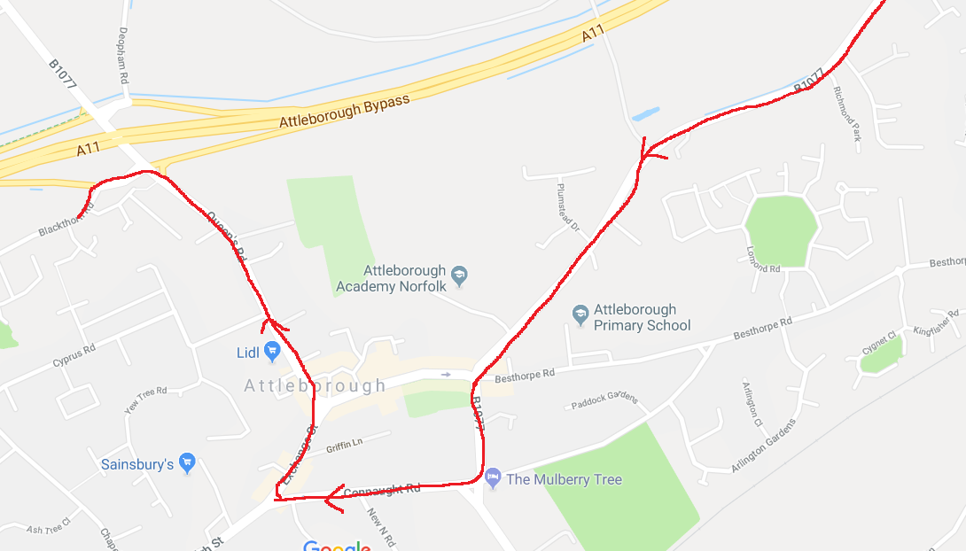
Snetterton Turn  Take slip road and proceed to rab.  Take 1st exit and proceed up incline to 2nd rab.  Take 1st exit and proceed (over bridge) to 3rd rab  Take 1st exit.  Proceed to 4th rab,  Take 2nd exit to join A11 east bound. | 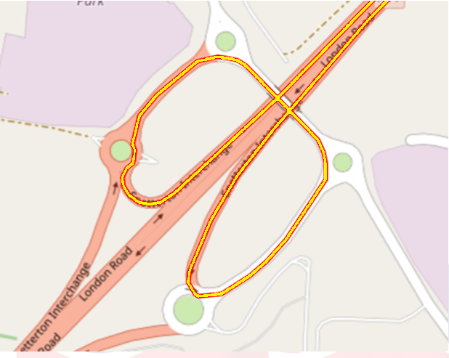

 | No. | Rider | Team | Start |  | No. | Rider | Team | Start
 | 1 | Martin Pyne | Anglia Velo | 16:01 |  | 41 | David Crisp | 3T-Racing | 16:41
 | 2 | Patrick Charlton | Wolsey | 16:02 |  | 42 | Jonny Hawes | GYCC | 16:42
 | 3 | Jonathan Lincoln | GYCC | 16:03 |  | 43 | David Yarham | Peterborough | 16:43
 | 4 | Doug Reilly | Godric | 16:04 |  | 44 | Colin Harris | CC Sudbury | 16:44
 | 5 | Chris Tye | Plomesgate | 16:05 |  | 45 | Terry Garlinge | Vision Racing | 16:45
 | 6 | Roger Sewell | Wisbech | 16:06 |  | 46 | Paul Dennington | VC Barrachi | 16:46
 | 7 | Toby Morrell | Tri Harder | 16:07 |  | 47 | Thomas Carroll | CCB | 16:47
 | 8 | Julian Claxton | GYCC | 16:08 |  | 48 | Paul White | Diss & District | 16:48
 | 9 | Greg Elliott | Harworth Dist | 16:09 |  | 49 | Hannah Randall | Stafford | 16:49
 | 10 | Jorge Viera | Pedal Revolution | 16:10 |  | 50 | Ryan Witchell | SalesEngine | 16:50
 | 11 | Iain Robertson | Tri Anglia | 16:11 |  | 51 | Anthony Stapleton | Chelmer | 16:51
 | 12 | Mark Farrow | Pedal Revolution | 16:12 |  | 52 | Chris Roberts | Pedal Revolution | 16:52
 | 13 | Michael Collings | Town & Country | 16:13 |  | 53 | Mark Fairhead | CCB | 16:53
 | 14 | Anouska Stott | Diss | 16:14 |  | 54 | Sarah Senderski | Bottrill Vanguard | 16:54
 | 15 | Andy Stuart | Velo St Raphael | 16:15 |  | 55 | Andrew Grant | Cambridge CC | 16:55
 | 16 | Paul Hayward | VC Barrachi | 16:16 |  | 56 | Julia Freeman | Easterly Road Club | 16:56
 | 17 | Denise Hurren | Sole Bay | 16:17 |  | 57 | Patrick Ellis | Diss | 16:57
 | 18 | Alan Hale | Pedal Revolution | 16:18 |  | 58 | Matthew Mitchell | Stratford | 16:58
 | 19 | Terry Law | CC Sudbury | 16:19 |  | 59 | Amanda Mallett | Plomesgate | 16:59
 | 20 | Matt O'Brien | Plomesgate | 16:20 |  | 60 | Ben Stancombe | Velo Velocity | 17:00
 | 21 | Steven Neill | KLCC | 16:21 |  | 61 | Sam Bradley | Alford Wheelers | 17:01
 | 22 | Adam Cross | CCB | 16:22 |  | 62 | Matt Ratcliffe | North Norfolk | 17:02
 | 23 | Malc Jacklin | Fenland Clarion | 16:23 |  | 63 | Carl Murley | Wisbech | 17:03
 | 24 | Ritchie Parkins | Diss | 16:24 |  | 64 | Brian Carr | GYCC | 17:04
 | 25 | Ken Platts | Cambridge CC | 16:25 |  | 65 | Murat Ozdenya | Team Vision | 17:05
 | 26 | Lee Thomas | Backstedt | 16:26 |  | 66 | Neil Empson | Anglia Velo | 17:06
 | 27 | Nigel Hodge | Tri Anglia | 16:27 |  | 67 | James Potter | Ipswich BC | 17:07
 | 28 | Trevor Figgitt | Plomesgate | 16:28 |  | 68 | Becky Schofield | Tri Anglia | 17:08
 | 29 | John Shellard | Pedal Revolution | 16:29 |  | 69 | Ron Back | West Suffolk | 17:09
 | 30 | Paul Jay | VeloVelocity | 16:30 |  | 70 | Jon Surtees | No Pinz | 17:10
 | 31 | Lee Garrod | Sole Bay | 16:31 |  | 71 | Damon Day | CC Sudbury | 17:11
 | 32 | Chris Womack | VC Baracchi | 16:32 |  | 72 | James Wylie | 3T-Racing | 17:12
 | 33 | Cindy Berry | Pedal Power | 16:33 |  | 73 | James Walgrove | Ride Harder | 17:13
 | 34 | Nick Parravani | CC Breckland | 16:34 |  | 74 | Jenny Anderson | GYCC | 17:14
 | 35 | Simon Scott | Anglia Velo | 16:35 |  | 75 | Darren Bennett | Ely | 17:15
 | 36 | Darren Davis | West Suffolk | 16:36 |  | 76 | Geoff Perry | Born to Bike | 17:16
 | 37 | Michael Wood | CCB | 16:37 |  | 77 | Anna Muir | Chelmer | 17:17
 | 38 | Graham Diiks | Norwich ABC | 16:38 |  | 78 | Andrew Skiggs | Tri-Anglia | 17:18
 | 39 | Paul Vergette | Godric | 16:39 |  | 79 | Denese Hallahan | Wisbech | 17:19
 | 40 | Stuart Fairweather | VeloVelocity | 16:40 |  | 80 | Matthew Senter | VeloVelocity | 17:20

Proceeds from the Event will be forwarded to the following Charities
 | 

