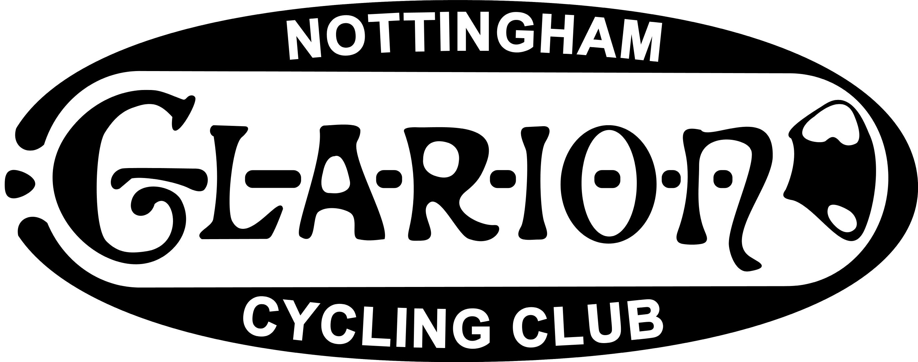

Nottingham Clarion Cycling Club
25 Miles 3up Team Time Trial

(Incorporating the National Clarion Team Time Trial Championship)

Promoted for and on behalf of Cycling Time Trials under their
Rules and Regulations.

Held on Sunday 8th July 2018 Course A25/3

Event secretary: Francis Grafton Timekeepers: Bill Stanley & Norman Portess
21 Vernon Avenue, (Melton Olympic C.C.)
Carlton,
NOTTINGHAM
NG4 3FX
Tel: 0115 9875784

Official Result

Fastest: Nottingham Clarion C.C.
Anthony Jackson, Michael Cooke & Stewart Bates 54-46 £75
2nd Fastest: Fenland Clarion C.C. “A”
Paul Lilley, Steve Kaye & Simon Pitchford 55-42 £60
3rd Fastest: Tuxford Clarion C.C. “A”
Jack Levick, Shawn Gough & Archie Hollingsworth 57-14 £51
Fastest all Veteran Team outside first 3 places: Lincoln Wheelers “A”
Richard Sheldrake, Andy Newham & Sean Hunt 57-41 £30

Fastest Composite Team: Tom Ward - Langdale Lightweights
Will Perrett - University of Derby 50-40 £45
Joe Perkins - University of Nottingham

National Clarion Champions: Nottingham Clarion C.C. The Tuxford Cup to be held for one year and a medal each to be presented at the 2019 Easter Meet.

The event secretary would like to congratulate the prizewinners and thank all the riders who supported the event.
Thanks also to the timekeepers and all the members of both Nottingham and Tuxford Clarion Sections who gave of their time to marshal or assist in whatever capacity on the day. Special thanks to the canteen staff and those who baked and donated cakes etc.
New events take time to establish themselves in the calendar and this was the first ever open event on this course. I hope we will run the event again next year, please encourage other riders to have a go and try something a little different.

