
Southborough & District Wheelers
www.southborough-wheelers.co.uk
25-mile Open Time Trial (G25/89) 10th June 2018

Promoted for and on behalf of Cycling Time Trials under their Rules & Regulations

Attn. all competitors
Please note that all competitors are now required personally to sign the signing out sheet when returning their number. Failure to do so will result in the competitor being recorded as DNF.﻿
Awards
Scratch: Men 1st £50 2nd £40 3rd £30
Scratch: Women 1st £50 2nd £40
Fastest Veteran OAS 1st £40 2nd £30 3rd £20
Fastest team 1st £25 x 3

The fastest rider on scratch will also receive the AJ Bathurst Trophy.

Timekeepers
Doug Finch (start) and David Watson (finish)

Event Secretary
Ian Turner, 6 Parkway, Tonbridge, Kent TN10 4RA
Tel: 01732358714 Mob: 07747136157 Email: ic.turner@btinternet.com

Course
G25/89 START on Maresfield by-pass 100 yards south of Lampool RBT at red arrow on curb 14 yards before LP12. Proceed to Batts Bridge RBT. Straight on to Black Down RBT. RIGHT and follow A22 via Copwood, Little Horsted, Golf Course and Halland RBT’s to The Shaw RBT. RIGHT and follow A22 via Whitesmith and Golden Cross to TURN at Boship RBT. Retrace on A22 via The Shaw, Halland, Golf Course, Little Horsted and Copwood RBT’s to Black Down RBT. LEFT to FINISH at red arrow on curb opposite drain in lay-by before Batts Bridge RBT.

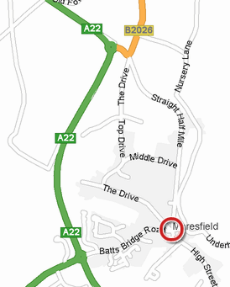
Headquarters
Maresfield Village Hall, Batts Bridge Rd, Maresfield TN22 2HJ. The HQ is approx 1 mile from the start. Numbers are available at the HQ. Competitors must sign on using the sheet provided at the number collection point in the HQ. No shoe plates in the hall please.

Please do not park too close to the traffic calming measures to the west of the hall; also use only one side of the road in which the hall is situated to avoid blocking through traffic. We have had complaints about this and risk losing the hall for future events. Additional parking: from hall proceed east, turn right at roundabout and right again to recreation ground.

Additional Information
- Riders must not warm up / turn in sight of the start finish areas and are requested not to warm up on the course after the first competitor has started
- No vehicles except those of the timekeepers and event officials shall be parked on the highway within sight of the starting or finishing points
- Riders must beware traffic from right on all roundabouts
- CTT regulations require the compulsory use of helmets for the under 18’s. In the interests of your own safety, Cycling Time Trials and the event promoters strongly advise all competitors to wear a hard/soft shell helmet that meets internationally accepted safety standards
- COMPETITORS MACHINES. It is recommended that a working rear light, either flashing or constant, is fitted to the machine in a position clearly visible to following road users and is active while the machine is in use
- Riders who currently use an inhaler for medical reasons must register this fact with British Cycling to satisfy UCI, CTT and BC Anti-Doping Regulations.
- It is an offence for a competitor in any event to use or to have administered to him any proscribed substance that might affect his competitive performance. A rider receiving medical treatment which could include a proscribed substance must not compete in time trials.
- Official observers will be stationed around the course.
- Riders' numbers should be centrally positioned below the waist so as to be clearly visible from the rear when in the normal riding position. No time may be recorded if a number is not correctly positioned:

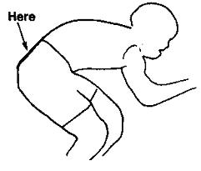

- HEAD-DOWN RIDING KILLS!

