

Bournemouth Arrow CC

Chris Braiden 10M Team Time Trial

Promoted for and on behalf of Cycling Time Trials under their Rules and Regulations


Supported by:

Bournemouth Arrow CC would like to thank David Lloyd Ringwood for their support in hosting this event.

Proceeds from the event will be donated to a Cancer Research UK.

Donations welcome please visit: http://donateinmemory.cancerresearchuk.org/0005470

Course: P311 Event Secretary: Peter Perrin
Date: Saturday 18th August 2018 34 Maundeville Road
First Rider: 3pm Christchurch Timekeepers: Dorset
Start Mr George Bolton BH23 2EN
Finish Mr Julian James
Mobile: 07704 873326
peter@perrinheating.com

Event Headquarters: David Lloyd Club 242 Christchurch Road Ringwood Hampshire BH24 3AS.
The HQ is approx 500metres from the start and finish. Refreshments, food and a bar are available. In addition, Changing rooms and showers are provided.

NUMBERS & SIGNING ON WILL BE IN THE RESTAURANT AT THE EVENT HEADQUARTERS, NOT AT THE START

Parking is available at the David Lloyd club, but you must use the left hand side of the facility.
There is no parking space at the finish.

Do not forget to sign out.
Have a great ride , heads up, and good luck.
P311 Course Description:
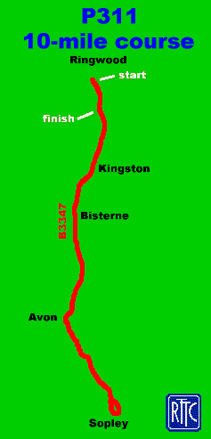
START at first lamp post in Wellworthy Road, proceed west for 30m to new roundabout at Ringwood on B3347.(SU153044)
Turn left onto Christchurch Road, proceed south via Bisterne and Avon to Sopley one-way system. (5.2m)
Turn right over bridge at the Woolpack and retrace to Ringwood via Avon and Bisterne to
FINISH at drain 10 yds south of junction with Hampshire Hatches Lane at Moortown Green. (SU153038)

Safe Route from HQ to the Start:
Left out of HQ along Christchurch Road, turn right at the new roundabout approx. 500m to the north.
Safe Route from Finish to HQ:
Continue north along Christchurch Road, David Lloyd club is approx. 500m to the north.

SAFETY INSTRUCTIONS
Riders must:
- Not make U turns in the vicinity of the Start or Finish
- Must not warm up on the Course.
- Riders can only use the road north of the start to warm up, That is from the HQ over the start roundabout and towards Ringwood.
- Not stop at the Finish but continue to the event Headquarters.
- Not cut corner at Sopley one-way system on 1st right turn as the road is two-way at this point
- Take Extra Care:-
    - From start to Moortown Lane – busy with houses and side roads, busy garage on Left, finish on Right.
    - Avon Tyrrell Farm - sharp bend with possible gravel.
    - Avon Causeway - beware of traffic stopping to turn right or emerging onto course.

Any rider observed riding in a manner which may jeopardise his or her own safety, the safety of others and the future of the Sport will be disqualified and reported to the South District Council of Cycling Time Trials.

PRIZES .Only one cash prize per rider
Team time trial
First £50.00
Second £40.00
Third £30.00
Prizes to be shared between both riders.

Solo First £30.00
Second £25.00
Third £20.00
Fourth £15.00

Ladies First £20.00

