Promoted for and on behalf of Cycling Time Trials under their Rules and Regulations

Birdwell Wheelers

Founded 1949

Green Moor Hill Climb

Sunday 26th Aug 2018
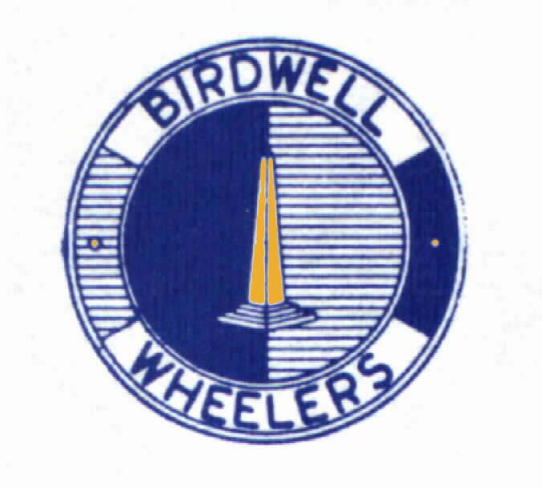
Event Secretary – Paul Heggie 22 Pollitt Street S75 1DJ
Mobile on day of event: 07960 704822
Timekeepers/Clerk: Philip Minto , Jan Wilson, Carol Booth
Holder up: Steve Myatt
Results board: Paul Heggie
Refreshments:Christine Minto, Angela Cancellara

Course – OHC17

Course description:
Start on the unclassified road Well Hill at lamp
post 11. Go up onto Green Moor Road to Green
Moor village to finish at LP 7 opposite small
playground 1100 yards

Headquarters: The headquarters is Hill Top Farm post code S35 7DX. Thanks to club member Greg Godley.

Directions can be found here
https://tinyurl.com/y7es4dzn

Parking is available on the grass verges as you leave the village.Please park considerately.
Numbers and signing on at the HQ

YOU MUST SIGN OFF AFTER THE EVENT OR YOU WILL RECORD A DNF

Awards Fastest overall £25 2nd £20 3rd £15
Fastest woman £25 2nd £20 3rd £15

The fastest overall to hold the Upperthorpe Rose Bowl for one year.

Local Regulations
No Warming up on the course once the event has started

In the interest of your own safety, the CTT and the event promoters strongly advise you to wear a hard shell Helmet that meets an internationally accepted safety Standard.
Regulation 15 requires all riders of 18 years and under to wear a suitable Helmet.
All riders under 18 must submit a signed parental consent form

Do not approach finish timekeeper for your time. Times will be displayed at HQ

Presentation of prizes will be at the HQ after the Climbs have finished.
This event is one of the qualifying rounds of the JE James Hill Climb series for North Midlands District clubs’ riders

The link gives details of the Hill Climb Series. http://northmidlandstimetrialseries.org/HillClimbs.html

No | Name | Club | start_time
1 | Marc Peasegood | Birdwell Wheelers | 18:01
2 | Robert Saxby | Sheffrec CC | 18:02
3 | John Woodhouse | Birdwell Wheelers | 18:03
4 | Paul Hutchin | Worrall Wheelers | 18:04
5 | Richard Edwards | Sheffrec CC | 18:05
6 | Trevor Mayne | Birdwell Wheelers | 18:06
7 | Tim Rutter | Norton Wheelers | 18:07
8 | David Martin | Holmfirth C C | 18:08
9 | Tim Birtwhistle | 7 Hills Cycling Club | 18:09
10 | Matthew Chappell | Worrall Wheelers | 18:10
11 | Adam Machan | Sheffrec CC | 18:11
12 | Rapid Rich Stoodley | 3 RT | 18:12
13 | Jake Harrison | Rutland Cycling Club | 18:13
14 | Sandra Mackay W | Velo Schils Interbike RT | 18:14
15 | Emilie Verroken W | Maxx R. T. | 18:15
16 | Claire Swoboda W | Velo Club St Raphael | 18:16
17 | Nicola Soden W | Velo Schils Interbike RT | 18:17
18 | Paul Whittaker | Rutland Cycling Club | 18:18
19 | Mark Shepherd | Hinckley Cycle RC | 18:19
20 | Chris Myhill | Peak Road Club | 18:20
21 | Hamish Mcdougall | Leicester Forest CC | 18:21
22 | Paul Armstrong | Sheffrec CC | 18:22
23 | Richard Marsden | Manchester Wheelers | 18:23
24 | Rick Bailey | Team B38/Underpin Racing | 18:24
25 | Calum Brown | Sheffrec CC | 18:25
26 | Paul Smith | Huddersfield Star Whs | 18:26
27 | Kieran Smith | Bolsover and District CC | 18:27
28 | Andy Nichols | Team B38/Underpin Racing | 18:28

Birdwell Whs website: http://www.birdwellwheelerscyclingclub.co.uk/

