
Bath Cycling Club Established 1880

Presents the

“Tony Mitchell 25 mile Time Trial”

Including the VTTA West Group 25 mile championship for the Jack Gray Memorial Trophy and scoring event for the WTTA Hardrider series.

Event date: 16th September 2018

(Promoted for and on behalf of Cycling Time Trials under their rules and regulations)

Event secretary: Nigel Vuagniaux Tel. 01225 482363
3 Michaels Mead, Emergency phone on day: 07841 437860
Bath
BA1 4JD Email: nvuagniaux@btinternet.com Note this email will not be available on the day.

Timekeepers: Paul Arayan (Bath CC) & Dennis Davis (Bath CC)

Headquarters: Maiden Bradley Village Hall (BA12 7JG) - open from 07:30m. Numbers at HQ

Course U370 details
Start on the B3092 at entrance to the Frome Showground; proceed to the Blatchbridge roundabout (Rbt) on A361; take 3rd exit on the A361 to Pylon Rbt and take 1st exit (left turn); take 2nd exit at Commerce Park Rbt (straight over); take 3rd exit to turn at the Oldford Rbt (CARE ENTERING RBT - traffic from the right has priority) and retrace to Blatchbridge Rbt. Complete Blatchbridge-Oldford-Blatchbridge circuit TWICE more. After completing the THIRD circuit take 1st exit at Blatchbridge Rbt towards Maiden Bradley to finish opposite start.

Important notes
No warming up on the course after 1st rider has started at 9.03am.
Please sign the official start sheet at the HQ at least 30 minutes before your start. Please do not forget to sign out after your race or you will be registered as a DNF. Please allow 15 minutes to get from the HQ to the start. Leaving the HQ turn right on B3029 and follow for approx. 2 miles to start in the entrance to the Frome Showground. Race numbers are available at HQ and can be exchanged for a drink after your ride, we are accepting contributions for cakes.
No U-turns are permitted near the start/finish area.

It is the rider’s responsibility to keep track of number of Blatchbridge-Oldford-Blatchbridge circuits done.
Please shout out your number at the finish and continue directly to the race HQ at Maiden Bradley.
PLEASE RESPECT THE OWNERS REQUEST FOR NO CYCLING SHOES IN HALL!!
All competitors should use the village hall car park. Additional parking is available on the other side of the B3029. Please show consideration to local residents, and do not block and entrances to driveways etc. Toilets at HQ will be open from 07:30am.

All riders are asked to comply with the following requests.
Please secure your number carefully in a central position below your waist (Reg. 16) in order that the Timekeeper can see it!
Do not leave your number flapping – four pins are supplied for each. Please check that your number is still visible if you use a Nopinz type pocket on a skinsuit.
No warming up on the course once the event has started
No turbo training within 100 m of dwellings.

Do call your number to the finishing timekeeper or you may be missed!.
Do keep your head up; be aware of your surroundings and HAVE A SAFE RIDE.
IN THE INTERESTS OF YOUR OWN SAFETY Cycling Time Trials and the Event Promoters strongly advise you to use a flashing red rear light and wear a HARD SHELL HELMET. In accordance with Regulation 15 ALL JUNIOR competitors must wear protective helmets.
It is further recommended that a working rear light either flashing or constant is fitted to your machine in a position visible to following road users and is active while the machine is in use

Course records:

Men : Matt Burden Severn RC 52:55 2015

Women : Claire Kitching Newbury RC 1:05:01 2014

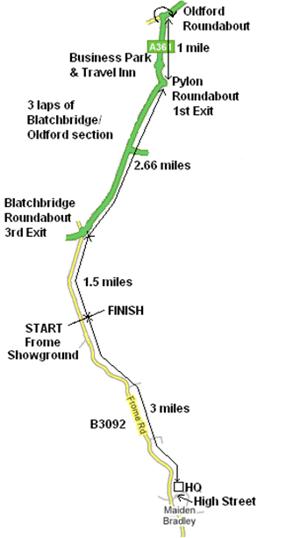
Prizes

Please note – One prize per rider except team prize and course record.

1st Male £20:00 1st Female £20:00 1st Vet £20:00

2nd Male £15:00 2nd Female £15:00 2nd Vet £15:00

3rd Male £10:00 3rd Female £10:00 3rd Vet £10:00

1st Male Team (3 to score) £10:00 each

1st Female Team (3 to score) £10:00 each

Course Record Male £25:00

Course Record Female £25:00

Trophys:

“Tony Mitchell” shield for the fastest Bath CC Vet’ on standard

“Jack Grey” Memorial Trophy for the fastest West Vet’ on actual time

“George Carter” cup for the fastest Bath CC rider

RIDER’S ATTENTION IS DRAWN TO C.T.T. REGULATIONS IN PARTICULAR:

No. 19 – Observance of the law
No. 20 – Paced riding and company riding
No.21 – Use of motor vehicles

Riders must shout out their number when passing the finish line

Please remember to keep your heads UP – watch out for tractors!!

IN THE INTERESTS OF YOUR OWN SAFETY the promoters strongly advise you to wear a HARD SHELL HELMET that meets an internationally accepted standard

Many thanks to all competitors for taking part and keeping this event alive: have a great ride.

Nigel

