Promoted for and on behalf of Cycling Time Trails under their rules and regulations
Beacon Wheelers Cycling Club
Great Dunn Fell Hill Climb – L826
Saturday 24th September 2016
START SHEET

Organiser: Time Keepers
Shona McLean Richard Abrham – Border City Wheelers
Home: 01228 532316 John Holliday - Border City Wheelers
Mobile: 07908991225
Email: Shomc1@aol.com Marshalls – Gary Rutland, Colin James &
Address: 29 Harraby Green Road, Bob Mclean
Carlisle, Cumbria CA1 2QA

Headquarters
Event HQ and parking is at right hand at the start of the Great Dunn Fell Radar station access road in council layby
Race numbers and signing on. Refreshments available here after the event.
Course L826
START 10m north East of telegraph pole on the Great Dunn Fell radar station access road, and at the north side of the entrance to the Christian Centre. Proceed north easterly direction climbing to FINISH adjacent to the last snow pole 5m below the cattle grid and entrance to the NATS radar station.

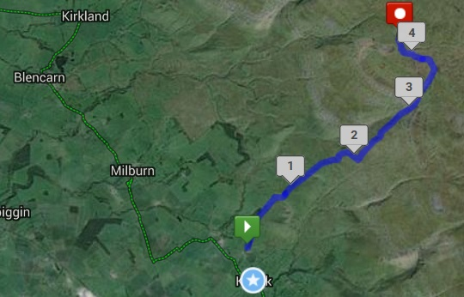

Safety Instructions
Local Reg No 5 – In ALL events, competitors prior to starting are not permitted to ride past the finish timekeeper during the duration of the event.

Local Reg No 6 – any competitor making a ‘U’ turn in the vicinity of the start finish will disqualified from the event.
Riders are not allowed to warm up on the course, ahead of the commencement of the event.
Riders must give their numbers at the finish and elsewhere on the course if requested.
Riders must NOT STAND in the road at the start or finish. (This constitutes obstruction and is a breach of regulations).
Riders must NOT ride with their heads down.
IN THE INTEREST OF YOUR OWN SAFETY
Cycling Time Trails and the event promoters strongly advise you to wear a HARD SHELL HELMET that meets an internationally accepted safety standard.
In accordance with Regulation 15 ALL JUNIOR competitors must wear Protective Hard Shell Helmets.
It is recommended that a WORKING REAR LIGHT, either flashing or constant, is fitted to the machine in the position visible to following road users and is active whilst the machine is in use.

Course Safety
The course is a single track road with passing places which is open to traffic at all times.
Sheep may be present on the course.

Rider are encouraged to hand in clothing to be taken to the finish area (at 2,720 feet).

Riders are to extreme care on the decent along the course whilst the race is in progress, the decent must at a slow speed respecting ascending riders.

The course beyond the barrier (Approx 3.5m) is a bridleway and not open to motor vehicles apart from the officials timing the event.

No Motor vehicles to be used on the course other than those associated with the organisation of the event.

Please respect the local residents and access.

Signing on Sheet & Race Numbers
Riders must sign the Official Signing on Sheet at the Event HQ to obtain their Race Number
Prize List – One rider one prize.

Fastest ride of the day – £25

Men - 1st £20, 2nd £15, 3rd £10

Veteran – 1st £20, 2nd £15, 3rd £10

Junior – 1st £15

Juvenile – 1st £15

Riders are encouraged to stay for refreshments and the Prize Giving at HQ shortly after the race.
Number | Start Time | First Name | Surname | Club | Gender | Category
1 | 11:01 | Archie | Irving | Beacon Wheelers CC | Male | Juvenile
2 | 11:02 | Tim | Nichol | Derwentside CC | Male | Senior
3 | 11:03 | Clive | Upton | Hambleton RC | Male | Senior
4 | 11:04 | David | Rydings | Liverpool Century RC | Male | Senior
5 | 11:05 | Niall | Paterson | Velo Club Cumbria | Male | Veteran
6 | 11:06 | Laurie | Lambeth | Beacon Wheelers CC | Male | Senior
7 | 11:07 | Samuel | Cooper | Beacon Wheelers CC | Male | Juvenile
8 | 11:08 | Lewis | McEvoy | Sunderland Clarion | Male | Senior
9 | 11:09 | Keith | Bickley | Border City Wheelers | Male | Veteran
10 | 11:10 | Courtney | Blockley-Campton | Lutterworth Cycle Centre Racing Team | Male | Senior
11 | 11:11 | Oliver | Hayward | University of Birmingham CC | Male | Espoir
12 | 11:12 | Tom | Roper | Beacon Wheelers CC | Male | Junior
13 | 11:13 | Callum | Dixon | NFTO Race Club | Male | Senior
14 | 11:14 | Mike | Morris | NFTO Race Club | Male | Senior
15 | 11:15 | Mark | Donovan | Beacon Wheelers CC | Male | Junior
16 | 11:16 | Eoin | Gormley | Blaydon CC | Male | Senior
17 | 11:17 | Nick | Badcock | Allen Valley Velo | Male | Senior
18 | 11:18 | David | Cookson | Preston CC | Male | Senior
19 | 11:19 | Matthew | Cooper | Rock to Roll CC | Male | Veteran
20 | 11:20 | Matthew | Smith | Muckle Cycle Club | Male | Senior
21 | 11:21 | Ayrton | Pope | Paceline RT | Male | Espoir
22 | 11:22 | Jake | Cowen | The Nab Racing | Male | Espoir
23 | 11:23 | Matt | Moorhouse | Preston CC | Male | Veteran
24 | 11:24 | Calum | Campbell | VTTA North Lancs and Lakes Group | Male | Veteran
25 | 11:25 | Alex | Foster | Rock to Roll CC | Male | Espoir
26 | 11:26 | Martin | Mikkelsen-Barron | Velo Club Cumbria | Male | Senior
27 | 11:27 | Jack | Rutland | Beacon Wheelers CC | Male | Juvenile

