
SEVERN ROAD CLUB
Hinton Hill Climb - Course UH90
Saturday 6th Oct 2018 - Start time 4:00pm
Promoted for and on behalf of Cycling Time Trials under their Rules and Regulations

www.severnroadclub.co.uk
Event Secretary:  Tom Bertenshaw  30 Bellotts Road  Bath  BA2 3RT | Timekeepers  Chris Broad-Drake  Rob Hutchinson

Please note that the start sheet is found on the “start sheet” tab on the CTT website.

Headquarters, Start area and Parking

The HQ for this event will be located at the “triangle” in Hinton. Parking will be in a field, through a gate on the right located next to the triangle. The field will be signposted with arrows. There will be toilet facilities at Dyrham village hall, but the key for the building will be kept at the HQ. Please see the HQ if you need the facilities. To reach the HQ, use postcode for “the bull” pub (post code: SN14 8HG) and drive further down the hill until you reach the triangle. See map below.

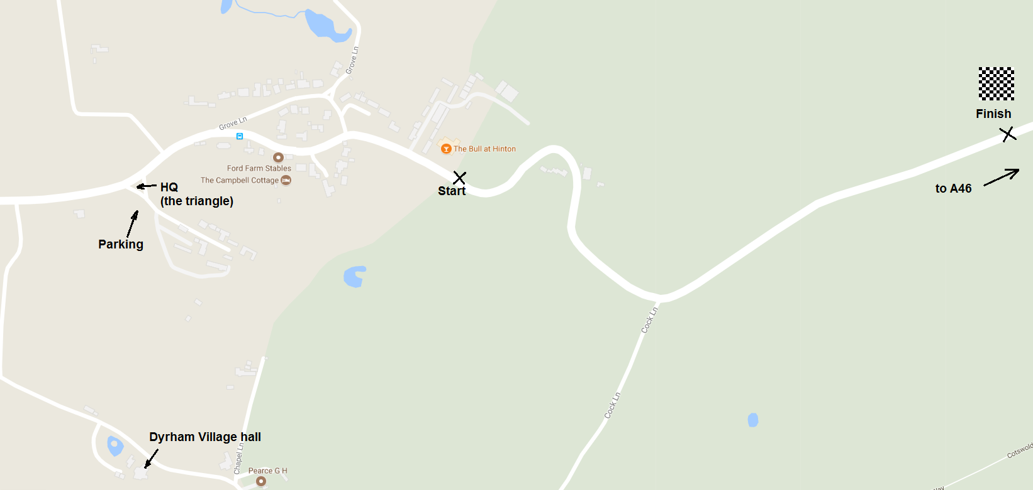

It will not be possible to park at the start area as the landlord is hiring out the entire pub for a private event; the car park is not available to competitors under any circumstances.

Please do not litter the HQ area or the car park (this includes banana skins!) Waste bins will be available at the HQ.

Numbers.
Riders must sign the signing on sheet at the HQ to obtain their race number and check for any last minute information. Please return your number and ensure that you sign out on the start sheet. If you do not sign out you may be disqualified.

Course details
START: At the base of Hinton Hill next to "the bull" Pub. Finish is at the crest of the hill just outside of the trees (approx ½ mile). See picture above.

Safety
Riders are asked to take great care and, in particular note the following points:
- Take care when descending the hill after the finish. There are a number of sharp blind bends, so please ensure that you don’t cut these corners whilst descending.
- Refrain from turning around on the race course
- CTT recommends that competitors wear a hard shell helmet that meets an internationally accepted safety standard.
- All juniors/juvenile riders MUST wear protective hard shell helmets.

Prizes

Prizes are as follows:

1st Junior - £20
2nd Junior - £10

1st Place - £40
2nd Place - £30
3rd Place - £20
4th Place - £10

1st Lady - £20
2nd Lady - £15
3rd Lady - £10

1st V40 - £20
2nd V40 - £10
1st V50 - £10

There is a trophy awarded to the fastest Severn RC rider, which will be awarded for the first time this year. There is no team prize – just the glory!!!!

