
SEVERN ROAD CLUB
Hinton Hill Climb - Course UH90
Saturday 8th Oct 2016 - Start time 2:30pm
Promoted for and on behalf of Cycling Time Trials under their Rules and Regulations

www.severnroadclub.co.uk
Event Secretary:  Tom Bertenshaw  16a Berenda Drive  Longwell Green  Bristol  BS30 9YX. | Timekeepers  Bridget Boon  Ian Boon

Please note that the start sheet is found on the “start sheet” tab on the CTT website.

Headquarters, Start area and Parking

The HQ for this event will be located in the garden of “The Bull” pub. The start is in the car park of “The Bull” pub. If arriving by car, the parking is located further down the road. To get there, drive down the road as far as “the triangle” shown on the map below, turn left, and take a right and the far end of the triangle. Parking will be in a field, through a gate on the right. The field will be signposted with arrows. Under no circumstances shall competitors park at The Bull pub – the landlord as kindly granted use of his facilities provided that his parking is for customers only. As suggested, the toilet facilities in the pub can be used.

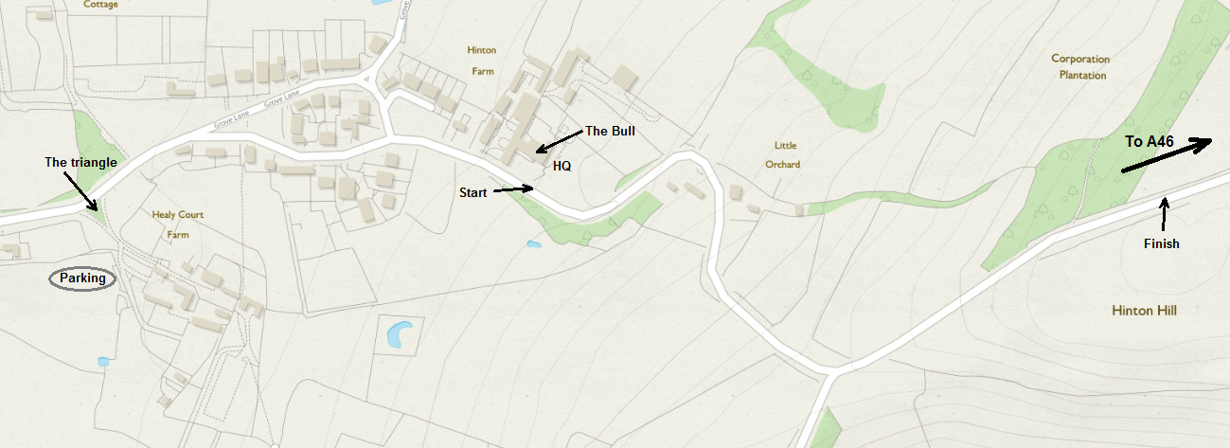

Address for “The Bull”: Hinton, Chippenham, SN14 8HG.

Numbers.
Riders must sign the signing on sheet at the HQ to obtain their race number and check for any last minute information. Please return your number for a free drink.

Course details
START: At the base of Hinton Hill next to "the bull" Pub. Finish is at the crest of the hill just outside of the trees (approx ½ mile). See picture above.

Safety
Riders are asked to take great care and, in particular note the following points:
- Take care when descending the hill after the finish. There are a number of sharp blind bends, so please ensure that you don’t cut these corners whilst descending.
- Refrain from turning around on the race course
- CTT recommends that competitors wear a hard shell helmet that meets an internationally accepted safety standard.
- All juniors/juvenile riders MUST wear protective hard shell helmets.

Prizes

1st Place - £20
2nd Place - £15
3rd Place - £10
4th Place - £5

1st Lady - £10
2nd Lady - £5

1st V40 - £10
1st V50 - £5

Juv/Jun - £5

