Northover's VT
Sponsored by Rudy Project

Present their

Easter 10 Mile Time Trials
Event Sponsored by:
Yellow Ltd
Rudy Project

Monday 22nd April 2019

Please Note That as a result of the current issues regarding the V718 SW DC have reviewed the start times and as a result we have to be clear of the road by 09:30hence change in start time.

Course S26R/10

(Promoted for and on behalf of Cycling Time Trials under
their rules and Regulations)

IN THE INTEREST OF YOUR OWN SAFETY, Cycling Time Trials and the event Promoters strongly advise you to wear a HARD SHELL HELMET that meets an internationally accepted safety standard.

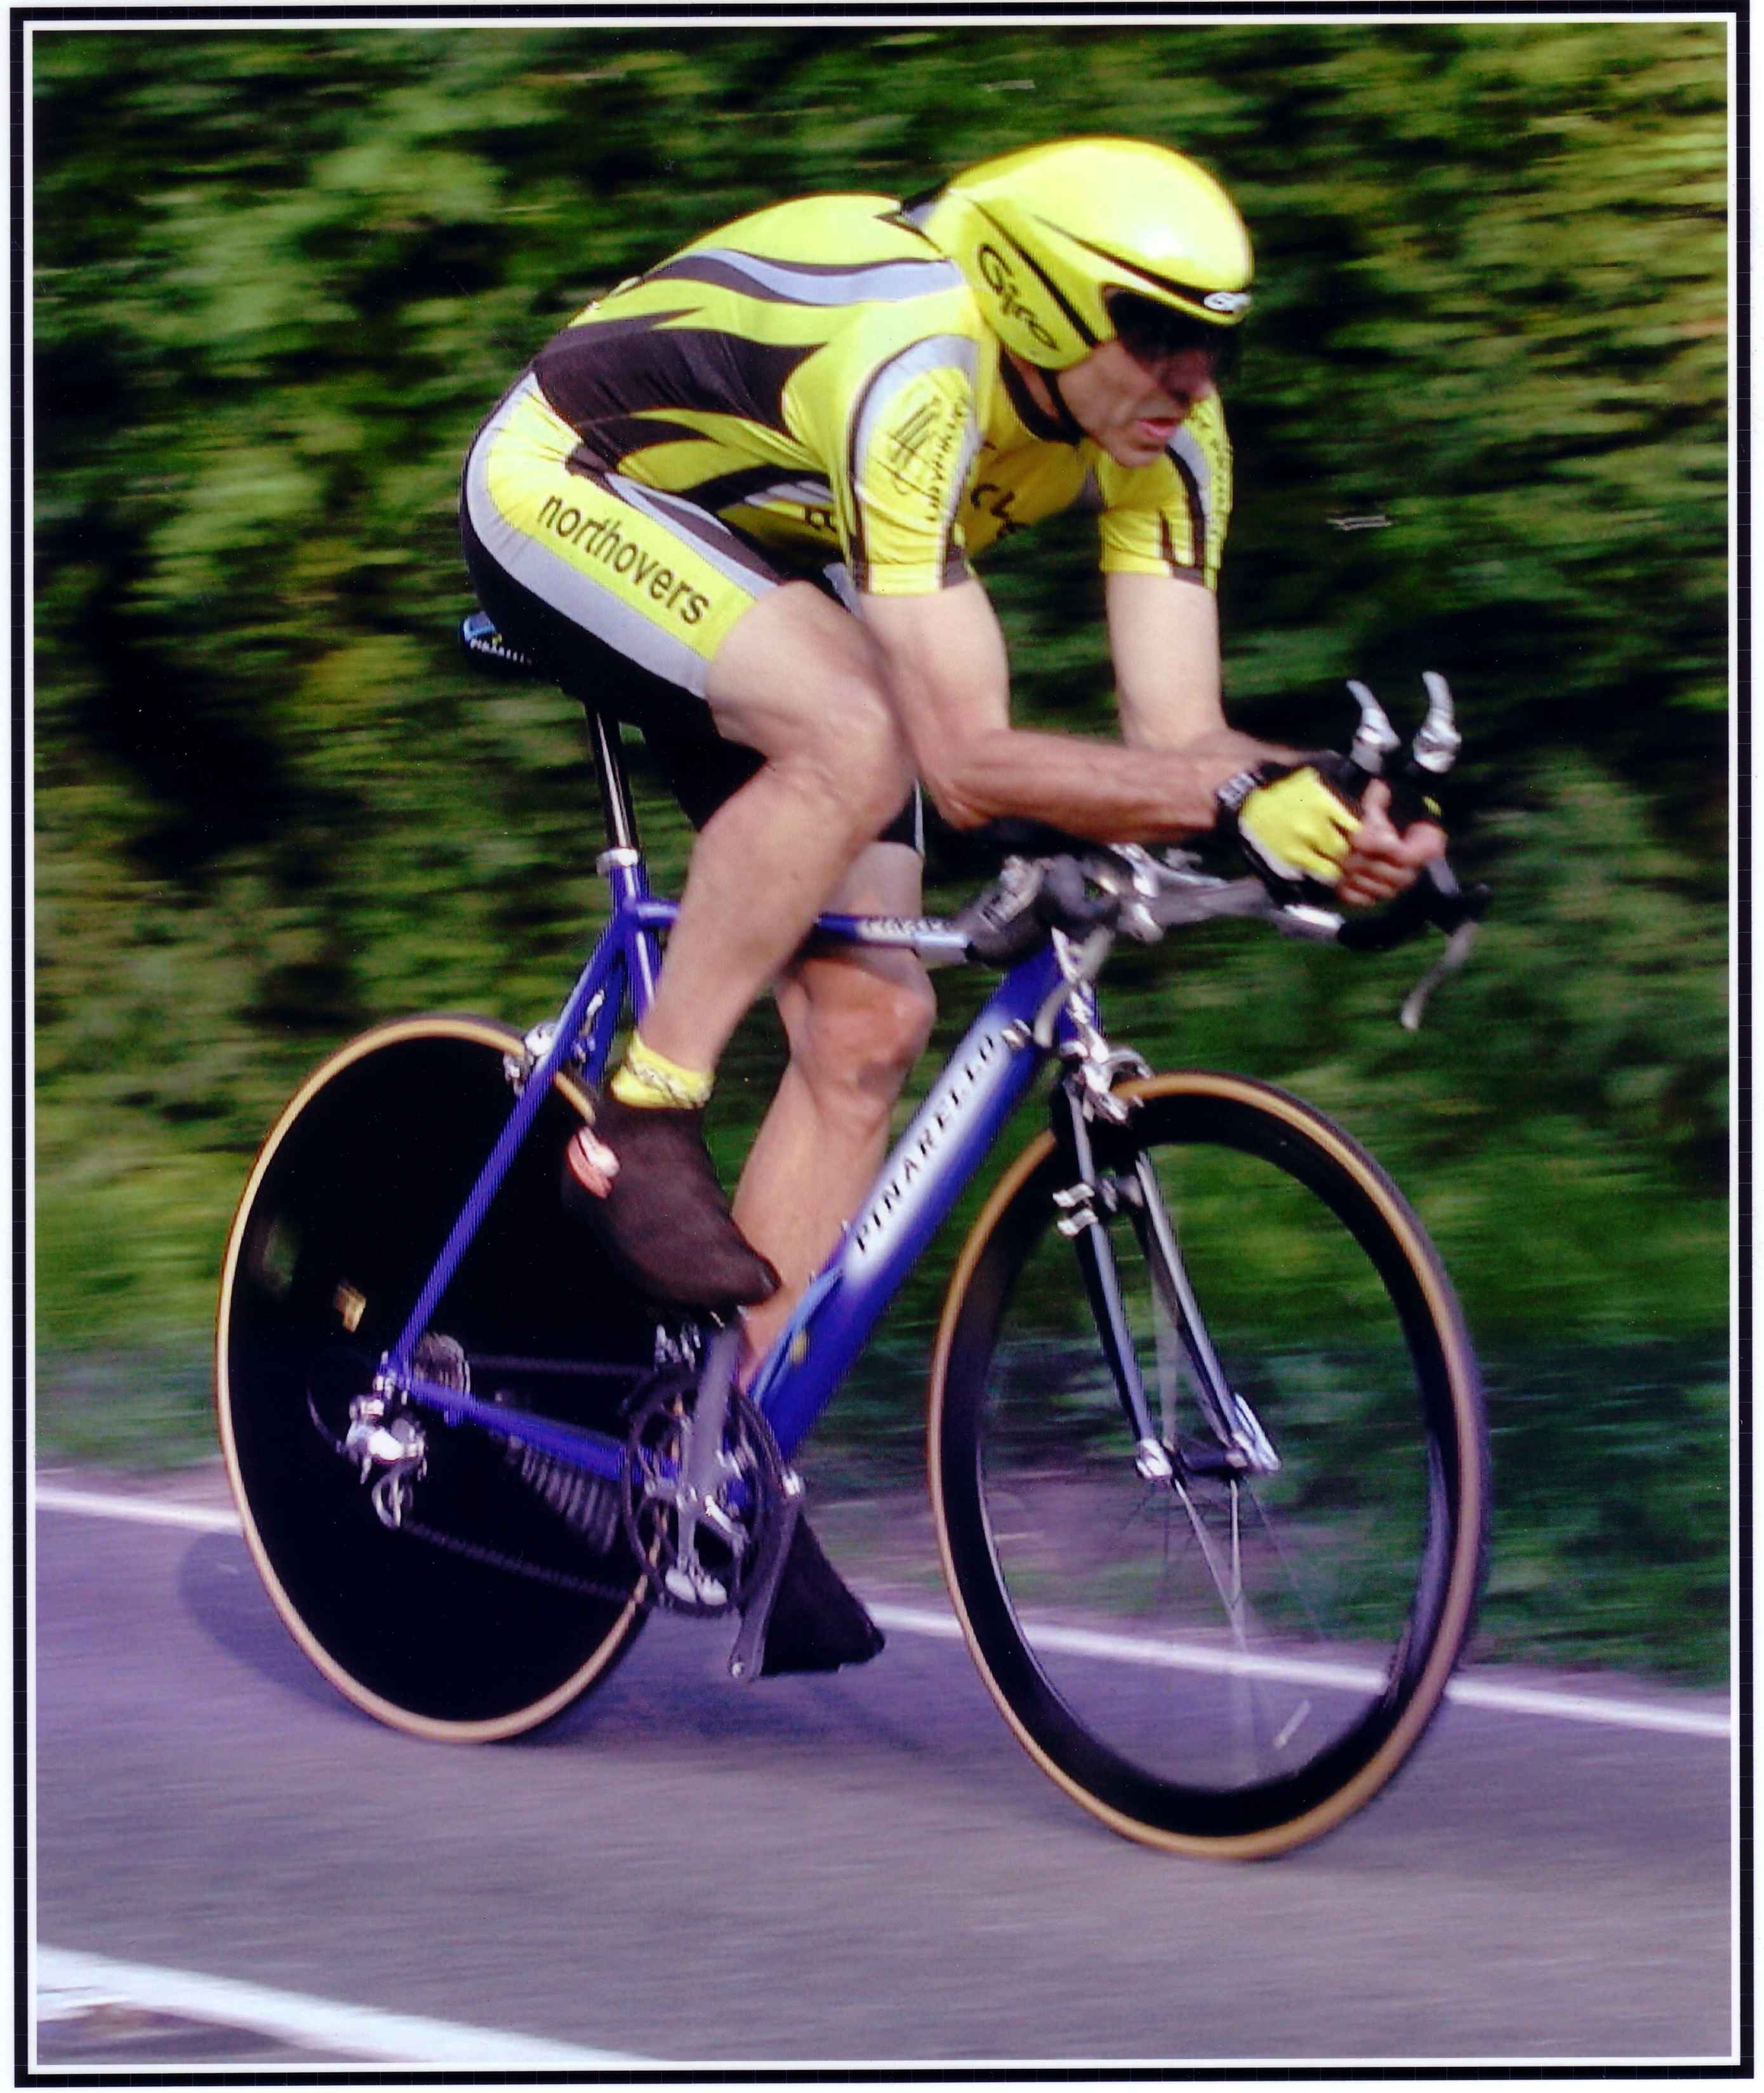

This Northover’s VT 10 Mile Solo & 2up TT is organised in memory of
our team-mate and good friend Bob Redrup.
who passed away unexpectedly on 26 September 2003 whilst on a training ride with the team prior to the Duo Normandy in Marigny, France.

Easter Solo & 2Up 10 Mile Time Trial

Course Details: S26R/10

Start on old A30 at the lay-by approximately 200 yds East of Pattersons Cross, Feniton at a point 127 yds prior to the splay end of the lay-by. Proceed eastwards to go under the railway bridge and join the new A30 (care). Continue on the A30 to pass Honiton and at SECOND SLIP ROAD filter left (M) into slip road signed Dorchester. Crossover A30 and turn right (M) to rejoin the A30 westbound. Pass Honiton and at slip road signed Otter Nurseries filter left to leave the A30, Give Way at base of the slip road and turn left onto the old A30 (M). Finish at a point 101 Yds prior to the old railway bridge and some 200 yds short of the start point.

Please Call Number Loud and Clear When Finishing

Event HQ Organiser Timekeepers

Feniton Village Hall Tom Cox Paul Arayan
Feniton, Nr Honiton 54 Graham Way Andy Greatwood
Devon Cotford St Luke
Somerset TA4 1JG

If the car park is full in the village and ride down to the changing rooms – try to leave the church clear, it would be nice if there is space near the church for the elderly residents to park – thank you

Directions to Start
Turn left out of the HQ, take left fork up hill, over bridge and take left at the tee junction. After approx. ½ mile pass under the A30 dual carriageway to Pattersons Cross and turn left. The start will be in approx. 400yds on the left.

At completion of the event continue past the finish to Pattersons Cross and turn right under the dual carriageway and follow the reverse of the route back to the HQ.

Prize List - Solo
1st £25
2nd £20
3rd £15
1st Vet 40+ £10
1st Vet 50+ £10
1st Vet 60+ £10
1st Junior £10
1st lady £25

Prize List – 2up
1st Club Team or Composite £25
2nd Club Team or Composite £20
NB: One Rider on Prize

Important Notes for Riders and Officials:-

- In the interests of your own safety Cycling Time Trail and the event promotors strongly advise riders wear a Hard Shell Helmet that meets approved international safety standards.

- Numbers will be at the start and can be exchanged for a drink at the end

- Riders are to ensure that they read the course risk assessment prior to starting the event which will be next to the numbers at the HQ

- No U-Turns within sight of the Start and Finish Timekeepers

- Riders waiting to start must do so 20yds before the Timekeeper and stand well to the left and in single file

- It is recommended that a working rear light, either flashing or constant, is fitted to the machine clearly visible to following road users and is active whilst the machine is in use.

- 2 up teams to have clothing of similar design & colour’s for reference please refer to CTT handbook rules & regulations.

- The course used for this event is on a High-Speed road and filtering off to the left – be aware of this possibility every time you cross any exit road.

- Please ensure that when signing on you make sure you have looked at and read the on the day risk assessment and ensure that there are no additional hazards to be aware of prior to starting.

- Please note if parking underneath the New A30 which is approx. 400yds from the start there is a private road opposite, this road is a private entrance to the farm and no parking is allowed on this road. This is a request from the farmer as he needs access to and from the farm. If you are seen parking here you will be asked to move even if you are due to start in the next couple of minutes YOU HAVE BEEN WARNED. Thank you for you cooperation in advance.

