Northover's VT
Sponsored by Rudy Project

Present their

Easter 2Up 10 Mile Time Trials
Event Sponsored by:
Yellow Ltd
Rudy Project

Monday April 22nd 2019

Course S26R/10

HQ Feniton Village Hall
Feniton, Nr Honiton

(Promoted for and on behalf of Cycling Time Trials under
their rules and Regulations)

IN THE INTEREST OF YOUR OWN SAFETY, Cycling Time Trials and the event Promoters strongly advise you to wear a HARD SHELL HELMET that meets an internationally accepted safety standard.

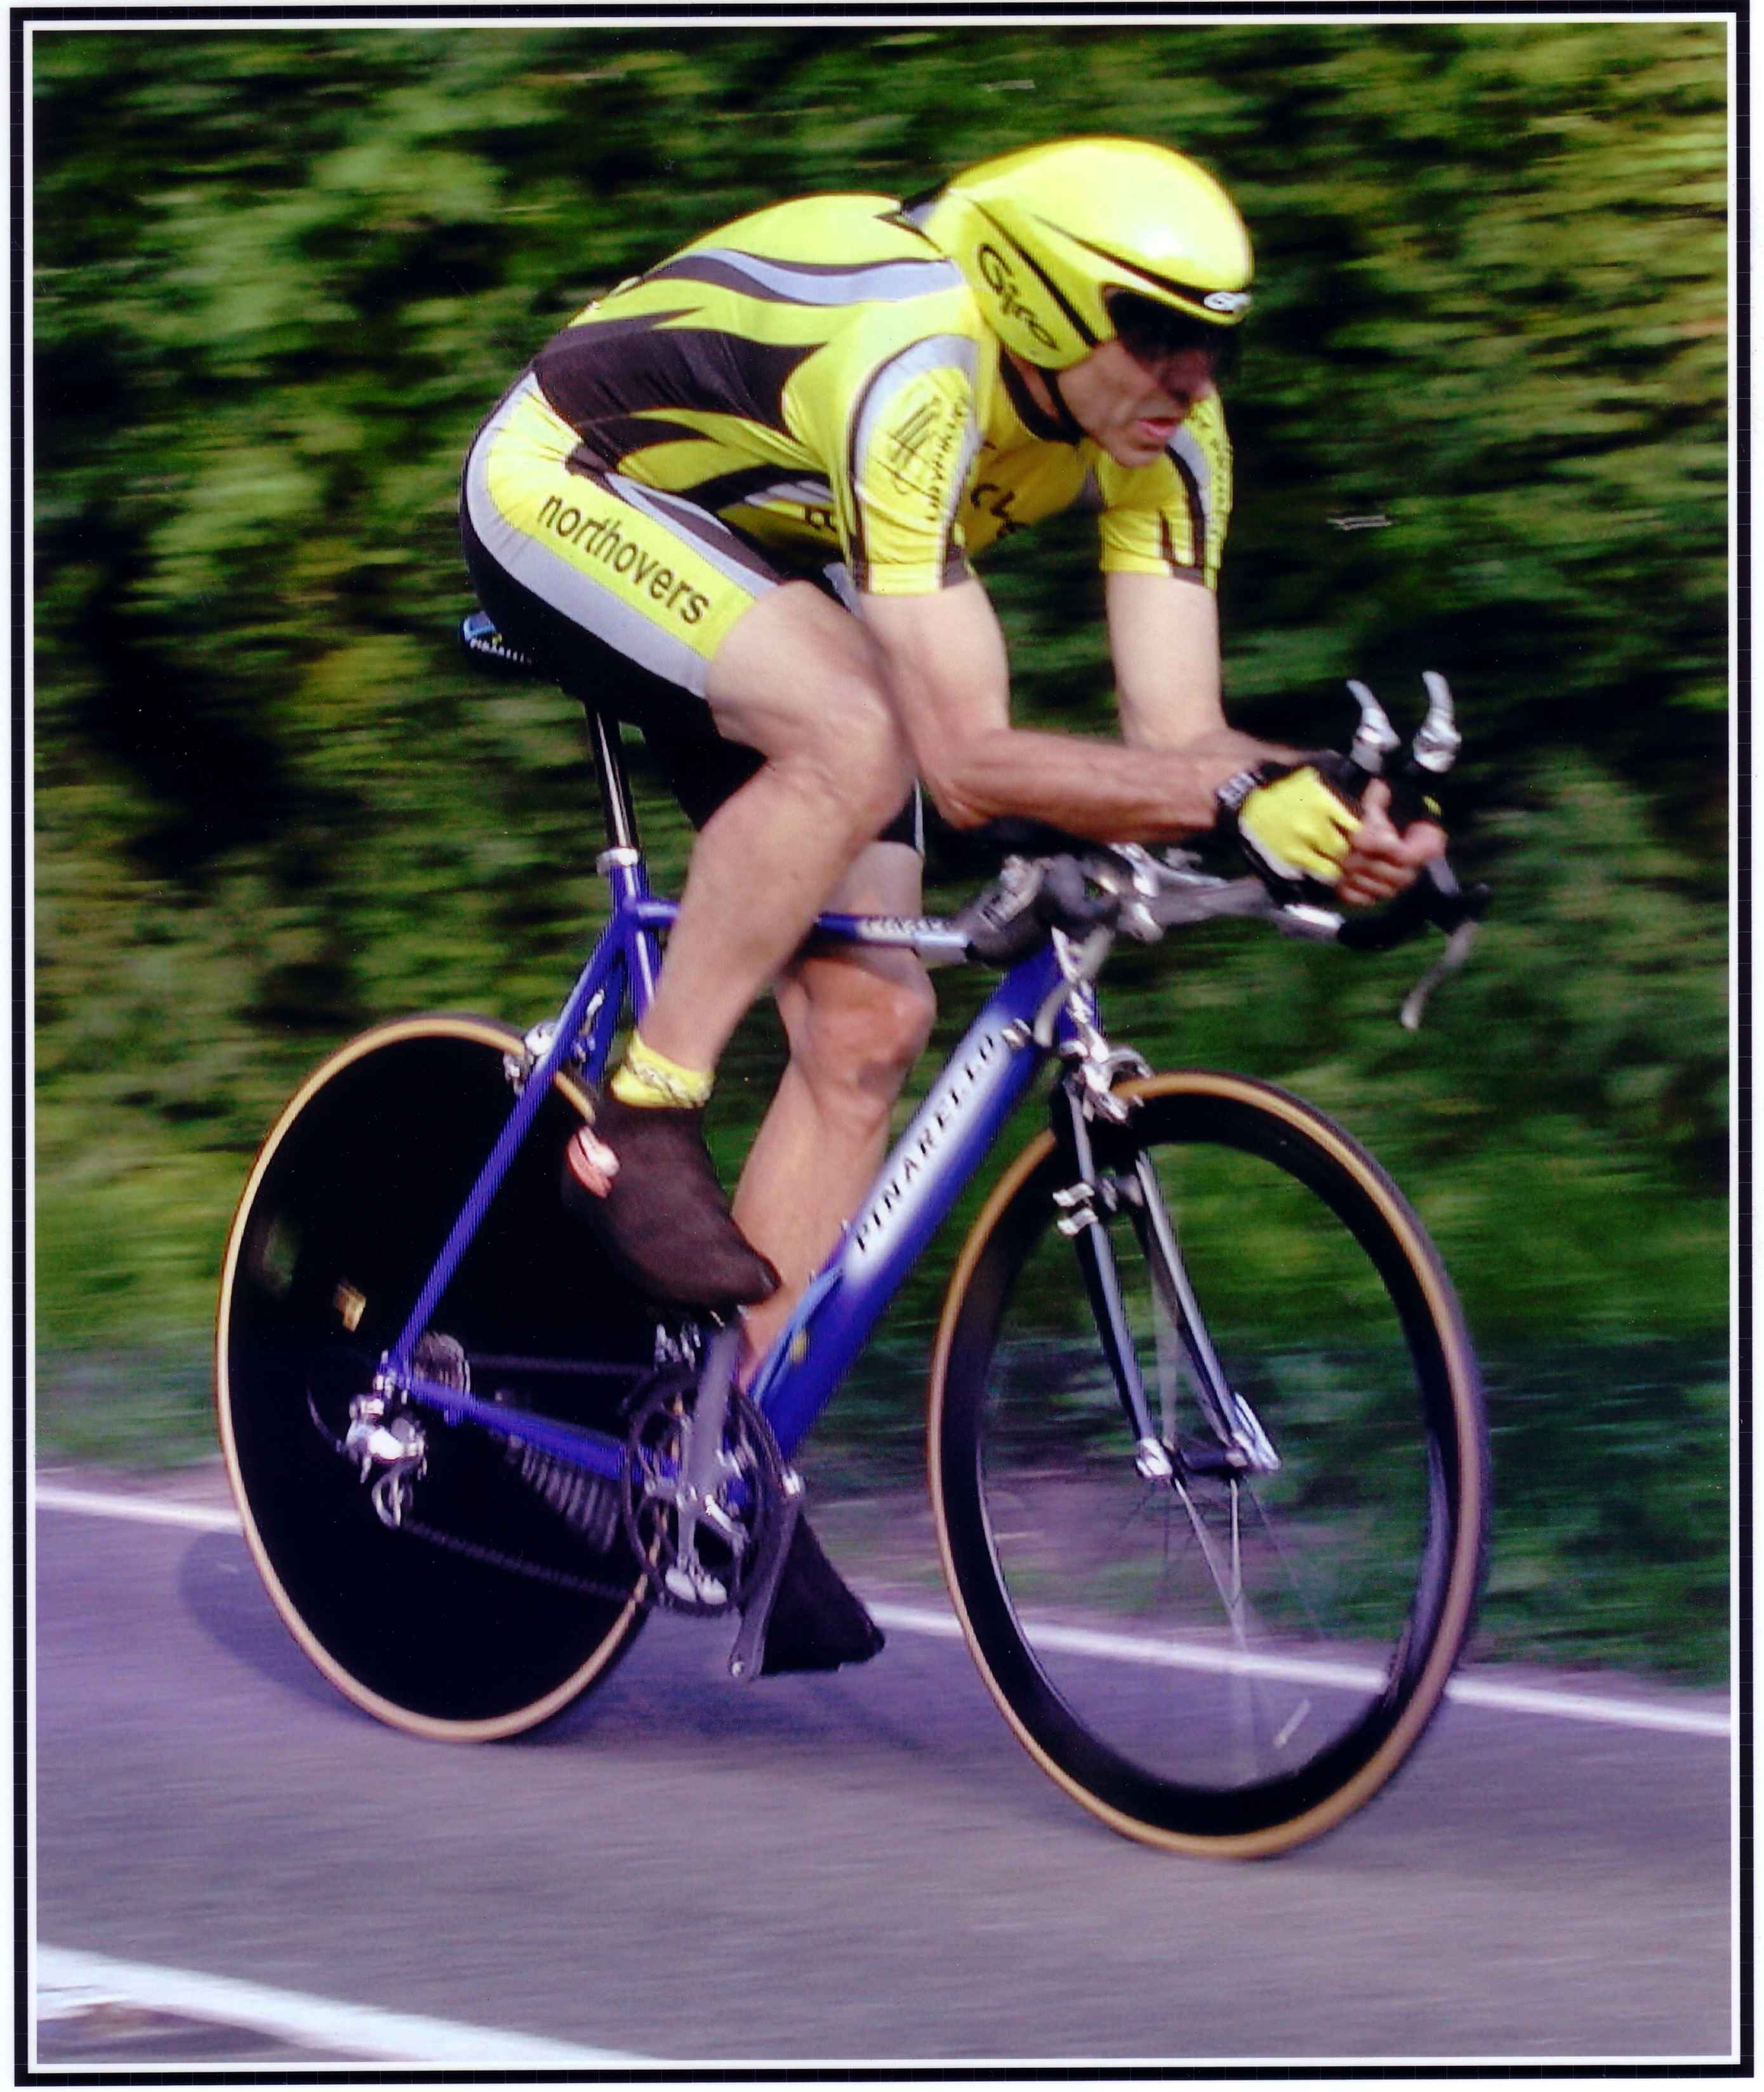

This Northover’s VT 10 Mile Solo & 2up TT is organised in memory of
our team-mate and good friend Bob Redrup.
who passed away unexpectedly on 26 September 2003 whilst on a training ride with the team prior to the Duo Normandy in Marigny, France.

Easter Solo & 2Up 10 Mile Time Trial
Results

Prize List - Solo
1st £25 Dean Robson Northover VT 20:11
2nd £20 Gavin Macdougall Tavistock Whrs CC 20:21
3rd £15 Lubos Obornik CS Dynamo 20:49

1st lady £25 Anja Roeding Exeter Whlrs CC 25:47

1st Vet 40+ £10 Andrew Paranowski Cycle City Couriers RT 21:00
1st Vet 50+ £10 Mark Sanders Mid Devon CC 22:55
1st Vet 60+ £10 Ian Deakin Mid Devon CC 23:59

1st Junior £10 Ruben Stacey North Devon Whlrs 24:45

Prize List – 2up
1st Club Team or Composite £25 Mat Slater / Liam Bard Revo Racing 19:15
2nd Club Team or Composite £20 Ian Cullen / Sean Ferguson Mid Devon CC 20:37

Thanks

I would like to congratulate all the prize winners and hope to see you all back next year. It will again be Easter Monday 2020, the hall is booked already!

Thanks must also go to the timekeepers Andy Greatwood & Paul Arayan. The lovley ladies in the kitchen serving refreshments, Lesley Pollard, Maureen Woollard and my wife Rosemary.

Thanks to all the marshals all members of Northovers VT who helped in this promotion in particular, Ray Pollard, Marino Pizii, John Williams, Tom Woollard, Leigh Pinchen, Simon & Dawn Coles.

Finally thanks to anyone I have missed.

Tom Cox

