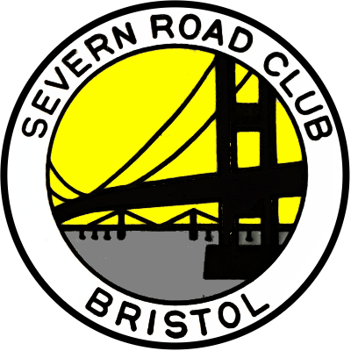 | SEVERN ROAD CLUB  Open 10 Mile Time Trial  Course U7B  Saturday 29th June 2019  Promoted for and on behalf of Cycling Time Trials  under their Rules and Regulations

RESULTS
Event Secretary |  | Timekeepers
Jamie Britton  53 Oakdale Close, Downend, Bristol.  Tel: 07760 389441 |  | Ian Boon  Bridget Boon
Thanks to everyone who came to participate in the event on Saturday. A beautiful day and not too windy, the early-ish start allowed everyone to finish before the heat built.
Congratulations to Jonathan Gates and Robert Willcocks, both riding for Royal Air Force Cycling Association, who shared the win (20.24). Nick Livermore (Bristol South CC) was next fastest just inside 21 minutes followed by Chris Massey of CES Sport 11 seconds back.
Fastest lady was Lauren Johnston (Avid Sport) with a time of 24.44. Gary Guntrip was the fastest of the trikes stopping the clock in 30.42.
Thanks again to the following people for their help with the event:
- Ian & Bridget Boon for the timekeeping and signage.
- The Marshals:
  - Bernie Brown - Start pusher.
  - David Leighton – Berkeley Bridge.
  - Paul Evans, Rob Sims and Richard Emery Slimbridge roundabout.
- Catering: Ally Britton.

I hope that everyone enjoyed the event and hope to see you all again next year.
Good luck to everyone for the rest of the season!

Jamie Britton
Severn Road Club

Awards
(One rider one prize)

=1st overall | Jonathan Gates  Robert Willcocks | Royal Air Force Cycling Association | 20:24
2nd overall | Nick Livermore | Bristol South CC | 20:59
3rd overall | Chris Massey | CES Sport | 21:10
1st Lady Rider | Lauren Johnston | Avid Sport | 24:44
1st V40 | Robin Short | Performance Cycles CC | 21.18
1st V50 | David Dickerson | Team Echelon | 21.23
1st V60+ | Mike Cox | Chippenham & Dist. Whls | 22.58
Fastest Trike | Gary Guntrip | A5 Rangers CC | 30:42
GHS – Fastest Rider | Euan Taylor | Salt & Sham CC | 23:33

Results

