Mr Stuart Reeves
27 Jubilee Park
Woodville, Swadlincote
South Derbyshire
DE11 7NZ

Our Ref: | T2.1.30.20
Your Ref: | CTT Form via e-mail
Ask for: | Ms Lesley Panton
Date: | Tuesday, 28 July 2026

Dear Stuart

COALVILLE WHEELERS CYCLING CLUB
SATURDAY 22ND FEBRUARY 2020

I acknowledge receipt of your notification concerning the above event and confirm that there are no police objections so far as this Force is concerned, provided all the rules of the road are adhered to with special emphasis on road safety.

Yours sincerely,
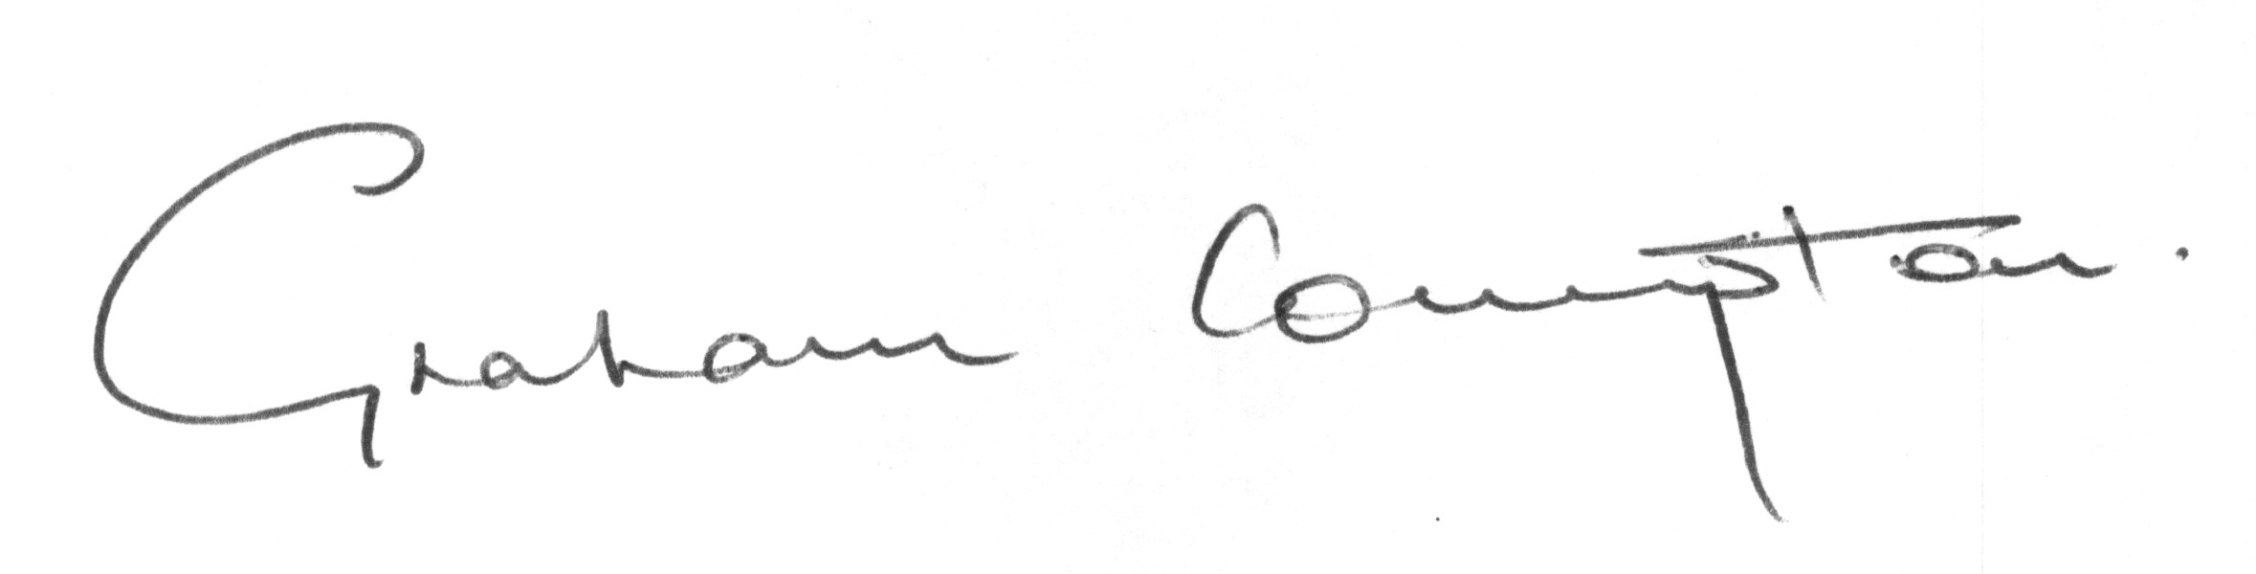
Graham Compton
Senior Traffic Management Officer
Traffic Management Section

