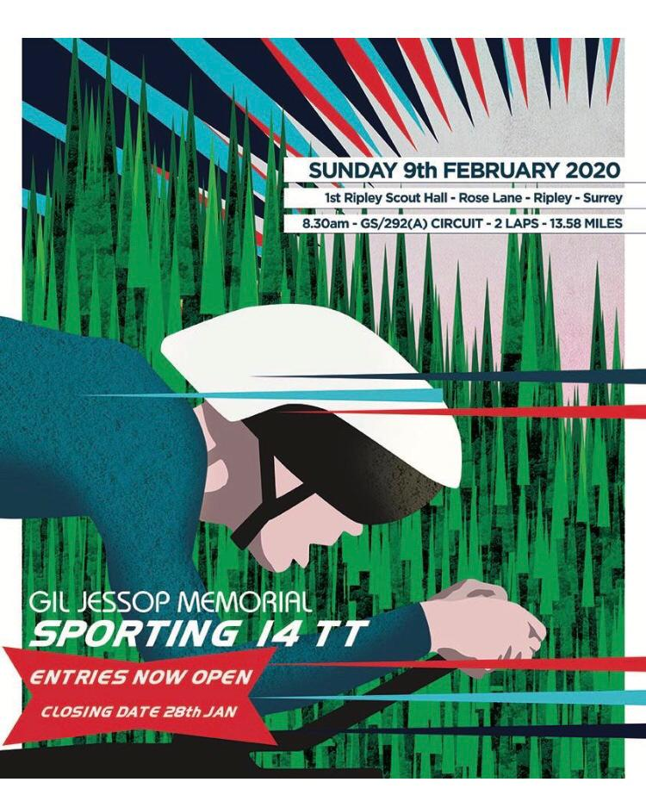



Gil Jessop Memorial 'Sporting 14' Time Trial
27th Edition

Promoted for and on behalf of Cycling Time Trials under their Rules and Regulations

Sunday 9th February 2020 at 08:30

Event Secretary
Alice Lethbridge
timetrial@kingstonwheelers.com

Contact on the Day

Aidan Culhane

Tel 07838254749

HQ
- 1st Ripley Scout Group Hall, Rose Lane, Ripley, Surrey GU23 6NE
- 0.5 km SE of junction B2215 (High Street) / B367 (Newark Lane)
- https://www.google.com/maps/place/Rose+Ln,+Ripley,+Woking+GU23+6NE/@51.2989822,-0.494119,17z/data=!3m1!4b1!4m5!3m4!1s0x4875d91f575a5de3:0xb791d78ed91d0b60!8m2!3d51.2989789!4d-0.4919303

Gil Jessop
The Kingston Wheelers Cycling Club was formed in 1924. Six cyclists met in a cafe on the Portsmouth Road near Kingston police station. Gil Jessop, for whom this race is a memorial, joined the club in about 1930. The Second World War curtailed activities for a number of years. The last club run was in 1941 and most members were called up for service. Gil Jessop served in the armed forces and after demob, he helped to reform the club in Chessington in 1953. He later became President of the club until his death in the early 1990s.

Event Records
Men: Edmund Bradbury 29.18 (2018) from John Dewey 30.07 (2017)
Women: Alice Lethbridge 34.18 (2018) from Alice Lethbridge 34.41 (2016)
Team: Paceline RT (Pat Wright, Thomas Whatley, Keith Lea) 1.33.34 (2018) from Paceline RT (Rob Sharland, Keith Lea, Pat Wright) 1.35.45 (2015)

Signing On
- Opens at 07:30 (first rider off 8.33)
- Sign-on and start numbers at Event HQ (Ripley Scout Hall)
- Numbers are to be worn in conjunction with Regulation 16. “No time may be recorded if number is not correctly positioned.”
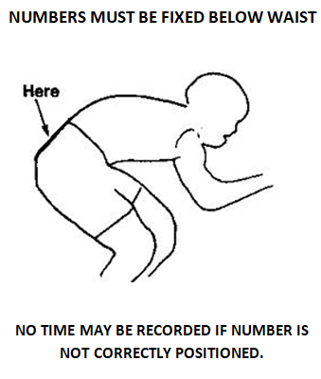

- Allow at least 5 minutes from HQ to START (0.8 miles)
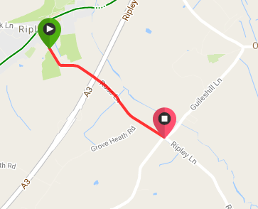

Signing out
Please be aware of the following regulation:
Regulation 17 (b) In Type A events a competitor must return to the event HQ either during the event or within a reasonable time after the last rider has finished the event and must (i) return their race number(s); and (ii) sign the official signing-out sheet. A rider who fails to so sign the official signing-out sheet shall be recorded as DNF

Doping control
This event may be subject to a Doping Control. As soon as you have finished you should return to the event HQ as it is your responsibility to check if you are required for Doping Control. Race numbers required for Doping Control will be displayed at the HQ adjacent to the result board. If your number is displayed you should report immediately to Doping Control which will be nearby. Remember, it is up to you to check and ensure that you comply. If required you must report to Doping Control after finishing without delay.

Safety Instructions
- CTT regulations require compulsory use of helmets for the under 18's. In the interests of your own safety, Cycling Time Trials and the event promoters strongly advise all competitors to wear a hard/soft shell helmet that meets an internationally accepted safety standard.
- Competitors are requested not to warm up on the course after the first competitor has started.
- Details of any additional hazards not listed on the start sheet will be displayed at the signing on point. All competitors must read these details when they sign on.
- Competitors are reminded that a safe ride is more important than a fast ride – please exercise extreme care. There are several potholes and areas of rough road scattered on the course. Please ensure you do not ride head down and that you are looking at the road ahead.
In particular:
  - there is a large pothole on the Hungry Hill climb about halfway up on the left
  - there are several potholes on the bend just before you descend Hungry Hill Lane
  - the road surface is broken between the slip road and main road as you come onto the A246
  - you must give way to any traffic approaching from your right at the West Horsley Roundabout, where there is also raised concrete between the main lane and the slip road to your left
  - there are several potholes on the stretch of road between the turn off the A246 and Ripley Lane
  - please exercise extra care when turning onto Hungry Hill lane to start the second lap – there are potholes on the corner and the corner is tight; make sure you scrub off sufficient speed before you turn
  - competitors crossing the central line of Rose Lane prior to turning left into Hungry Hill Lane may be disqualified
- I have contacted the local riding stables to warn them of the event, but there is a small possibility of horse riders on the course. If you come across a horse, please obey the highway code as you pass.
- Official Observers will be stationed around the course.
- No times will be given at the finish.

Please note there is a new CTT regulation for 2020
14(i) No competitor shall be permitted to start either a Type A or Type B event unless such competitor has affixed to the rear of their machine a working rear red light, either flashing or constant, that is illuminated and in a position that is clearly visible to other road users.
As such, the requirement for a rear red light to be used in CTT events is now compulsory. Organisers should be aware however that the requirement is that a competitor must not start the event unless such competitor is compliant with this regulation. It is not a matter of disqualification.
NO WORKING REAR RED LIGHT – NO START.
If the competitor’s light should fail during the course of the event, that is not a breach of the regulation and the time or distance recorded by that competitor is good and shall be valid for all purposes.

General Notes
- London South District Regulation: No Vehicles, except those of the Timekeepers’ and Event Officials, shall be parked in the vicinity of the start and finish areas

Specific to Event
- Due to the large number of novice riders in this event with no prior times to assist with seeding, riders’ attention is drawn to the regulations that govern Time Trials and prohibits drafting (riding in company). If you catch a rider ahead of you, please make it is safe to overtake them move past quickly and maintain your speed
- Please be aware of parking restrictions in side roads off Rose Lane (near Scout Hut). There is a new car park WITH HEIGHT BARRIER. Those with roof mounted bikes please be aware.

PLEASE KEEP NOISE TO MINIMUM FOR RESIDENTS AND RESPECT PARKING RESTRICTIONS

Prizes
- One prize per rider of the highest value (excluding team prize and course record)
- KW Sporting 14 Artwork by Darren Marshall for fastest man (TT), fastest woman (TT), fastest man (road bike), fastest woman (road bike), fastest Kingston Wheeler rider (male) and fastest Kingston Wheeler rider (female)
- Course record prizes are donated by the club
- The team prize is three riders to count

Prize List | 1st | 2nd | 3rd | 4th | 5th
Men TT Bike | £50 | £40 | £30 | - | -
Women TT Bike | £50 | £40 | £30 | - | -
Vets on standard TT bike | £20 | £15 | £10 | - | -
 |  |  | - | - | -
Team TT Bike | £30 | - | - | - | -
Men Road Bike | £50 | £40 | £30 | £20 | £10
Women Road Bike | £50 | £40 | £30 | - | -
Vets on standard Road bike | £20 | £15 | £10 | - | -
Team Road Bike | £30 | - | - | - | -
Junior/Juvenile Men – across both events | £15 | £10 | - | - | -
Junior / Juvenile Women – across both events | £15 | - | - | - | -
Team: New Course Record | £60 | - | - | - | -
Men: New Course Record | £100 | - | - | - | -
Women: New Course Record | £100 | - | - | - | -

Road Bike Competition:

To be eligible for this competition you must be riding a bicycle that has:
• Drop handlebars
• No aerobars fitted
• No Discs or Tri/Quad spoke wheels; Wheels must have rims no more than 65mm deep.

For the rider
• Time trial helmets not allowed - must wear a helmet that is legal in a road race (aero Road helmets, e.g. Specialized Evade, Giro Air Attack, are acceptable).
• Skinsuits are permitted
• Shoe covers are permitted

Teams

Road Bike Competition | TT Bike Competition
Charlotteville CC | Kingston Phoenix RC
Epsom CC | Kingston Wheelers CC
Kingston Wheelers CC | London Dynamo
Paceline RT | VC de Londres
Waldy Wheelers
Windrush Triathlon Club

Course
- London South DC – 13.58 mile circuit course - GS/292(A)
- Hungry Hill Lane > East Clandon > West Horsley > Ripley Lane
- 2 laps, 13.58 miles
- The course details are as follows:
OS REF | Details | Distances
062558 | START in Hungry Hill Lane at TP7, 114 yards south of junction with Rose Lane and about 0.8 miles southeast of Ripley. | 0.00 | 0.00
062516 | Proceed along Hungry Hill Lane and Ripley Road to East Clandon, where LEFT into The Street. Follow this road round SHARP RIGHT HAND bend to junction with A246 | 3.12 | 3.12
079523 | LEFT (CARE) and follow A246 to West Horsley roundabout  LEFT 1st exit into The Street and after ¼ mile, fork LEFT into Ripley Lane.  Continue into Rose Lane to junction with Hungry Hill Lane | 1.15  2.61 | 4.27  6.88
062558 | LEFT into Hungry Hill Lane to complete first circuit or FINISH at a point 100 yards before the junction with Rose Lane and Hungry Hill Lane. | 6.70 | 13.58

Please note, marshals are provided for your safety, NOT to provide directions. It is the riders’ responsibility to know the course.
CTT Regulation 18. Covering the Course
The onus of keeping to the course rests with each rider.
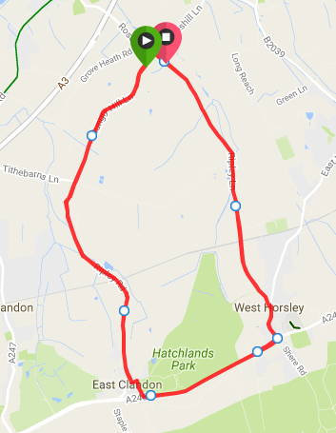

Strava link to the course
https://www.strava.com/segments/8887633

Please note there is a new CTT regulation for 2020
14(i) No competitor shall be permitted to start either a Type A or Type B event unless such competitor has affixed to the rear of their machine a working rear red light, either flashing or constant, that is illuminated and in a position that is clearly visible to other road users.
As such, the requirement for a rear red light to be used in CTT events is now compulsory. Organisers should be aware however that the requirement is that a competitor must not start the event unless such competitor is compliant with this regulation. It is not a matter of disqualification.
NO WORKING REAR RED LIGHT – NO START.
If the competitor’s light should fail during the course of the event, that is not a breach of the regulation and the time or distance recorded by that competitor is good and shall be valid for all purposes.

Start Sheet
No. | Start Time | Name |  | Club | Gender | Category | Road/ TT
3 | 08:33:00 | Eben | Jones | Brixton Cycles Club | Male | Senior | Road
4 | 08:34:00 | Adrian | M | Kingston Wheelers CC | Male | Veteran | Road
5 | 08:35:00 | Les | Liddiard | Team Jewson - MI Racing ~Poly Pipe~McCann | Male | Veteran | Road
6 | 08:36:00 | Alex | Przyjemski | Windrush Triathlon Club | Male | Senior | Road
7 | 08:37:00 | Michael | Evans | Kingston Wheelers CC | Male | Senior | Road
8 | 08:38:00 | David | Scrivener | Epsom CC | Male | Senior | Road
9 | 08:39:00 | Mike | Anderson | Club Cycliste Moncontourais | Male | Veteran | Road
10 | 08:40:00 | Gary | Baker | Reading CC | Male | Veteran | Road
11 | 08:41:00 | Alex | Green | Windrush Triathlon Club | Male | Senior | Road
12 | 08:42:00 | Philip | Deacon | Kingston Wheelers CC | Male | Veteran | Road
13 | 08:43:00 | Austin | Bell | Charlotteville Cycling Club | Male | Veteran | Road
14 | 08:44:00 | Craig | Bruce | Kingston Wheelers CC | Male | Senior | Road
15 | 08:45:00 | Alan | Oakley | Southborough & Dist. Whs | Male | Veteran | Road
16 | 08:46:00 | Paul | Quinn | GS Mossa | Male | Senior | Road
17 | 08:47:00 | Joe | Lane | Windrush Triathlon Club | Male | Senior | Road
18 | 08:48:00 | Connor | Backhouse | Kingston Wheelers CC | Male | Espoir | Road
19 | 08:49:00 | Edward | Cronan | Paceline RT | Male | Senior | Road
20 | 08:50:00 | Steven | Cicognani | Waldy Wheelers | Male | Senior | Road
21 | 08:51:00 | Chris | Mcglynn | 6AM Cycling | Male | Senior | Road
22 | 08:52:00 | Frederic | Frizzarin | Waldy Wheelers | Male | Veteran | Road
23 | 08:53:00 | Jaak | Van Der Werff | Epsom CC | Male | Senior | Road
24 | 08:54:00 | Andrew | Shute | Waldy Wheelers | Male | Veteran | Road
25 | 08:55:00 | Steve | Winder | Epsom CC | Male | Veteran | Road
26 | 08:56:00 | Tim | Lewis | Ful-on Tri | Male | Veteran | Road
27 | 08:57:00 | Daniel | Sharp | Charlotteville Cycling Club | Male | Veteran | Road
28 | 08:58:00 | Vernon | Schutte | Farnborough & Camberley CC | Male | Veteran | Road
29 | 08:59:00 | Jean-paul | Quenet | 1485 Tri Club | Male | Veteran | Road
30 | 09:00:00 | Harry | Bunnell | Kingston Wheelers CC | Male | Senior | Road
31 | 09:01:00 | Daniel | Loveday | Charlotteville Cycling Club | Male | Veteran | Road
32 | 09:02:00 | Joseph | Kirton | Kingston Wheelers CC | Male | Senior | Road
33 | 09:03:00 | Nick | Eisinger | Dorking Cycling Club | Male | Veteran | Road
34 | 09:04:00 | Martin | Scofield | VTTA (Surrey/ Sussex) | Male | Veteran | Road
35 | 09:05:00 | Duncan | Jensen | Paceline RT | Male | Senior | Road
36 | 09:06:00 | Ben | Budgen | Kingston Wheelers CC | Male | Senior | Road
37 | 09:07:00 | Ross | Vart | Velo Club Godalming & Haslemere | Male | Veteran | Road
38 | 09:08:00 | Brendan | Barnes | Kingston Wheelers CC | Male | Veteran | Road
39 | 09:09:00 | Dan | Cole | Dorking Cycling Club | Male | Veteran | Road
40 | 09:10:00 | Simon | Mumme | Paceline RT | Male | Senior | Road
41 | 09:11:00 | Seb | Ashton | Kingston Wheelers CC | Male | Senior | Road
42 | 09:12:00 | James | Trigg | Redhill CC | Male | Veteran | Road
43 | 09:13:00 | James | Barrett | London Dynamo | Male | Veteran | Road
44 | 09:14:00 | Robert | Durnford | Paceline RT | Male | Senior | Road
45 | 09:15:00 | Mark | Greenwood | Army Cycling | Male | Veteran | Road
46 | 09:16:00 | Richard | Seabrook | Kingston Wheelers CC | Male | Senior | Road
47 | 09:17:00 | Justin | Webb | VTTA (London & Home Counties) | Male | Veteran | Road
48 | 09:18:00 | Benoit | Ramsay | Paceline RT | Male | Senior | Road
49 | 09:19:00 | Paul | Newsome | Project 51 | Male | Senior | Road
50 | 09:20:00 | Adam | Page | Paceline RT | Male | Veteran | Road
51 | 09:21:00 | Neil | Harrigan | Gravesend CC | Male | Veteran | Road
52 | 09:22:00 | Karl | Moseley | Fishface Cycles RT | Male | Veteran | Road
53 | 09:23:00 | Keith | Lea | Paceline RT | Male | Veteran | Road
54 | 09:24:00 | Jerome | Watts | Team Salesengine.co.uk | Male | Veteran | Road
55 | 09:25:00 | Shaun | King | Kingston Wheelers CC | Male | Senior | Road
56 | 09:26:00 | Dave | Dent | GS Stella | Male | Veteran | Road
57 | 09:27:00 | Paul | Burton | Paceline RT | Male | Senior | Road
58 | 09:28:00 | Nick | Robin | Epsom CC | Male | Veteran | Road
59 | 09:29:00 | Mark | Aldred | Kingston Wheelers CC | Male | Senior | Road
60 | 09:30:00 | Suzanne | Shaw | Kingston Phoenix RC | Female | Veteran | Road
61 | 09:31:00 | Flora | Perkins | VC de Londres | Female | Junior | Road
62 | 09:32:00 | Fiona | Inskip | Njinga Cycling | Female | Veteran | Road
63 | 09:33:00 | Moira | Brailsford | Kingston Wheelers CC | Female | Senior | Road
64 | 09:34:00 | Cat | Gaskell | Brixton Cycles Club | Female | Senior | Road
65 | 09:35:00 | Linda | Wijlaars | Dulwich Paragon CC | Female | Senior | Road
66 | 09:36:00 | Mathilde | Pauls | 1904RT | Female | Senior | Road
67 | 09:37:00 | Kathryn | Hughes | Onyx RT | Female | Senior | Road
68 | 09:38:00 | Maryka | Sennema | Paceline RT | Female | Veteran | Road
69 | 09:39:00 | Meredith | Gilbert | ŠKODA DSI CYCLING ACADEMY | Female | Espoir | Road
70 | 09:40:00 | Alice | Lethbridge | DRAG2ZERO | Female | Senior | Road
71 | 09:41:00 | Josh | Robin | Epsom CC | Male | Juvenile | Road
72 | 09:42:00 | Louis | Bell | Charlotteville Cycling Club | Male | Juvenile | Road
73 | 09:43:00 | William | Smith | Verulam Really Moving | Male | Juvenile | Road
74 | 09:44:00 | Billy | Gilbey | VC de Londres | Male | Junior | Road
75 | 09:45:00 | Jack | Hartrey | Kingston Wheelers CC | Male | Juvenile | Road
76 | 09:46:00 | Olivier | Mangham | VC de Londres | Male | Juvenile | TT
78 | 09:47:00 | Ali | Platt | Charlotteville Cycling Club | Male | Junior | TT
78 | 09:48:00 | Oliver | Wollaston | VC de Londres | Male | Junior | TT
79 | 09:49:00 | Ivan | Newsome | Surrey Hills Cycleworks | Male | Junior | TT
80 | 09:50:00 | Mattie | Dodd | VC de Londres | Male | Juvenile | TT
81 | 09:51:00 | Harry | Ives | Woolwich CC | Male | Junior | TT
82 | 09:52:00 | Henrik | Persson | Kingston Wheelers CC | Male | Senior | TT
83 | 09:53:00 | Amber | Junker Brameld | VC de Londres | Female | Juvenile | TT
84 | 09:54:00 | Katie | Simmonds | URDT | Female | Senior | TT
85 | 09:55:00 | Lucy | Hurn | Woking Cycle Club | Female | Veteran | TT
86 | 09:56:00 | Sarah | Lewis | Ful-on Tri | Female | Senior | TT
87 | 09:57:00 | Lenka | Vackova | Rapha Cycling Club | Female | Senior | TT
88 | 09:58:00 | Claire | Moxon | Njinga Cycling | Female | Veteran | TT
89 | 09:59:00 | Isabella | Escalera | VC de Londres | Female | Junior | TT
90 | 10:00:00 | Samantha | Fawcett | Lovelo | Female | Senior | TT
91 | 10:01:00 | Tina | Reid | ROTOR Race Team | Female | Veteran | TT
92 | 10:02:00 | Andrew | Payne | Maidenhead & District CC | Male | Veteran | TT
93 | 10:03:00 | Anthony | Baker | Charlotteville Cycling Club | Male | Senior | TT
94 | 10:04:00 | Justin | Clarke | Dorking Cycling Club | Male | Veteran | TT
95 | 10:06:00 | Simon | Halloway | Paceline RT | Male | Senior | TT
96 | 10:06:00 | Peter | King | Leetl Donki CC | Male | Veteran | TT
97 | 10:07:00 | Mike | Cook | Njinga Cycling | Male | Veteran | TT
98 | 10:08:00 | Liam | Smith | Kingston Wheelers CC | Male | Senior | TT
99 | 10:09:00 | Michael | Page | Epsom CC | Male | Senior | TT
100 | 10:10:00 | Jonathan | Pontin | Addiscombe CC | Male | Senior | TT
101 | 10:11:00 | Andy | Long | Epsom CC | Male | Veteran | TT
102 | 10:12:00 | Simon | Trehearn | Kingston Phoenix RC | Male | Veteran | TT
103 | 10:13:00 | Peter | Owen | Norwood Paragon CC | Male | Veteran | TT
104 | 10:14:00 | Sebastian | Lea | London Dynamo | Male | Senior | TT
105 | 10:15:00 | Jack | Donaghy | Brighton Phoenix Athletic Club | Male | Senior | TT
106 | 10:16:00 | Darren | Clarke | Festival Road Club | Male | Veteran | TT
107 | 10:17:00 | Rob | Gardner | Kingston Wheelers CC | Male | Veteran | TT
108 | 10:18:00 | Edward | Hales | London Dynamo | Male | Veteran | TT
109 | 10:19:00 | Simon | Pontin | Addiscombe CC | Male | Senior | TT
110 | 10:20:00 | Jack | Kellam | Cambridge University CC | Male | Senior | TT
111 | 10:21:00 | Lee | Davies | London Dynamo | Male | Senior | TT
112 | 10:22:00 | Dale | Lush | Kingston Phoenix RC | Male | Veteran | TT
113 | 10:23:00 | Simon | Smythe | Norwood Paragon CC | Male | Veteran | TT
114 | 10:24:00 | Neil | Grunshaw | Kingston Wheelers CC | Male | Senior | TT
115 | 10:25:00 | Alexander | Kew | Kingston Phoenix RC | Male | Veteran | TT
116 | 10:26:00 | Chris | Holmes | Twickenham CC | Male | Veteran | TT
117 | 10:27:00 | Moustafa | Fawzy | Paceline RT | Male | Veteran | TT
118 | 10:28:00 | Ben | Williams | GS Mossa | Male | Senior | TT
119 | 10:29:00 | Justin | Thomas | Dorking Cycling Club | Male | Veteran | TT
120 | 10:30:00 | Liam | Maybank | Twickenham CC | Male | Veteran | TT

Time Keepers
Clive Walton (Start) Paul Tunnell (Finish)

Artwork
Darren Marshall

Event Secretary
Alice Lethbridge

With thanks to all the marshals and cake bakers

All proceeds from cake sales to be donated to The London Air Ambulance
https://www.londonsairambulance.org.uk/

We have photographers attending on the day. Links for photos will be provided in the results booklet.

Kingston Wheelers Cycling Club
https://www.kingstonwheelers.com/

