 | West DC : Risk Assessment
Course Assessed: U41 | Distance / Roads: 10 miles B4696 (Spine Road / Latton)
Sheet 1 of 2 | Date of Assessment: 18 September 2020

Cycling Time Trials – West DC Course Risk Assessment Document. The measures to reduce risk identified in the right hand column must be included on the start sheet or implemented for the duration of the event as applicable. Failure to comply with the requirements of this document may result in approval being withheld with respect to subsequent race promotions by the promoting club.

Notes and Restrictions: Use of arm numbers is recommended as this is a circuit event and riders will overlap.

No. | Distance / Location | Risk/Hazard | Level of Risk  (L / M / H) | Measures to reduce Risk  (if applicable)
a) Introduction
1 | General Requirements | Time of Road Usage meets CTT Traffic Standards | L | Traffic counts within acceptable numbers; Take Traffic Counts during event
b) HQ to Start
2 | Before Start | Competitors riding from Event HQ; Competitors warming up | L | Instructions on Start Sheet and at event HQ signing on advising riders of safe routes; prohibition on warming up past the start
3 | Area of Start | Competitors waiting | L | Instructions on Start Sheet and at event HQ signing on - warning against making ‘U’ turns; Cycle Event warning sign
4 | Start  SU 04149 95984  (note this is the second layby from the first turn) | Unclassified road; Light traffic; Layby north of Aggregate Industries Site | L | Cycle Event Warning Sign before Start; Start Sheet instruction – wait on hardstanding
5 | Junction / X-roads with B4696 and Spine Road | Visibility good  Riders turning left have priority over all traffic | L | Cycle Event Warning Sign and marshal (optional) – drivers may not expect cyclist turn.
6 | B4696 Spine Road East | Junctions from minor roads on left and right  Riders have right of way | L | Cycle Event Warning Signs
7 | A419 / Spine Road junction RaB (traffic from South) | Traffic joining course from A419 and from B4696 Spine Road; Riders go straight across on Cirencester Road, 2nd exit | M | 1 Marshal; 2 Cycle Event Warning Signs on RaB plus one sign on slip road (not highway).
8 | A419/ Cirencester junction RaB (traffic from North) | Traffic joining course from A419 and from Cirencester Road (Latton); Riders take 3rd exit towards Latton | M | 1 Marshal; 2 Cycle Event Warning Signs on RaB plus one sign on slip road (not highway).
9 | Junction to / from Down Ampney | Traffic joining course from Down Ampney | M | Cycle Event Warning Sign on approach to junction from Down Ampney
10 | Latton | Traffic calming build-outs | L | Warning on Start Sheet
11 | Marston Meysey RaB | Riders turn at RAB to retrace | M | 1 Marshal (optional); Cycle Event Warning signs on approaches
12 | Latton | Traffic calming build-outs | L | As 10 above
13 | A419/ Cirencester junction RaB (traffic from North) | Traffic joining course from A419 and from Cirencester Road (Latton); Riders take 1st exit towards Cotswold Water Park (not down slip road) and straight across | M | As 8 above
14 | A419 / Spine Road junction RaB (traffic from South) | Traffic joining course from A419 and from B4696 Spine Road; Riders go straight across on Cirencester Road, 2nd exit for Cotswold Water Park | M | As 7 above
15 | A419 / Spine Road | Cotswold Water Park Complex Bus Stop. May be queuing cars if a bus is at the stop | L | Notice to riders at signing on
16 | B4696 Spine Road East | Junctions from minor roads on left and right  Riders have right of way | L | Cycle Event Warning Signs
17 | Finish near Clayhill Car Park in gated area just before car park, ½ mile short of Spine Road junction  SU 05190 95242 | Other road users; riders finishing | L | Cycle Event Warning sign; Number checker needed with timekeeper
18 | Finish | Road Users; riders performing U turns after the finish | M | Warning on start sheet not to perform ‘U’ turns at the finish. Also a note to be aware of surroundings and other road users at the finish.

Course Description:
Start in layby on unclassified road 0.3 mile north of Aggregate Industries entrance (second layby from first turn) . Head south to junction of Spine Rd West and Spine Rd East (B4696) and turn left. Ride East along Spine Road East towards Cotswold Water Park and A419. Cross the double RAB over the A419 (straight on at first RAB) and turn right at second RAB (second exit) towards Latton (DO NOT TAKE A419 EXITS). Ride South East along Cirencester Road through village of Latton (note traffic calming road narrows) to RAB for A419 and circle RAB to return along Cirencester Road through Latton to the double RAB with A419. At first RAB take second exit (straight across) to second RAB and take second exit along Spine Rd East past Cotswold Water Park (DO NOT TAKE A419 EXITS). Ride West along Spine Rd East to finish 0.5 mile short of junction at West end of small gated layby before Clayhill Car Park

https://ridewithgps.com/routes/25084348

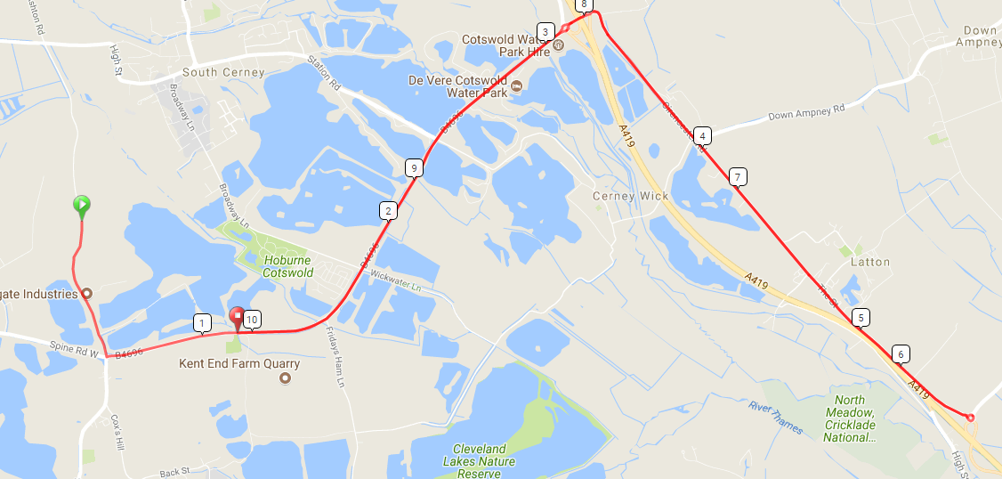

This document remains live and any changes to the items listed above or new hazards/risk that arise should be notified to the district committee at the earliest opportunity. This document was last updated on May 2009.

CYCLING TIME TRIALS IS A COMPANY LIMITED BY GUARANTEE REGISTERED IN ENGLAND No: 4413282
Registered Address: 77 ARLINGTON DRIVE, PENNINGTON, LEIGH, LANCASHIRE. WN7 3QP November 2003

Traffic Counts
Saturday May 2019
RAB Cotswold Water Park |  |  | Points
0800 - 0815 | E | 65 | 260
 | W | 60 | 240
0900 - 0915 | E | 101 | 404
 | W | 86 | 344
Spine Road
0800 - 0820 | E | 28 | 168
0810 - 0820 | W | 28 | 168
0900 - 0910 | E | 30 | 180
0900 - 0910 | W | 36 | 216
Spine Road
0908 - 0918 | E | 42 | 252

