
PRESENT THEIR

Hilly 26 mile Time Trial
Promoted for and on behalf of Cycling Time Trials under their Rules and Regulations
ON Sunday 2nd April 2017

This is a qualifying event for SPOCO South East Group 2 2017

EVENT H.Q.
Easterley Country H.Q., North Hall Lane, Ugley, Essex.

EVENT ORGANISER
Richard Jordan 56 Charlotte Gardens, Collier Row, Romford, RM5 2ED 07966374116

TIMEKEEPERS
Main Time keeper: Mr. T Groves Assistant: Ms B Groves

IMPORTANT NOTES TO RIDERS:
- Riders’ Car parking is only allowed under and in the area immediately to the west of the motorway bridge, near the event HQ. Parking space is limited so please park close together. Parking is forbidden in Widdington Lane and on the B1383 between Stansted and Newport.
- Sign on and collect your number at the Event H.Q.
- Toilets are available at the HQ – do NOT use the fields.
- No ‘U’ turns within sight of either the start or finishing points. Riders carrying out this dangerous manoeuvre are liable for disqualification from the event and further disciplinary action by London East D.C.
- Static Trainers:- Out of consideration for local residents, the use of static trainers (e.g. turbo trainers) is banned from all morning events held in London East DC.
- After you have finished, please return directly to the event HQ via the recommended route below. Return your number for a free drink.
IN THE INTERESTS OF YOUR OWN SAFETY, Cycling Time Trials and the Event Promoters strongly advise you to wear a HARD SHELL SAFETY HELMET that meets an internationally accepted safety standard. ALL Juniors and/or riders under the age of 19 years are required to wear a suitably approved helmet. Cycling Time Trials and the Event Promoters recommend the use of a flashing rear light whilst competing.

E1/26a - COURSE DETAILS
START in North Hall Road, Ugley at PP02B at southern end of slip road from railway crossing (south of railway bridge). Proceed south to take second left (0.4m) (mp1). Proceed to Henham (1.3m)(mp2). Turn right to junction with B1051 (2.2m)(mp3). Turn left on B1051 to Thaxted (8.1m)(mp4). Turn left on B184 to Thaxted Church (8.3m)(mp5). Continue on B184 through Howlett End to turn left (11.9m)(mp6). Proceed through Elder Street to Debden Crossroads (13.5m)(mp7). Turn left through Debden to complete circuit at Thaxted Church (18.2m)(mp5). Turn left on B184 through Howlett End to turn left (21.9m)(mp6). Proceed through Elder Street to Debden Crossroads (23.3m)(mp7). Turn left through Debden to FINISH at TP19 short of Debden Green.
NB this course contains two RIGHT turns. Riders must take GREAT CARE at these junctions and give way to any traffic. Remember - the marshals are there to direct you - not to stop the traffic.
Note the recommended (and shortest) route back to the Event HQ is via. Debden Green and Henham (shown as a single black line).
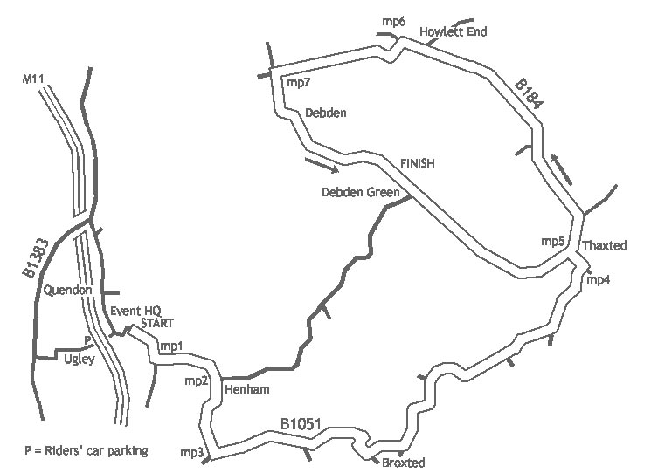
Prizes
Men: 1st £50, 2nd £30, 3rd £20, 4th £10
First Lady: Maud Harrison Trophy plus £20 , 2nd £10

NB: NO WARMING UP ON THE COURSE

