WITHINGTON WHEELERS 

OPEN & NOVICES 25 MILE TIME-TRIAL, J4/8 Course
Saturday 14th August 2021
PROMOTED FOR AND ON BEHALF OF CYCLING TIME TRIALS
UNDER THEIR RULES AND REGULATIONS.
Headquarters: Goostrey Village hall
The Old Paddock, Goostrey CW4 8PE
open from 12.30 pm

FACILITIES AT THE HQ - NO CONGREGATING PLEASE AND THERE WILL BE A ONE-WAY SYSTEM THROUGH THE BUILDING.

CAR PARKING – PLEASE PARK SOCIALLY DISTANCED IN THE CAR PARK IF POSSIBLE. PLEASE USE THE CROWN PUBLIC HOUSE CAR PARK OPPOSITE IF GOOSTREY IS FULL. NO PARKING OR CHANGING ON THE MAIN ROAD PLEASE. There are 108 riders who will be racing please arrive an hour before your start time to avoid congestion and riders congregating.

TOILETS – KEEP SOCIALLY DISTANCED

SIGNING ON AND OFF – WE WILL TRY AND DO THIS OUTSIDE WEATHER DEPENDING PLEASE BRING YOUR OWN PEN AND KEEP SOCIALLY DISTANCED.

NUMBERS WILL BE SANITISED PRIOR TO EVENT

CHANGING - PLEASE COME READY CHANGED

NO REFRESHMENTS OR RESULTS AVAILABLE ON THE DAY.

HAND SANITISER WILL BE AVAILABLE PLEASE USE WHERE REQUIRED.
Event Secretary
Paul Ekgren
12 Lodgeside close
Droylsden
Manchester
M43 7QZ

07456 841594

Masks must be worn indoors please and any signs of covid symptoms or feeling unwell please do not attend.

With Covid infections still quite high we have to follow Goostrey’s Risk Assessments and also the CTT updated ones. We are trying to reduce the risk of transmission by having a restricted event to try and minimise large groups gathering. No results and refreshments on the day and a standing start with no push off.

Please note we are under the microscope currently after recent events and cycling and time trialling have had some very bad press about rider behaviour in general both in races and large groups on the road.
Please respect other road users, no crossing the white line on turns please and general safe riding for everyone’s safety.

Race Numbers
These will be available at the HQ from 12.30 pm. Please return them after the event and sign out or you will be disqualified.

NO U TURNS IN SIGHT OF THE START AND FINISH AREA PLEASE AND ALWAYS RIDE WITH YOUR HEAD UP. A REAR WORKING LIGHT MUST BE FITTED BEFORE STARTING.

TIME KEEPERS - Tony Millington and Martin Jackson

Getting to the start

Please allow 20 minutes to get to the start from the HQ approximately 4 miles. Leave the HQ and turn left on to Main road. Continue down here to the A50 approximately 2 miles. Caution crossing the A50
and continue along Middlewich Road to King’s Lane which is the first turning on the right after approx. 0.5 miles. Follow King’s Lane and take the next left after approx. 0.5 miles (still on King’s Lane) and continue along here to the start approx. 0.6 miles.

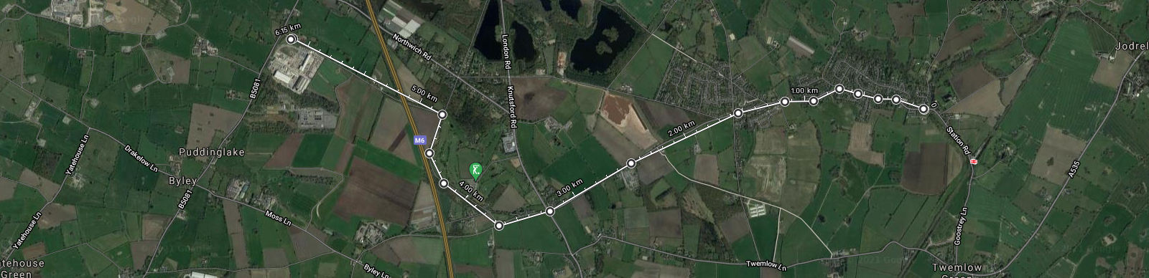

J4.8 Course Details

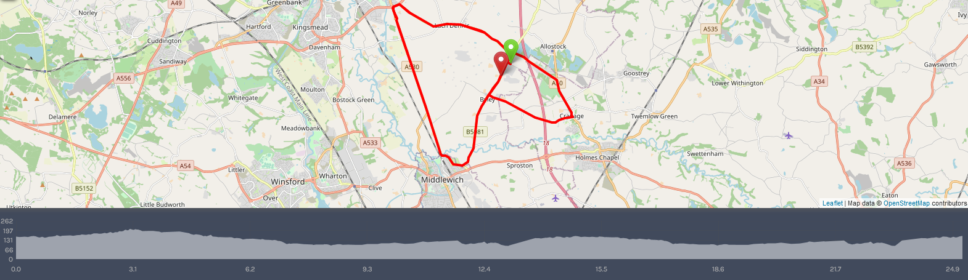

start
start near FP McCann and proceed to T junction with B0581. |  |  |  |  |  |  |  | approx. 250yards
left on B5081 to Byley crossroads where |  |  |  |  |  |  |  | approx. 1.2 miles
left onto Moss Lane and continue to the A50 at Cranage |  |  |  |  |  |  |  | approx. 3.1 miles
left along the A50 to Penny’s Lane where |  |  |  |  |  |  |  | approx. 4.10 miles
left along the B5082 to join A556 |  |  |  |  |  |  |  | approx. 8.25 miles
CAUTION; left here onto A556 then at roundabout take first left onto A530 |  |  |  |  |  |  |  | approx. 8.40 miles
after 3.6 miles filter left onto the B5309 |  |  |  |  |  |  |  | approx. 12 miles
left at the mini-roundabout onto Centurion Way |  |  |  |  |  |  |  | approx. 12.5 miles
left onto the B5081 and proceed back to the Three Greyhounds pub junction |  |  |  |  |  |  |  | approx. 15.50 miles
CAUTION; turning left onto the B5082, retrace for second circuit back to A556 |  |  |  |  |  |  |  | approx. 18.40 miles
CAUTION; turning left onto A556 then first left back onto A530 |  |  |  |  |  |  |  | approx. 18.61 miles
along the A530 to the B5309 |  |  |  |  |  |  |  | approx. 22.20 miles
along here left at the mini roundabout onto Centurion Way |  |  |  |  |  |  |  | approx. 22.80 miles
left onto the B0581 and along here finishing near FP McCann. |  |  |  |  |  |  |  | 25 miles

Returning to HQ after the ride.
You can either retrace your steps back to HQ the same way you came or continue along B5081 to the Three Greyhounds being aware riders are behind you ready for their second lap. Cautiously turn right and ride to the A50 the opposite way to the event. Turn right on the A50 and take the first left into Goostrey Lane (changes to Main Road) and continue along here to the HQ. See below:
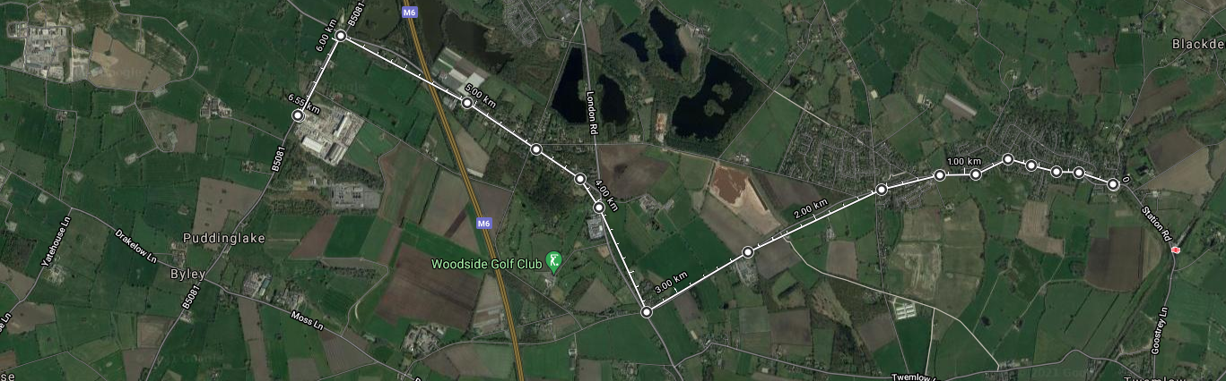

Novice Prizes One rider one prize, except for the team award.
Prizes will be sent out by post in the week following the event.
First Male £25
Second Male £20
Third Male £15
Fourth Male £12
Fastest Vet on Standard £12

Open Prizes One rider one prize, except for the team award.
Prizes will be sent out by post in the week following the event.
First Male £35 | First Female £35
Second Male £30 | Second Female £30
Third Male £25 | Third Female £25
Fourth Male £20 | Fourth Female £20
Fifth Male £15 | Fifth Female £15
Best improver £12
Fastest Vet on Standard £15 | Fastest Female Vet on standard £15
Fastest Espoir £15 | Fastest Juvenile £15
Fastest team £15 x 3

Care at Road Junctions: Riders must exercise care at all junctions. Any competitor who’s riding line causes him/her to cross the white line when approaching or leaving a junction will be liable to disqualification from the event and may be reported to the District Committee for further disciplinary action.
A556 Island: Riders must negotiate A556 Island in a safe and sensible manner in accordance with CTT Reg. 20 and the rules of the road. Riders must be able to brake and stop at the Island if traffic conditions require this.
Riders must not approach and turn left at the island using tri-bars. Remember – traffic on the island has priority over traffic (including riders) entering it. Any riders seen in breach of this regulation will be disqualified from the event and may be reported for further disciplinary action.

In the interests of your own safety – Cycling Time Trials and the event promoters strongly advise you wear a hard-shell helmet that meets an internationally accepted safety standard. In accordance with Reg.15 all junior competitors MUST wear protective hard shell helmets.
It is Mandatory that a working rear light, either flashing or constant, is fitted to the machine in a position visible to following road users and is active while the machine is in use.

Have a great and safe ride.

Thanks to all the marshals and time keepers for their help on the event.

Please note there are two events today. The Novices event for first time riders completing a 25 mile tt . The Novices event will start at 13.31 please take note.

The main Open event with 88 riders will start as normal with first rider at 14.03

Novices start
number | start time | first name | last name | club | gender | category | vet std
131 | 13:31 | Robert | Barker | Worrall Wheelers | M | sen
132 | 13:32 | Andrew | Taylor | Team Wheelguru | M | sen
133 | 13:33 | Martin | Dickson | Manchester Triathlon Club | M | sen
134 | 13:34 | Steve | Nixon | Congleton CC | M | vet 55 | 01:09:57
135 | 13:35 | Russell | Bridge | Stockport Clarion CC | M | vet 44 | 01:06:44
136 | 13:36 | Jonathan | Beckett | Bury Clarion CC | M | vet 48 | 01:07:31
137 | 13:37 | Robert | Schooling | Total Tri Training | M | vet 53 | 01:08:37
138 | 13:38 | Michael | Coulter | East Lancashire RC | M | vet 52 | 01:08:23
139 | 13:39 | Andy | Smith | Wild Bikes Cycling Club | M | vet 51 | 01:08:10
140 | 13:40 | Jon | Blackshaw | Liverpool Phoenix CC (Aintree) | M | vet 41 | 01:06:11
141 | 13:41 | Martin | Sandford | Cheshire Maverick Cycle Club | M | vet 44 | 01:06:44
142 | 13:42 | Stephen | Mellor | Rochdale Tri Club | M | vet 41 | 01:06:11
143 | 13:43 | John | Peasland | Buxton CC/Sett Valley Cycles | M | sen
144 | 13:44 | Neil | Bluer | Lancashire RC | M | vet 43 | 01:06:32
145 | 13:45 | Matt | Morris | Wigan Whs CC | M | sen
146 | 13:46 | Martin | Bell | Total Tri Training | M | vet 50 | 01:07:56
147 | 13:47 | Danny | Glynn | Bury Clarion CC | M | sen
148 | 13:48 | Karim | Hammad | Mersey Tri | M | sen
149 | 13:49 | Richard | Baker | Audlem Cycling Club | M | vet 45 | 01:06:55
150 | 13:50 | Kenny | Mitchell | East Lancashire RC | M | vet 53 | 01:08:37

Open Race

number | start_time | firstname | lastname | club | gender | category | v std
3 | 14:03 | Vic | Trigger | Crewe Clarion Wheelers | Male | v75 | 01:17:04
4 | 14:04 | Robbie | Harcourt | Salford Cycling Club | Male | v58 | 01:09:56
5 | 14:05 | Ian | Slater | VTTA (Manchester & NW Group) | Male | v53 | 01:08:37
6 | 14:06 | Alan | Shuttleworth | Weaver Valley CC | Male | v74 | 01:16:28
7 | 14:07 | Chris | Wilcox | Lyme Racing Club | Male | v58 | 01:09:56
8 | 14:08 | Andy | Whitehead | Seamons CC | Male | v58 | 01:09:56
9 | 14:09 | Niamh | Coulter | East Lancashire RC | Female | esp
10 | 14:10 | Phil | Murphy | Total Tri Training | Male | v41 | 01:17:50
11 | 14:11 | Sam | Shepherd | Total Tri Training | Male | sen
12 | 14:12 | Matthew | Heath | Weaver Valley CC | Male | sen
13 | 14:13 | Lee | Hemmings | Rochdale Tri Club | Male | v43 | 01:06:32
14 | 14:14 | Lesley | Norbury | Congleton CC | Female | fv65 | 01:19:13
15 | 14:15 | Kevin | Blades | Bury Clarion CC | Male | v50 | 01:07:56
16 | 14:16 | Stephen | Hilton | Wigan Whs CC | Male | v50 | 01:07:56
17 | 14:17 | Claire | Harrison | Congleton CC | Female | fv47 | 01:13:40
18 | 14:18 | Paul | Kearney | Cheshire Maverick Cycle Club | Male | v51 | 01:08:10
19 | 14:19 | Jon | Batt | Buxton CC/Sett Valley Cycles | Male | v58 | 01:09:56
20 | 14:20 | Stephen | Dooley | Seamons CC | Male | sen
21 | 14:21 | Michael | Pugh | Rapha Cycling Club | Male | sen
22 | 14:22 | Stephen | Taylor | Manchester Triathlon Club | Male | v51 | 01:08:10
23 | 14:23 | Mike | Nolan | Cheshire Maverick Cycle Club | Male | v49 | 01:07:43
24 | 14:24 | John | Moulds | Knutsford Tri Club | Male | v56 | 01:09:23
25 | 14:25 | Peter | Howarth | Stretford Wheelers CC | Male | v61 | 01:10:51
26 | 14:26 | Nicholas | Smith | Westmead Team 88 | Male | juv
27 | 14:27 | Paul | Robinson | Lyme Racing Club | Male | v57 | 01:09:39
28 | 14:28 | Terry | Bolland | Harry Middleton CC | Male | v57 | 01:09:39
29 | 14:29 | Lauren | Mollart | Knutsford Tri Club | Female | sen
30 | 14:30 | Jonathan | Lloyd | Westmead Team 88 | Male | v53 | 01:08:37
31 | 14:31 | David | Ireland | East Lancashire RC | Male | v54 | 01:08:52
32 | 14:32 | Anna | Weaver | East Lancashire RC | Female | fsen
33 | 14:33 | Paul | Timms | Rochdale Tri Club | Male | v43 | 01:06:32
34 | 14:34 | Michael | Gregson | The Racing Chance Foundation | Male | v59 | 01:10:14
35 | 14:35 | Robert | Pollen | Ashley Touring CC | Male | v43 | 01:06:32
36 | 14:36 | Matthew | Last | Manchester Bicycle Club | Male | sen
37 | 14:37 | Denis | Thompson | West Pennine Road Club | Male | v71 | 01:14:52
38 | 14:38 | Jennifer | Newbery | Team Sheffield | Female | fsen
39 | 14:39 | Zachary | Oultram | Stockport Clarion CC | Male | sen
40 | 14:40 | Ben | Norbury | Congleton CC | Male | sen
41 | 14:41 | Phil | Gayes | Leek CC - Den Engel Belgian Bar | Male | v51 | 01:08:10
42 | 14:42 | Paul | Marshall | Wigan Whs CC | Male | v49 | 01:07:43
43 | 14:43 | Dane | Stanley | Total Tri Training | Male | v43 | 01:06:32
44 | 14:44 | Kemmel | Atkinson | Total Tri Training | Male | v62 | 01:11:11
45 | 14:45 | Lee | Faulkner | Preston CC | Male | v59 | 01:10:14
46 | 14:46 | Robert | Bagot | Warrington Road Club/Horton Light Engineering | Male | v45 | 01:06:55
47 | 14:47 | Rich | Brown | Knutsford Tri Club | Male | v42 | 01:06:22
48 | 14:48 | Jason | Henson | Team Bottrill | Male | v50 | 01:07:56
49 | 14:49 | Tim | Smith | Westmead Team 88 | Male | v46 | 01:07:07
50 | 14:50 | David | Crawley | Velotik Racing Team | Male | v45 | 01:06:55
51 | 14:51 | Stephen | Turner | Westmead Team 88 | Male | v61 | 01:10:51
52 | 14:52 | Martin | Wiggan | Seamons CC | Male | v48 | 01:07:31
53 | 14:53 | Paul | Coulter | Element Cycling Team | Male | v49 | 01:07:43
54 | 14:54 | Alex | Taylor | Sportstest RT | Male | v46 | 01:07:07
55 | 14:55 | Dan | Prescott | Wigan Whs CC | Male | v42 | 01:06:22
56 | 14:56 | Paul | Basson | ABC Centreville | Male | v49 | 01:07:43
57 | 14:57 | Sean | Caldwell | Glossop Kinder Velo Cycling Club | Male | v52 | 01:08:23
58 | 14:58 | Jasmine | Holmes | University Of Manchester CC | Female | f esp
59 | 14:59 | Julie | Fletcher - Fox | Knutsford Tri Club | Female | fv50 | 01:14:23
60 | 15:00 | Alastair | Ribbands | Manchester Wheelers | Male | sen
61 | 15:01 | George | Higgins | Birkenhead North End CC | Male | esp
62 | 15:02 | Kelvin | Milward | Congleton CC | Male | v59 | 01:00:14
63 | 15:03 | Richard | Coates | Leek CC - Den Engel Belgian Bar | Male | v56 | 01:09:23
64 | 15:04 | Chris | Barlow | Holmes Chapel Velo | Male | sen
65 | 15:05 | Ian | Peers | Army Cycling | Male | v40 | 01:06:00
66 | 15:06 | Daniel | Mathers | Seamons CC | Male | v48 | 01:07:31
67 | 15:07 | Fraser | Snape | North Lancashire Road Club | Male | v54 | 01:08:52
68 | 15:08 | Stephen | Kane | Congleton CC | Male | v52 | 01:08:23
69 | 15:09 | Derek | Black | Wigan Whs CC | Male | v72 | 01:15:23
70 | 15:10 | Adrian | Hughes | Seamons CC | Male | v54 | 01:08:52
71 | 15:11 | Richard | Evans | Birkenhead North End CC | Male | sen
72 | 15:12 | Tobias | Edwards | Team Lifting Gear Products/Cycles In Motion | Male | esp
73 | 15:13 | Lucy | Rogers | Congleton CC | Female | fv52 | 01:14:53
74 | 15:14 | Rebecca | Gregson | The Racing Chance Foundation | Female | f esp
75 | 15:15 | Benjamin | Akin | TricentralUk | Male | sen
76 | 15:16 | David | Wright | Warrington Road Club/Horton Light Engineering | Male | v62 | 01:11:11
77 | 15:17 | Naomi | Wright | Manchester Triathlon Club | Female | f sen
78 | 15:18 | John | Keegan | Knutsford Tri Club | Male | sen
79 | 15:19 | Peter | Trolley | Army Cycling | Male | sen
80 | 15:20 | Ben | Stead | 3 RT | Male | sen
81 | 15:21 | Andy | Cummings | Warrington Triathlon Club | Male | v42 | 01:06:22
82 | 15:22 | George | Booth | TricentralUk | Male | esp
83 | 15:23 | Paul | Crankshaw | Wigan Whs CC | Male | v52 | 01:08:23
84 | 15:24 | Liz | Batt | Buxton CC/Sett Valley Cycles | Female | fv56 | 01:16:00
85 | 15:25 | James | Rees | Seamons CC | Male | sen
86 | 15:26 | Nigel | Modlinsky | Element Cycling Team | Male | v48 | 01:07:31
87 | 15:27 | David | Butters | ...a3crg | Male | v57 | 01:09:39
88 | 15:28 | Adrian | Derbyshire | Leek CC - Den Engel Belgian Bar | Male | v49 | 01:07:43
89 | 15:29 | Simon | Donoghue | Total Tri Training | Male | v45 | 01:06:55
90 | 15:30 | Tom | Thornely | Buxton CC/Sett Valley Cycles | Male | sen
91 | 15:31 | Chris | Lea | Buxton CC/Sett Valley Cycles | Male | v59 | 01:10:14

Riders unable to attend are highlighted in yellow. Best wishes to Tom and hope he is recovering well.

