LIVERPOOL CENTURY

2021 BRIAN ROONEY 10 MILE TT
SAT 11 ^{th} September @14.00 D10/1

In accordance with CTT Covid 19 advice there will be no results board or trophy presentation after the event.
Results will be published on the CTT Website.

PLEASE MAINTAIN SOCIAL DISTANCING WHERE POSSIBLE IN THE H/Q AREA

FOR AND ON BEHALF OF CYCLING TIME TRIALS UNDER THEIR RULES AND REGULATIONS

IN THE INTERESTS OF YOUR OWN SAFETY
CYCLING TIME TRIALS AND EVENT PROMOTERS STRONGLY ADVISE YOU TO WEAR A HARD SHELL HELMET THAT MEETS AN INTERNATIONALY ACCEPTED SAFETY STANDARD.
IN ACCORDANCE WITH REGULATION 15 :ALL JUVENILE and JUNIOR COMPETITORS MUST WEAR PROTECTIVE HARD SHELL HELMETS.

TIME KEEPERS:

MR John Lahiff(PRINCIPAL) MR Richard Ashton(ASSISTANT)

ORGANISER: Steve Schofield

Stephen.Schofield5419@gmail.com(MOB: 07914 492319.)

IT IS RECOMMENDED THAT A WORKING REAR LIGHT, EITHER FLASHING OR CONSTANT, IS FITTED TO THE MACHINE IN A POSITION VISIBLE TO THE FOLLOWING ROAD USERS AND IS ACTIVE WHILST THE MACHINE IS IN USE.

NEW REGULATIONS :
ALL RIDERS MUST NOW SIGN OFF as well as SIGNING ON!!!
PLEASE ALLOW SUFFICIENT TIME FOR THIS REQUIREMENT.
------------------------------------------------------------------------------------------------------------------------

THERE WILL BE A CTT OBSERVER ON THE COURSE TAKING NOTES OF ANY RIDERS BREAKING THE RULES.
PLEASE RIDE WITH YOUR HEAD UP AND HAVE A GOOD RIDE.
------------------------------------------------------------------------------------------------------

PLEASE NOTE : This is a special category(see below and prize list ).
It is AN ALTERNATIVE to the Aero TT CATEGORIES.
IT IS NOT COMPULSORY!
Road bike; Yes! TT bike; No!
Road wheels; Yes! Disc / Deep sections; No!
Road helmet; Yes! Aero helmet; No!
Dropped bars; Yes! Time Trial bars; No!
Skin suit; Yes! Tri extensions; No!
Please note the maximum combined “TYRE and RIM” depth is to be no more than 55mm. Please notify the organiser before signing on if you want to be in the road category and have your bike checked for conformity!


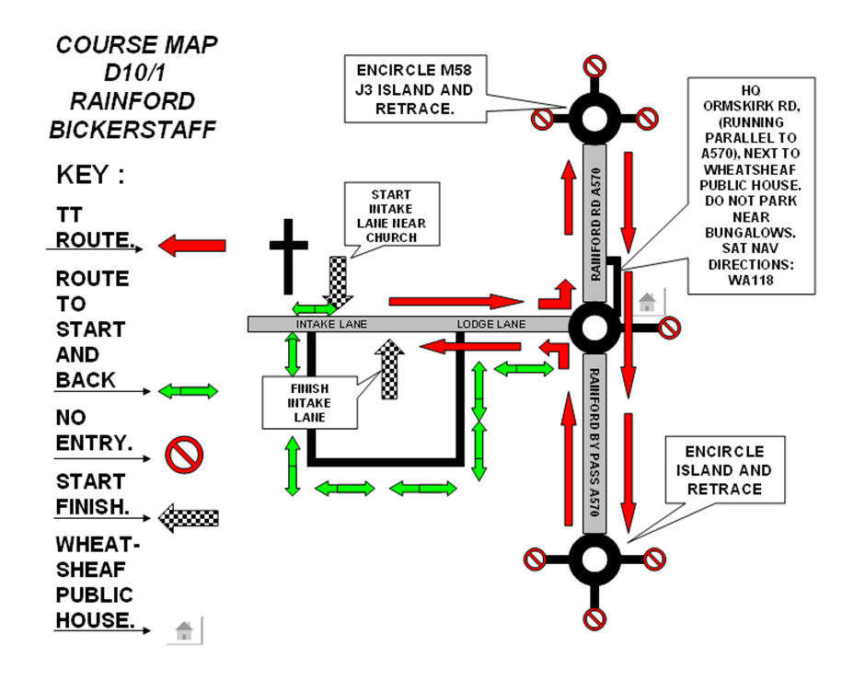
DO NOT PASS THE START OR FINISH ON YOUR WAY OUT OR BACK! FOLLOW THE ROUTE SHOWN ON THE MAP BY THE GREEN ARROWS. KEEP IN SINGLE FILE !!

PLEASE KEEP AWAY FROM THE BUNGALOWS IN THE HQ AREA. PARK VEHICLES AT THE FAR END OF THE ROAD. RESIDENTS HAVE COMPLAINED ABOUT CYCLISTS URINATING IN THIS AREA. ANYONE FOUND WILL BE DISQUALIFIED.

HEADQUARTERS: SAT NAV DIRECTIONS: WA11 7TA.

ORMSKIRK RD, RUNNING PARALLEL TO A570 RAINFORD RD. NEXT TO THE OLD WHEATSHEAF PUBLIC HOUSE.(SEE COURSE MAP.)

PRIZE LIST

- 1ST OVERALL £15………………  - 2nd OVERALL £10……………….  - 3RD OVERALL £5……….……… | - 1ST VET A £15...…………………  - 2ND VET A £10.….……………….  - 3RD VET A £5..……………………

- 1ST VET B £15..……………….  - 2ND VET B £10….……………..  - 3RD VET B £5………………….. | - 1ST VET C £15....…………………  - 2ND VET C £10..….……………….  - 3RD VET C £5..……………………

- 1ST LADY £15……………………..  - 2ND LADY £10……………………  - 3RD LADY £5……………………. | - 1ST TEAM OF 3 £5 EACH….…….  - 1st OVER 80 YEAR OLD £15…

- 1ST JUV / JUN £15……………..  - 2ND JUV / JUN£10………………  - 3RD JUV / JUN £5…………….. | - 1ST ROAD BIKE £15…………  - 2NDROAD BIKE £10 ………..  - 3rd ROAD BIKE £5 ………….
((((( ONE RIDER ONE PRIZE - EXCEPT FOR TEAM )))))

THE “BRIAN ROONEY MEMORIAL TROPHY” WILL BE AWARDED TO THE FASTEST LIVERPOOL CENTURY RIDER AT THE LCRC CLUB DINNER.

