
Wrekinsport CC Chris Edwards Hilly 18 Mile Time Trial

Friction and Hydraulic Services Shropshire Championship Points Series - Round 19
Fastest Wrekinsport rider to hold the Chris Edwards Shield

Promoted for and on behalf of Cycling Time Trials under its rules & regulations

Event to be held on 16th October, 2021 commencing at 2:00pm

Officials

Timekeeper: Mrs Jenny York, Mid Shropshire Wheelers
Asst Timekeeper: Mr Dave York, Mid Shropshire Wheelers
Recorder: Mr Dave York, Mid Shropshire Wheelers
Event Secretary: Dave Fletcher, 373, Holyhead Road, Wellington, Telford, Shropshire

Headquarters

HQ is Worfield Cricket Club WV15 5JZ, off the A454 at Grid Reference SO755958 on Landranger 138.

Leave the A454 opposite “The Wheel” Public House and follow the lane, taking the left fork past the Village Hall for ¾ mile. The Cricket Club is on the left at the top of the hill.

HQ will be open from 12:30pm. There is ample parking, including a small overflow car park to your left as you enter.

DO NOT PARK ON THE CRICKET PITCH

Safety

Riders are advised to warm up off course in the lanes towards the start. Please ride with your head up at all times, and respect the rules of the road as laid down in the Highway Code. Do not perform U-turns on the course within sight of the start and finish points. IN THE INTERESTS OF YOUR OWN SAFETY Cycling Time Trials and the event promoters strongly advise you to wear a HARD SHELL HELMET that meets an internationally accepted safety standard. In accordance with Regulation 15 ALL JUNIOR competitors MUST wear protective hard shell helmets.

CTT Regulation 14(i) – Compulsory rear red light

No competitor shall be permitted to start either a Type A or Type B event unless such competitor has affixed to the rear of their machine a working rear red light, either flashing or constant, that is illuminated and in a position that is clearly visible to other road users. NO REAR LIGHT – NO RIDE.

CTT Regulation 16 – Competitor’s Clothing

Triathlon style sleeveless tops are not permitted in Open events. No trade team tops or tops carrying advertising except where the rider’s club has paid the advertising levy. Manufacturer’s logos are allowed.

CTT Regulation 17d - Signing Off

Competitors MUST return to the event HQ either during the event or within a reasonable time after the last rider has finished the event and must return their race number and sign the official signing out sheet.

Thanks

I would like to thank all the marshals, helpers and officials who have made this event possible. I hope all riders have an enjoyable afternoon and have good, safe and fast rides. Dave Fletcher

Course K21/18e

- Start on B4176 at splay of T-junction at Stableford crossroads shortly before TFM Farm Machinery
- Proceed west to island junction at Sutton Maddock garage (3.68)
- Take first exit along A442 towards Bridgnorth to first island – NAVIGATE ISLAND WITH CARE (10.02)
- Take first exit up Hermitage Hill to island junction with A454 (10.73)
- Take second exit along A454 towards Wolverhampton to Rudge Heath island (15.28)
- Take first exit to proceed west along B4176 to finish at entrance to (closed) The Folley Inn car park (17.42)

Course map at: https://www.mapmyride.com/routes/view/1920159080
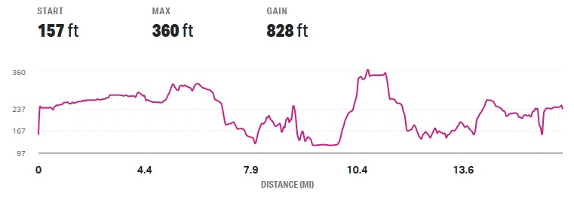
To start line

- Turn left out of Cricket Club car park.
- At Y-shaped fork in road take right-hand lane
- At T-junction turn right
- Follow lane towards Stableford B4176.
- Distance to start: 1.9 miles
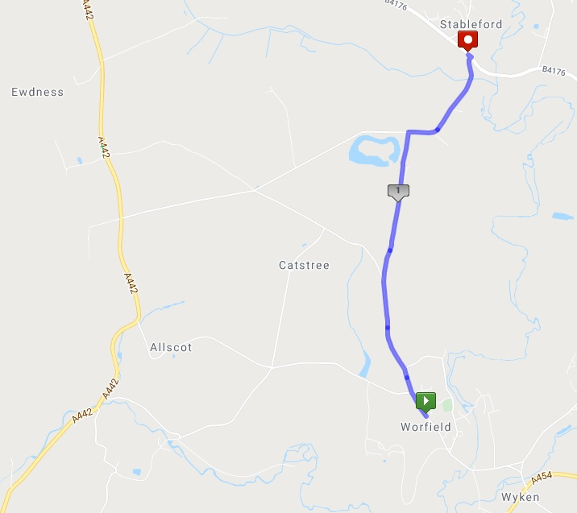

Start Order

Start No. | Forename | Surname | Club | Vet Std | Cat | Sex | Age | Time Off
1 | Dave | Moore | Wrekinsport CC | 00:50:03 | V | M | 58 | 14:01
2 | Alison | Dockney | Market Drayton CC |  | W | F | 35 | 14:02
3 | Ben | Southgate | Wrekinsport CC |  | J | M | 16 | 14:03
4 | Emma | Serjeant | Hafren CC | 00:52:00 | WV | F | 42 | 14:04
5 | Tim | Beardmore | Bridgnorth CC | 00:48:29 | V | M | 49 | 14:05
6 | Deb | Hutson-Lumb | Nova Raiders | 00:54:24 | WV | F | 56 | 14:06
7 | Phil | Roberts | Wrekinsport CC |  | S | M | 29 | 14:07
8 | Mike | Senior | Wolverhampton Wheelers |  | S | M | 38 | 14:08
9 | Jason | Garratt | Wrekinsport CC | 00:47:31 | V | M | 42 | 14:09
10 | Dave | Fellows | Solihull CC |  | S | M | 29 | 14:10
11 | Henri | Bedford | Revolutions Racing |  | J | M | 17 | 14:11
12 | Tomos | Hales | Wrekinsport CC |  | S | M | 29 | 14:12

Links

- Visit the Club Website at: www.wrekinsport.org.uk

- Full result will appear on Wrekinsport CC's Twitter at: www.twitter.com/wrekinsportcc

- Visit the Shropshire Cycling Clubs Association Website for race report at: https://shropshirecca.uk/

- Details of other County Series and Competitions appear on Shropshire Cycling Clubs Association's Twitter at: www.twitter.com/shropshirecca

In Memory of Chris Edwards

