Wrekinsport CC Chris Edwards Hilly 18 Mile Time Trial

Friction and Hydraulic Services Shropshire Championship Points Series - Round 1

Fastest Wrekinsport rider to hold the Chris Edwards Shield

Promoted for and on behalf of Cycling Time Trials under its rules & regulations

Event to be held on 5th March, 2022 commencing at 2:00pm

Officials

Timekeeper: Mr Dave York, Mid Shropshire Wheelers
Asst Timekeeper: Mr Dave York, Mid Shropshire Wheelers
Start line official and Recorder: Deb Hutson-Lumb, Wrekinsport CC
Event Secretary: Dave Fletcher, 373, Holyhead Road, Wellington, Telford, Shropshire

Headquarters

HQ is Worfield Cricket Club WV15 5JZ, off the A454 at Grid Reference SO755958 on Landranger 138.

Leave the A454 opposite “The Wheel” Public House and follow the lane, taking the left fork past the Village Hall for ¾ mile. The Cricket Club is on the left at the top of the hill.

HQ will be open from 12:30pm. There is ample parking, including a small overflow car park to your left as you enter.

DO NOT PARK ON THE CRICKET PITCH

Safety

Riders are advised to warm up off course in the lanes towards the start. Please ride with your head up at all times, and respect the rules of the road as laid down in the Highway Code. Do not perform U-turns on the course within sight of the start and finish points. Per Regulation 15 it is COMPULSORY to wear a properly affixed cycle helmet that meets an internationally accepted safety standard.

CTT Regulations 14(i) & 14(j) – Compulsory rear red light and front white light

No competitor shall be permitted to start either a Type A or Type B event unless such competitor has affixed to their machine a working rear red light, either flashing or constant; AND a working white front light either flashing or constant and that are illuminated and in positions that are clearly visible to other road users. NO LIGHTS – NO RIDE.

CTT Regulation 16 – Competitor’s Clothing

Triathlon style sleeveless tops are not permitted in Open events. No trade team tops or tops carrying advertising except where the rider’s club has paid the advertising levy. Manufacturer’s logos are allowed.

CTT Regulation 17d - Signing Off

Competitors MUST return to the event HQ either during the event or within a reasonable time after the last rider has finished the event and must return their race number and sign the official signing out sheet.

Thanks

I would like to thank all the marshals, helpers and officials who have made this event possible. I hope all riders have an enjoyable afternoon and have good, safe and fast rides. Dave Fletcher

Course K21/18e

- Start on B4176 at splay of T-junction at Stableford crossroads shortly before TFM Farm Machinery
- Proceed west to island junction at Sutton Maddock garage (3.68)
- Take first exit along A442 towards Bridgnorth to first island – NAVIGATE ISLAND WITH CARE (10.02)
- Take first exit up Hermitage Hill to island junction with A454 (10.73)
- Take second exit along A454 towards Wolverhampton to Rudge Heath island (15.28)
- Take first exit to proceed west along B4176 to finish at entrance to (closed) The Folley Inn car park (17.42)

Course map at: https://www.mapmyride.com/routes/view/1920159080
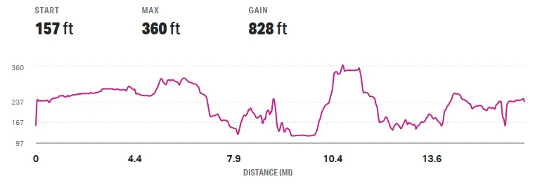
To start line

- Turn left out of Cricket Club car park.
- At Y-shaped fork in road take right-hand lane
- At T-junction turn right
- Follow lane towards Stableford B4176.
- Distance to start: 1.9 miles
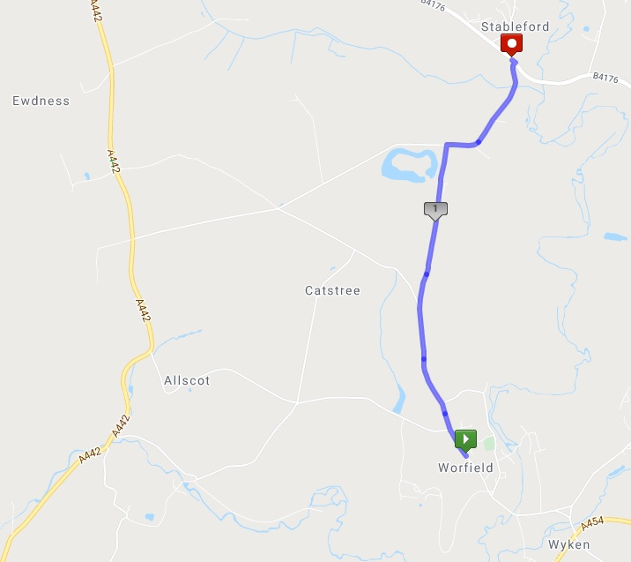

Start Order

Start No. | Forename | Surname | Club | Vet Std | Cat | Sex | Age | Time Off
1 | Stuart | Wortley | Wrekinsport CC | 00:50:03 | V | M | 58 | 14:01
2 | Jayne | Dickens | ProVision RC | 00:53:48 | WV | F | 53 | 14:02
3 | Chris | Riley | Paramount CRT | 00:49:07 | V | M | 53 | 14:03
4 | Victoria | Doran | Wrekinsport CC | 00:52:00 | WV | F | 42 | 14:04
5 | Joseph | Costello | Walsall Roads CC | 00:51:10 | V | M | 63 | 14:05
6 | Karl | Moseley | Bridgnorth CC | 00:50:03 | V | M | 58 | 14:06
7 | Nick | Giles | Pocomotion Road Club | 00:51:10 | V | M | 63 | 14:07
8 | Ben | Beachell | Rhos On Sea CC | 00:48:57 | V | M | 52 | 14:08
9 | Emma | Serjeant | Hafren CC | 00:52:00 | WV | F | 42 | 14:09
10 | Tim | Beardmore | Bridgnorth CC | 00:48:38 | V | M | 50 | 14:10
11 | Thomas | Bill | Stafford Triathlon Club |  | S | M | 31 | 14:11
12 | Tomos | Hales | Wrekinsport CC |  | S | M | 29 | 14:12
13 | Graeme | Donnell | Revolutions Racing | 00:49:40 | V | M | 56 | 14:13
14 | Ian | Holbrook | Stone Wheelers | 00:53:48 | V | M | 53 | 14:14
15 | Jonathan | Mills-Keeling | Bridgnorth CC | 00:48:29 | V | M | 49 | 14:15
16 | Simon | Dighton | Beacon Roads CC | 00:50:03 | V | M | 58 | 14:16

Links

- Visit the Club Website at: www.wrekinsport.org.uk

- Full result will appear on Wrekinsport CC's Twitter at: www.twitter.com/wrekinsportcc

- Visit the Shropshire Cycling Clubs Association Website for race report at: https://shropshirecca.uk/

- Details of other County Series and Competitions appear on Shropshire Cycling Clubs Association's Twitter at: www.twitter.com/shropshirecca

In Memory of Chris Edwards

