
Presents
10 mile Spring Classic Time Trial

Promoted for and on behalf of Cycling Time Trials under their Rules and Regulations

Saturday 12th March 2022
Course E91/10b - Start at 8:00

Event Headquarters: Willingale Village Hall, The St, Ongar, CM5 0SN – Open from 7:00

Event Organiser: Mr Paul Hart, Heath View, 32 Downham Road, Ramsden Heath, Essex, CM11 1PU
paul@hartperformancecoaching.com / 07528 681085

Timekeepers: Mr Trevor Pedley & Mr Ian Taylor

AWARDS
Junior Girl Winner: HPC Trophy. £50 NoPinz Voucher & Turbo Towel

Junior Boy Winner: HPC Trophy & £50 NoPinz Voucher & Turbo Towel
Junior Boy 2nd: HPC Trophy & £50 NoPinz Voucher & Turbo Towel
Junior Boy 3rd: HPC Trophy & £50 NoPinz Voucher & Turbo Towel

Ladies Winner: HPC Trophy
Ladies 2nd: HPC Trophy
Ladies 3rd: HPC Trophy

Men’s Winner: HPC Trophy
Mens 2nd: HPC Trophy
Mens 3rd: HPC Trophy

Ladies Vet Winner: HPC Trophy
Men’s Vet Winner: HPC Trophy

Ladies Road Bike: HPC Trophy
Men’s Road Bike: HPC Trophy

One prize per rider.

Prize Presentations: 10:45am in the Village Hall. Please stay and either collect your prize or congratulate the award winners. There will be refreshments at HQ.

Course Code: E91/10b

START at give way sign in Lane from High Easter just before the Four Wantz crossroads at Margaret Roding. Turn left on A1060 towards Chelmsford.
TURN at Beddells End Roundabout (5.4miles) and retrace to FINISH at a point 392 yards past Peppers Green sign, opposite wooden post 15yards before signpost to ‘The Easters’

Course map
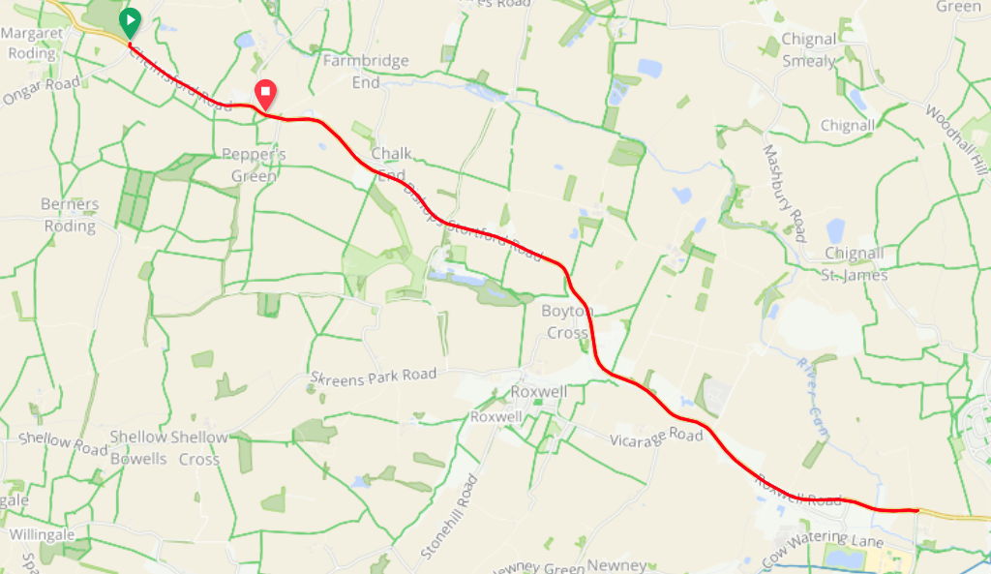

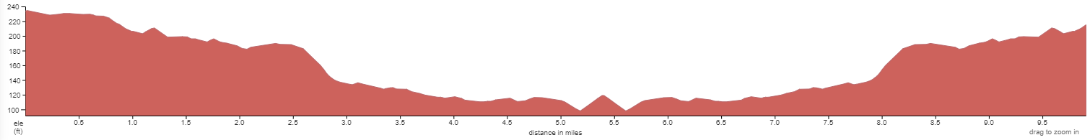

Strava: https://www.strava.com/segments/10246105?filter=overall

Course Records: Ladies: Unknown, Mens: Alex Dowsett 19:06 (2010)

HQ to start: 3.4 miles.
PLEASE ALLOW MINIMUM 20 MINS.
LEFT out of HQ. LEFT onto Dukes Lane. RIGHT onto Ongar Road (signposted Berners Roding). Follow to main road (A1060). There will be directional signs at the junctions. This is a typical country lane with some debris and can be susceptible to the odd puddle, so please take care.

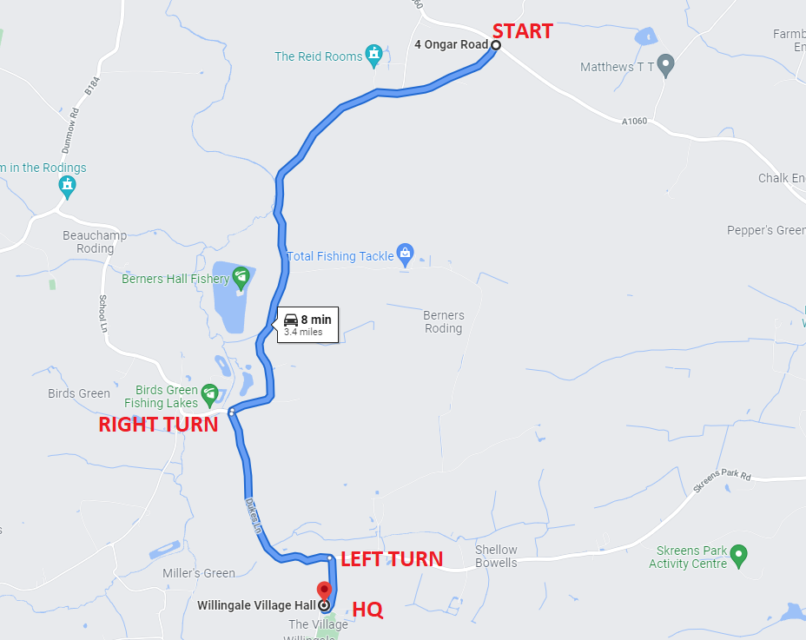

Finish to HQ: After finish, stay on A1060, then LEFT onto Ongar Road and retrace the above map. There will be directional signs at the junctions.

Parking: The HQ has a generous car park which will accept approx 30 cars. Please park efficiently and considerately. We have also hired a field at the cricket club which is approx. 100 yards up the road in the street for the additional parking. Please avoid parking in the street. Whilst there are no yellow lines its very important we are considerate to the neighbours. Please note this village lane is part of a bus route.

Parking nearer the start. If you wish to park nearer the start there is a lay-by outside the Rodings Primary School in Leaden Roding (CM6 1PZ) which will accept approx. 30 cars. Please note no cars may park at the start or the finish, nor on the verges adjacent.

Sign In / Out. All competitors must sign in at HQ and collect their number. Once finish you must return your number to HQ and Sign out. If you do not sign out you will be DQ’d.

Lights: The use of FRONT and REAR lights whilst competing is MANDATORY. These lights must be switched on and working at the start of the event. No lights No ride.

Cycling helmets: Cycling Time Trials require ALL COMPETITORS wear a HARD-SHELL HELMET that meets an internationally accepted safety standard. No Helmet No ride.

Litter: Riders are reminded that dropping litter (such as energy gel wrappers) is a criminal offence and offenders will be liable to disciplinary action by the District Committee.

Warming up: In respect of consideration for local residents, the use of static trainers, e.g.. turbo trainers, is banned from all morning events held in the London East District. No warming up along the course by competitors once the event has started.

No ‘U’ Turns: are allowed within sight of either the start or finishing points. Riders carrying out this dangerous manoeuvre are liable for disqualification from the event and further disciplinary action by the District Committee.

Roundabout at mile 5.4: There is no prize for crashing. The roundabout is not the place to try and save 2 secs. Take your time, be aware of traffic. The road is not closed, there will be cars. You must follow the highway code.

Spare Wheels: There will be a few spare wheels at the start if you are unlucky to pick up a puncture during warm up. The wheels are mine so please return them!

Covid-19 Reminder: There will be pushing off at the start, and results at HQ like the good old times. Just a polite reminder that if you are experiencing any COIVD like symptoms then please do not ride. Even if you have a negative test, riding full gas whilst unwell isn’t sensible.

Photographer: Annabelle May Photography will be taking photos before, during and after the time trial. Give a BIG smile if the camera comes near you. You will receive free photos of yourself racing and we aim to capture the amazing friendly atmosphere of a typical local time trial to share with all those who did not enter (but hopefully will next time!)

Road Bike Prizes: We have a ladies road bike winner, and men’s. There will be a marshal at the start who will note those who are on a road bike making them legible for the prizes. To clarify:
- No clip on TT bars
- No wheels over 50mm deep (including disc wheel)
- No aero helmet

Is this your first time trial?

We are delighted to have so many new time triallists at our event. Thank you to all of you that have entered. To help with that pre-race anxiety here are a few tips:

- Read the full start sheet. It will contain lots of important information.
- Aim to arrive at the HQ an hour before your start time. Being late increases stress. Park in the designated car park and you can change at the HQ.
- Sign on and collect your race number. Pin it down low on your back so it can be seen by the timekeepers. If you are under 18 you must have a signed parental form and hand it to the organiser or official when signing on.
- Ensure your bike is ready a few days before the event. You do not want to be making adjustments before the race. Its beneficial to be relaxed and calm before your race.
- Know how to get to the start. Maybe print a map. Also buddy up with someone in the car park who is starting at a similar time to you and ride to the start together. This will also help with pre-race nerves.
- Ensure you have your number pinned on, a working front and rear light and are wearing a helmet before you set off towards the start.
- The start is 3.4 miles from HQ. Use this ride as your warmup. Allow minimum 20mins, although I would suggest 30mins to allow plenty of time to relax and do a thorough warm up. Arrive at the start 5mins before your start time and wait. Remember No U turns in sight of the start or finish.
- Know the route. At 5.4 miles there is a small roundabout. Retrace that and ride back. Simple!
- Ride as fast (and safely) as you can. Take your time at the roundabout. That is not the place to try and save a few seconds. Be safe!
- If you see a photographer on the course, ensure you have a BIG smile!
- Once finished ride back to the HQ. Ensure you hand your race number back and sign out. To be featured in the results you must do this.
- When at the HQ have a cuppa and some cake and get your excuses ready for why you didn’t win!
- Start to plan how you will go faster next time.

HPC Partners











