Promoted for and on behalf of Cycling Time Trials under their Rules and Regulations

Birdwell Wheelers Open 7.5 Mile Time Trial
Saturday 8th May 2017
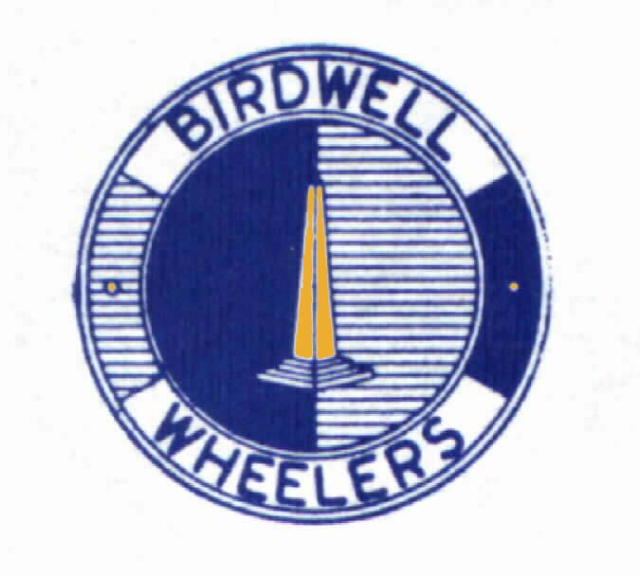
Event Secretary: Paul Heggie 10 Wellfield Road
BARNSLEY S75 2AL 01226200776

Timekeepers: Philip Minto Jan Wilson

Taylor Trophy: Dan Barnett Team Bottrill/HSS Hire
Jim Carr Trophy: Karen Ledger Rutland CC
1st Male £30 Dan Barnett Team Bottrill/HSS Hire
2nd Male £25 Patrick Gould Matlock CC
3rd Male £15 Antony Bromley Barnsley RC

1st Woman £30 Karen Ledger Rutland CC
2nd Woman £25 Alex Deck Rutland CC
3rd Woman £15 Victoria Howden LincsQuad

1st Vet40-44 £15 Richard Bielby Hull Thursday RC
1st Vet45-49 £15 Stuart Wells Flex-Tech Ettridge CRT
1st Vet50-59 £15 Chris Ledger Rutland CC
1st Vet60-69 £15 Mark Philipson City RC (Hull)
1st Vet70+ £15 Anthony Keyworth Kiveton Park CC
1st 15-18 £15 Tom Booth Birdwell Wheelers

1st road bike £25 Oliver Bridgewood Spokes BPC Racing
2nd road bike £20 Andy Bishop Andy Moore Autocentres
3rd road bike £10 Dominic Watts Veloviewer

1st Team of 3 £3 x £10 Langsett Cycles RT
Andrew Whitely Keith Ainsworth Tim Fearn

Thanks to helpers and marshals:
Malcolm Wilson Christine Minto Carol Booth Trevor Mayne
Shaun Dolby Rob Booth Jack Hollington Roger Bacon

