Start Sheet for the  Northampton & District Cycling Association  12.8 mile Time Trial (TT Series Event 6 of 8) | 
Sunday 7th July 2024 starting at 9 am | FOUNDED 1935
 | PRESIDENT:
Promoted for and on behalf of Cycling Time Trials under their Rules and Regulations | Sue Holliday
This event is a counting event for all categories of the N&DCA Time Trial Series Championships.
For the latest points tables visit the results website: http://www.northamptondca.org.uk/

Headquarters:
Rockingham Forest Wheelers Clubhouse, 11 Ashley Road, Middleton LE16 8HR

Facilities:
The HQ will be open from just after 07.30am for toilets and sign on.
On the day parking is in the field past the clubhouse, it will be signposted. Please do not park on the road junction directly oppose the clubhouse.

Timekeepers: Sharon Fensom and Sue Holliday

Event Secretary: Phil Wilkison sarnbach@gmail.com

Please note that:
Prize Values | Handicap Prize
1st | £15
2nd | £12
3rd | £10
4th | £ 8
5th | £ 5

The handicap prize for this event is based on best improvement against predicted Spindata times. In the event of no Spindata prediction being generated which might be the case if not many events have been ridden recently, the time to beat will be the rider’s PB for 10 miles as supplied by the CTT entry form data. To be eligible for this prize competitors must have a 10 mile best time to beat.

Spot prizes: A spot prize will be awarded to every 10th place finisher on actual time (regardless of machine type) ie 10th, 20th, 30th, 40th, 50th, 60th place etc.

Local Regulations:

NO U-TURNS are allowed within sight of either the start or the finishing points. Riders carrying out this dangerous manoeuvre are liable for DISQUALIFICATION from the event and further disciplinary action by the district committee.
Please also remember that there is a need for good behaviour and consideration towards other road users and local residents in order to avoid any complaints being received.

Numbers:

These will be available at the Event Headquarters, not at the Start. Each number will have pins in each corner, please remove and place in box if not needed because you are using a NoPinz pocket. Also only use the corner pin holes and do not make more holes if using pins. Please ensure that the body number is clearly visible from behind and fixed on the lower back.

Signing In/Out:
Please ensure that you sign the “Signing-On” Sheet when collecting your number and clearly call out your number when crossing the finish line. Please ensure you return your number to HQ and sign-out, using the “Signing-on/off” Sheet. Failure to do so could result in your exclusion from the Results.

Road Bike category

For your ride in this event to be eligible for the season long Road Bike category it is assumed that your entry category covers the actual bike you are riding on the day. The start line assistant will check your bike meets the road bike criteria at the same time as checking lights. To be eligible your bike must not have “tri-bars” or equivalent, disc wheels, less than 12 spokes or other fairings. In event of a dispute regarding RB eligibility, the organisers decision is final.

Compulsory Front/Rear Lights and Helmets:

Regulation 14(i) requires all Competitors to have affixed to the rear of their machine a working rear red light, either flashing or constant, that is illuminated and in a position that is clearly visible to other road users.
Regulation 14(j) requires all Competitors to have affixed to the front of their machine a working front white light, either flashing or constant, that is illuminated and in a position that is clearly visible to other road users.
Regulation 15 requires that all Competitors must wear a properly affixed helmet which must be of hard/soft shell construction. Helmets should conform to a recognised Standard such as SNELL B95, ANSI Z90.4, AUS/NZS 2063:96, DIN 33-954, CPSC or EN 1078.
Failure of any of the above three points will render the competitor not being allowed to start the event.

Doping Control:

This event may be subject to Doping Control. As soon as you have finished you should return to HQ as it is your responsibility to check if you are required for a Doping Control. Race numbers required for Doping Control will be displayed at the HQ adjacent to the Result Board. If your number is displayed you should report immediately to Doping Control which will be nearby. Remember, it is up to you to check and ensure you comply.

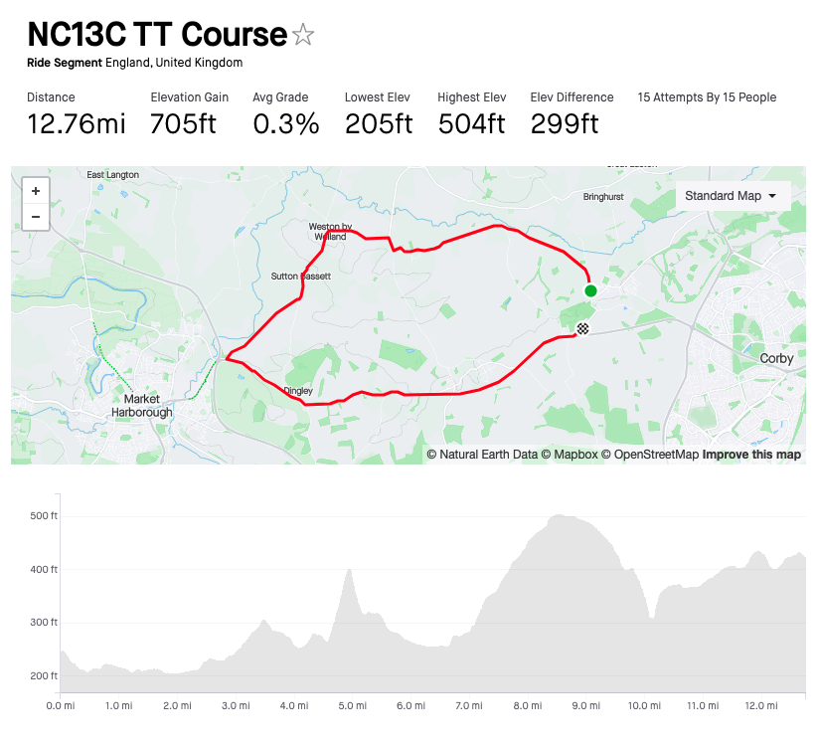

COURSE IDENTIFICATION: COURSE NUMBER NC13C

START Outside the Rockingham Forest Wheelers Clubroom, 11 Ashley Road, Middleton, in line with fence between the clubhouse and adjoining garages. Proceed along the road to Ashley and continue through Ashley to the T-junction with the B664 (M)
TURN LEFT onto the B664 and proceed through Weston-by-Welland and Sutton Bassett to the junction of the B664 and the A427 where (M)
TURN LEFT onto A427 and proceed through Dingley to the junction of the A427 and B670 at East Carlton where (M)
TURN LEFT ono the B670. Continue on the B670 to
FINISH 10 yards past the gates to East Carlton Park, opposite the ‘East Carlton’ village sign.

COURSE NOTES:
The only motor vehicles associated with the Event allowed near Start or Finish will be those of the Timekeepers If passing any Horse Riders, please give due consideration and plenty of space.
Please refrain from warming up on the course after the event has started, as this causes extra work for the timekeepers.
Please keep well into the side, while waiting to start.

You must observe the Highway Code and comply with traffic law and regulations. You must also ride in a manner that is safe for yourselves and all others, and must rely on your own ability and judgement in dealing with hazards, though every effort has been made to marshal the course and the position of ‘Event Aware’ signs, so as to minimise the risk, as required by the Course ‘Risk Assessment’. The onus is still on you the rider, so familiarise yourself with the course details.

Competitors:
(A) = Association Club
Categories: S = Senior/Open F = Female J = Junior/ Juvenile
Masters Open: A = 50-54, B = 55-59, C = 60-64, D = 65-69, E = 70-74, F = 75 plus Masters Female: A = 40-44, B = 45-49, C = 50-54, D = 55-59, E = 60-64, F = 65 plus

*NB Masters age category is age on day of first N&DCA event ridden this year.

Juniors/Juveniles:
For the 2024 season there are no separate juvenile or junior sections, only a single U19 category, i.e. Those Competitors aged under 18 or have their 18th birthday during 2024

Result Sheet app:
Subject to availability of sufficiently tech savvy volunteers, we will be trialling the Result Sheet application which will enable you to track times live via the application on your phone if you scan the printed QR code at the Race HQ. Alternatively you can also view the results on screen at the HQ whilst enjoying tea and homemade cakes and some lively banter.

Season long competition prizes:
Please note that the actual value of the cash prizes awarded for performance in the various categories will be published after the last event of the season when the total prize fund is known as determined by the surplus generated by the event entry fee income.
Trophies:
Trophies and end of season competition prizes will be awarded at the annual Prize Award Lunch (usually held in January). NB Separate event prizes will be awarded after the last event in the series, not after each event.

The Association’s 12-hour trophies will be awarded to members of Association Clubs for their performances in any open 12-hour event held under CTT Rules & Regulations. The Association’s Long Distance BAR will be awarded to the highest placed rider of an Association Club in the National BBAR. Qualifying events are marked B in the CTT Handbook

For more information on the season long competitions and N&DCA trophies, including past winners, please refer to our website:

www.northamptondca.org.uk

Good luck and trust you all have a good and trouble free ride.

No | Time | FN | SN | Machine | Club/Team | Class | Cat
1 | 09:01 | David | Cook | Road Bike | Bedfordshire Road CC | Open | Veteran
2 | 09:02 | Carolyn | Pfalzgraf | TT Bike | VéloElite RC | Female | Senior
3 | 09:03 | Trevor | Parrish | TT Bike | A5 Rangers CC | Open | Veteran
4 | 09:04 | Martin | Paston | TT Bike | Rockingham Forest Wheelers | Open | Senior
5 | 09:05 | Lynne | Scofield | Road Bike | Rockingham Forest Wheelers | Female | Veteran
6 | 09:06 | Ethan | Mitchell-Clarke | Road Bike | Rockingham Forest Wheelers | Open | Junior
7 | 09:07 | Leah | Cuthbertson | Road Bike | Onyx RT | Female | Senior
8 | 09:08 | Linda | Hubbard | TT Bike | Welland Valley CC | Female | Veteran
9 | 09:09 | Paul | Beattie | Road Bike | Royal Air Force Cycling Association | Open | Veteran
10 | 09:10 | Pete | Trotman | TT Bike | A5 Rangers CC | Open | Veteran
11 | 09:11 | Diego | Patteri | Road Bike | Kingston Wheelers CC | Open | Senior
12 | 09:12 | Steve | Skelhon | TT Bike | Fenland Clarion CC | Open | Veteran
13 | 09:13 | Malcolm | Moore | Road Bike | Ambion Racing Team | Open | Veteran
14 | 09:14 | Noel | Toone | Road Bike | Kettering CC | Open | Veteran
15 | 09:15 | Maria | Cayford | TT Bike | Kettering CC | Female | Senior
16 | 09:16 | Nathan | Dalton | Road Bike | VéloElite RC | Open | Senior
17 | 09:17 | Steven | Brierley | Road Bike | VéloElite RC | Open | Veteran
18 | 09:18 | John | Beckett | TT Bike | Rugby Velo | Open | Veteran
19 | 09:19 | Alex | Whitmore | Road Bike | Ratae RC | Open | Senior
20 | 09:20 | Paul | Russell | TT Bike | Rockingham Forest Wheelers | Open | Senior
21 | 09:21 | Chris | Spray | TT Bike | Ratae RC | Open | Veteran
22 | 09:22 | Adrian | McHale | TT Bike | Peterborough CC | Open | Veteran
23 | 09:23 | Neil | Barford | TT Bike | 45 RC | Open | Veteran
24 | 09:24 | Mark | Tomlinson | TT Bike | Peterborough CC | Open | Veteran
25 | 09:25 | Cian | Leveridge | TT Bike | Team PB Performance | Open | Senior
26 | 09:26 | Simon | Hunt | TT Bike | VéloElite RC | Open | Veteran
27 | 09:27 | Ed | Watson | TT Bike | Ratae RC | Open | Veteran
28 | 09:28 | Richard | Golding | TT Bike | Equipe Velo | Open | Veteran
29 | 09:29 | Stuart | Morgan | TT Bike | VéloElite RC | Open | Veteran
30 | 09:30 | Michael | Weaver | Road Bike | Rockingham Forest Wheelers | Open | Veteran
31 | 09:31 | Jamie | Murray | TT Bike | Peterborough CC | Open | Veteran
32 | 09:32 | Dan | Whitehouse-Smith | TT Bike | Army Cycling | Open | Senior
33 | 09:33 | Adam | Wells | TT Bike | Rockingham Forest Wheelers | Open | Senior
34 | 09:34 | Jack | Eastman-Nye | TT Bike | George Fox Cycling Solutions | Open | Senior
35 | 09:35 | Kevin | Hobbs | TT Bike | Peterborough CC | Open | Veteran
36 | 09:36 | Adam | Fisher | TT Bike | Cambridge CC | Open | Veteran
37 | 09:37 | Jack | Patmore | TT Bike | George Fox Cycling Solutions | Open | Senior
38 | 09:38 | George | Fox | Road Bike | George Fox Cycling Solutions | Open | Senior
39 | 09:39 | Paul | Pardoe | TT Bike | Peterborough CC | Open | Veteran
40 | 09:40 | Malcolm | Giles | Road Bike | Pocomotion Road Club | Open | Veteran
41 | 09:41 | Nick | Giles | Road Bike | Pocomotion Road Club | Open | Veteran

